Standard-type apartments, September 1, 2026

In August 2026, standard-type apartment prices in Riga housing estates experienced fluctuations – within a month, the average price of standard-type apartments increased by 0.9%. In August, the average price of standard-type apartments rose to 972 EUR/m².

Price changes for standard-type apartments since the beginning of 2026, in %

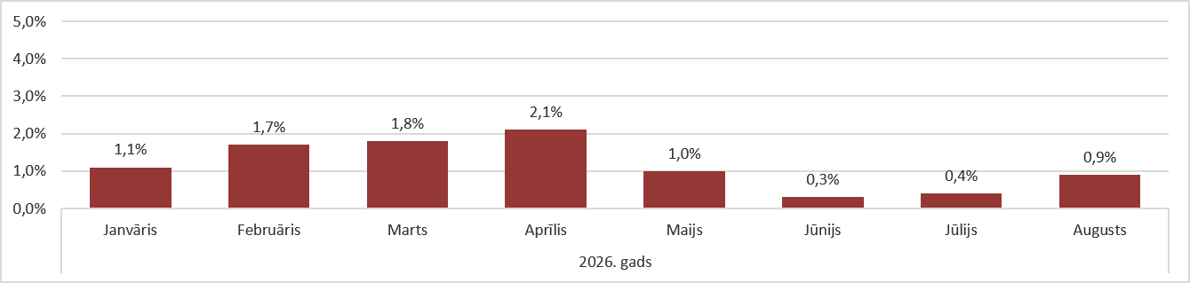

Source: ARCO REAL ESTATE

The average price increase recorded in August was the largest compared to the other summer months. Overall, apartment prices have risen by an average of more than 9% since the beginning of 2026. This year, apartment prices increased every month, and the upward trend continues.

The number of apartments offered for sale decreased slightly in August. A similar decline in supply was also observed in August of the previous year. In August 2026, there were just over 1,100 apartments offered for sale in the largest housing estates of Riga.

Dynamics of apartment supply in the largest housing estates of Riga

Source: ARCO REAL ESTATE

Since the beginning of 2026, apartment prices in the largest housing estates of Riga have increased by 6–13%. The most significant changes in apartment prices were observed in Imanta, where they have risen by 13% this year. In Āgenskalns and Zolitūde, the price growth for standard-type apartments was also relatively higher than in other housing estates, with prices increasing by an average of 11%.
In the remaining housing estates of Riga, price changes did not exceed 10% this year. The smallest changes in apartment prices were recorded in Bolderāja, the cheapest housing estate in terms of pricing, as well as in Teika, the most expensive housing estate. In both areas, the average apartment price growth in 2026 was 6%.
Price changes in the largest housing estates of Riga since January 1, 2026, in %

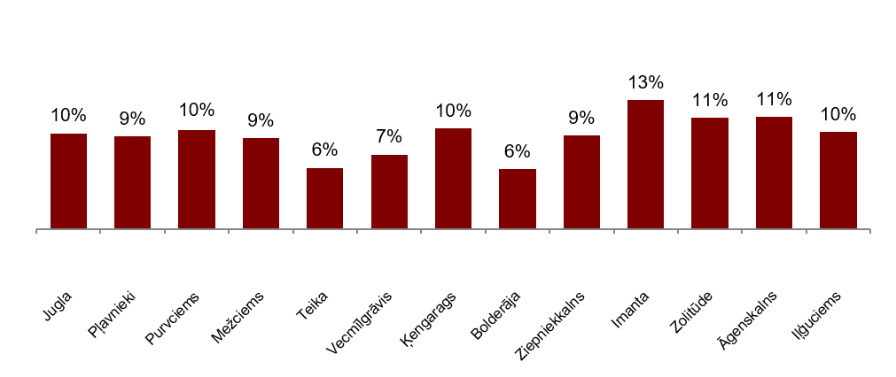

Source: ARCO REAL ESTATE

In August, the average price of standard-type apartments increased to 972 EUR/m². Prices were on average 40% lower than on August 1, 2007, when the average price of an unrenovated standard-type apartment reached an all-time highest level of EUR 1,620/m².

Dynamics of average price of standard-type apartments in the major housing estates of Riga, EUR/m²

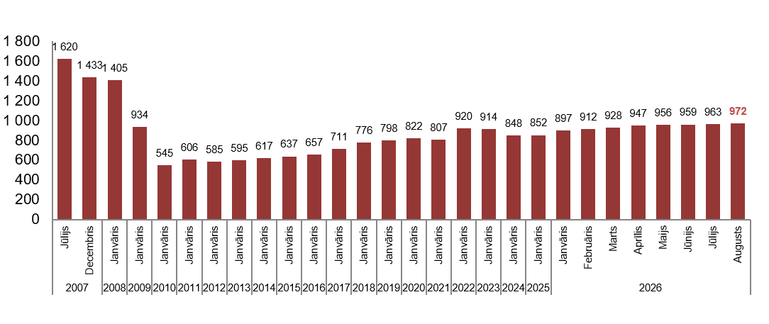

Source: ARCO REAL ESTATE

Changes in prices of standard-type apartments in housing estates of Riga, in %

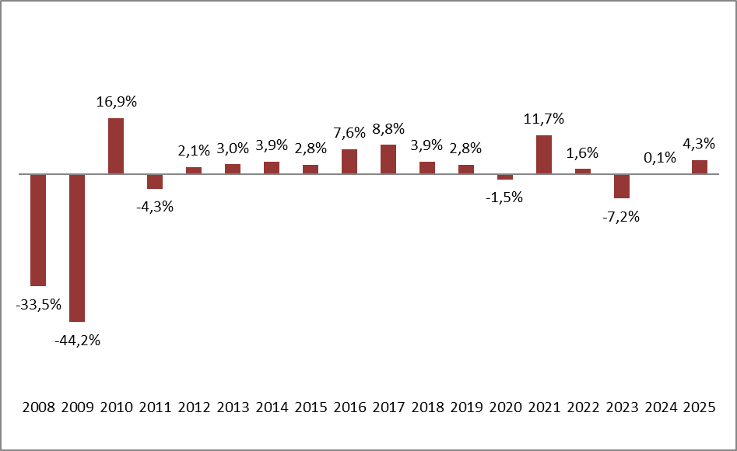

Source: ARCO REAL ESTATE

In August, the average price per square meter of standard-type apartments increased for one-room apartments (+0.9%), two-room apartments (+1.2%), three-room apartments (+1.1%), and four-room apartments (+0.7%). Since the beginning of this year, the price of two-room apartments has increased the most (+10.4%).

Average prices of standard-type apartments in Riga housing estates by number of rooms, EUR/m²

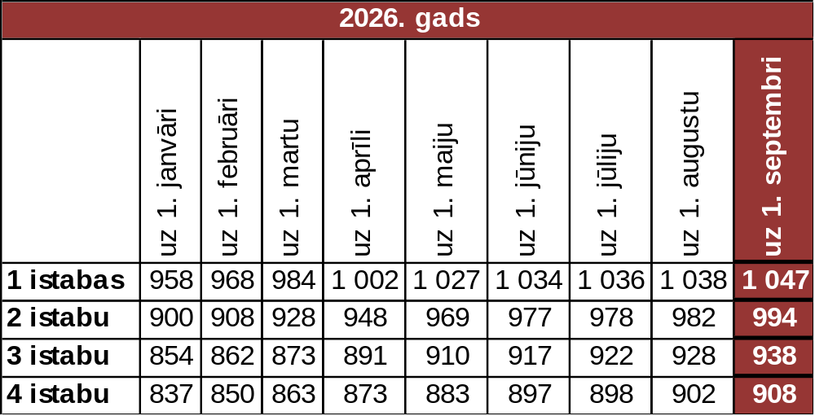

Source: ARCO REAL ESTATE

Compared to the previous month, the supply of apartments in Riga decreased by 1% in August. The number of offers in the largest housing estates of Riga analyzed by “ARCO REAL ESTATE” also decreased - by 4%. Compared to August 2025, the supply of apartments was generally lower: the total number of apartments offered for sale was 8% lower, but the number of apartments offered for sale in the largest housing estates was 18% lower

Dynamics of supply of apartments in Riga

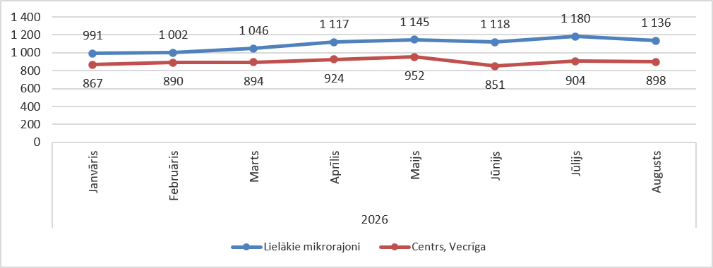

Source: ARCO REAL ESTATE

Summarizing the number of apartments offered for sale in Riga housing estates, it can be concluded that the largest supply in August still was in Āgenskalns, while the smallest supply was in Bolderāja.

Number of apartments offered for sale in Riga at the end of August 2026

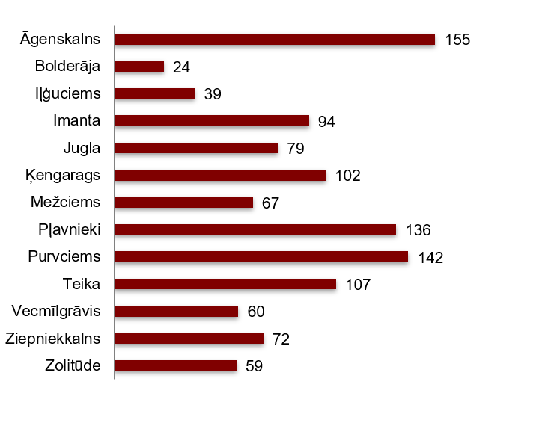

Source: ARCO REAL ESTATE

In August, the number of apartments offered for sale in the largest housing estates of Riga both increased and decreased. However, overall, the number of apartments offered for sale was lower than last month. The number of offers increased the most in August in Zolitūde (+23%) while decreased the most in Iļģuciems (-35%).

In August, when analysing the number of apartments offered for sale in proportion to the size of the housing estate, i.e., by population, the largest number of apartments offered for sale was found in Āgenskalns. In contrast, the number of apartments offered for sale in Iļģuciems was proportionally the smallest.

Number of apartments offered for sale in proportion to the size of the housing estates in Riga in August 2026

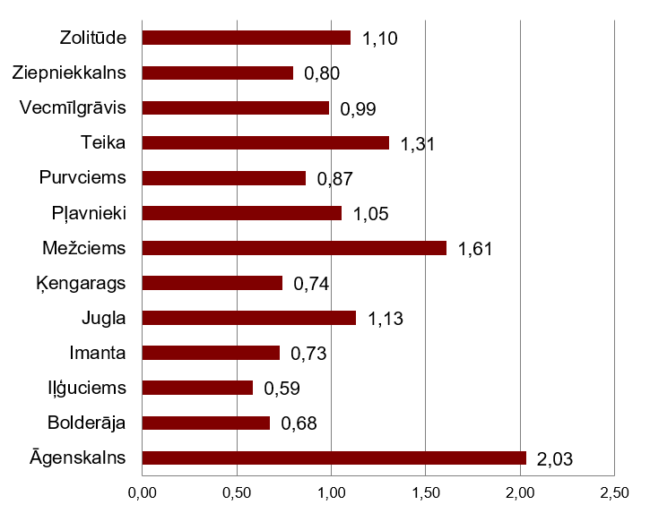

Source: ARCO REAL ESTATE

In August, changes could be observed in the prices of standard-type apartments in Riga housing estates. An increase in the average price of apartments could be observed in all the largest housing estates of Riga. The largest increase in the average price was observed in Ķengarags, Zolitūde and Āgenskalns, where prices increased by 1.6% during the month. In other housing estates of Riga, the price increase was also higher compared to previous months.

Changes in the average square meter price of standard-type apartments in Riga housing estates, in %

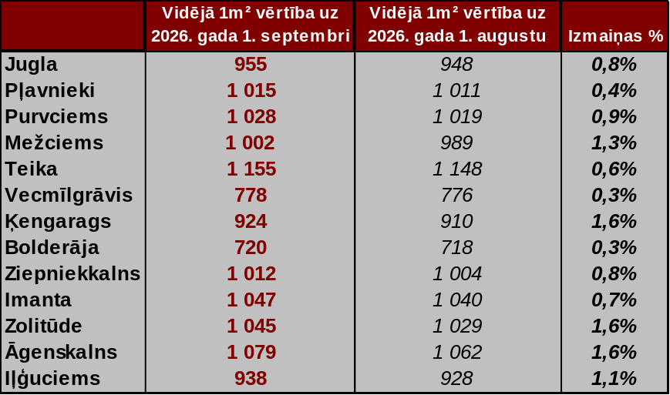

Source: ARCO REAL ESTATE

Compared to the beginning of 2026, in August, prices for standard-type apartments were higher in all major housing estates of Riga. The highest average price per square meter of an apartment was in Teika, but the lowest was still in Bolderāja.

Average standard-type apartment prices in housing estates of Riga, EUR/m²
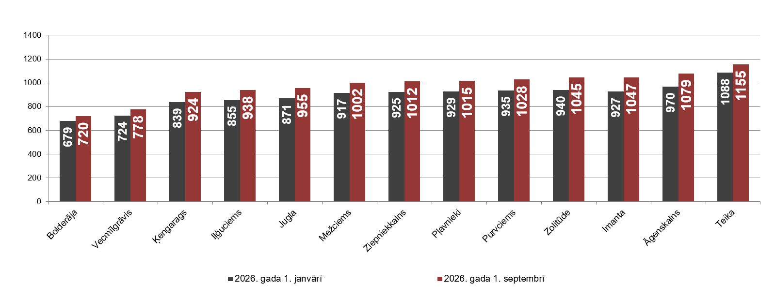

Source: ARCO REAL ESTATE

The highest prices for standard-type apartments in August remained in Teika, where the average price per square meter increased to 1,155 EUR/m². The lowest average price per square meter in August was in Bolderāja (720 EUR/m²), which also increased compared to the previous month.

Average standard-type apartment prices in housing estates of Riga on September 1, 2026, EUR/m²

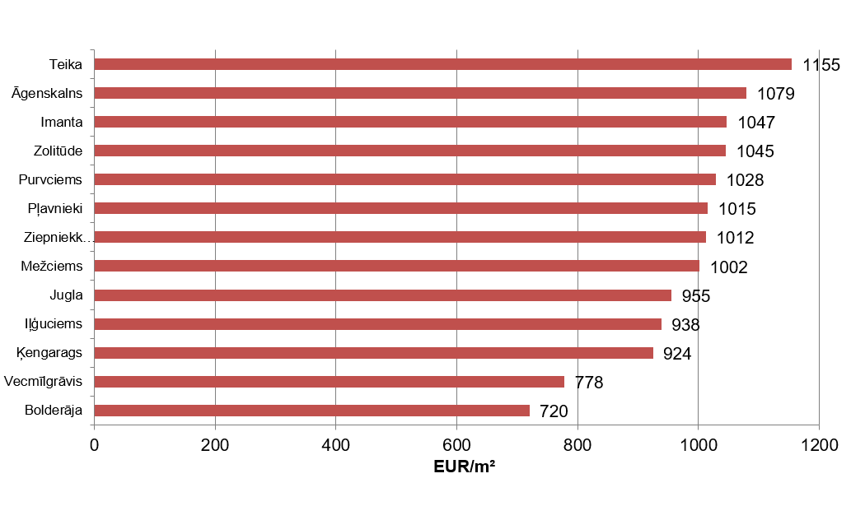

Source: ARCO REAL ESTATE

In August, the most expensive apartments still were apartments in the houses of the series 119 and 104, where the price of 2-room apartments in a satisfactory condition varied from 58 000 to 62 000 EUR depending on the location. In turn, the so-called Lithuanian design houses were the cheapest ones, where the price of 2-room apartments varied from 34 000 to 49 000 EUR, and the so-called Khrushchev-time houses, where the price of a 2-room apartment varied from 33 000 to 50 000 EUR depending on the housing estate.

Standard-type apartment prices by series in Riga housing estates in August 2026 (2-room apartments), EUR

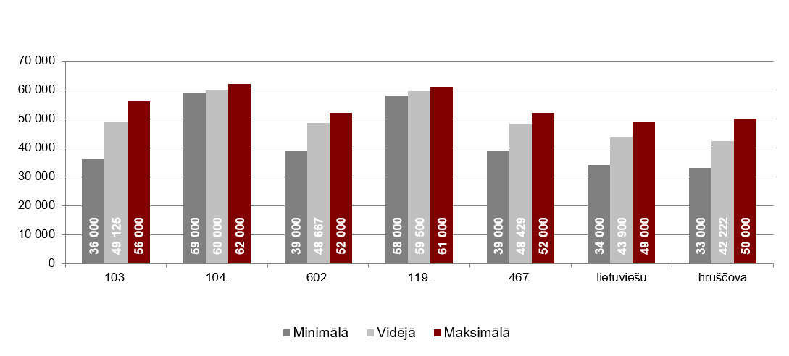

Source: ARCO REAL ESTATE

Apartment market in the vicinity of Riga

Ogre

In August 2026, the prices of standard-type apartments increased by 0.6%. The average price per square meter of an apartment rose to EUR 977/m². In August, apartment prices in Ogre were 11% higher than at the beginning of 2026.

Dynamics of the average price of standard-type apartments in Ogre, EUR/m²

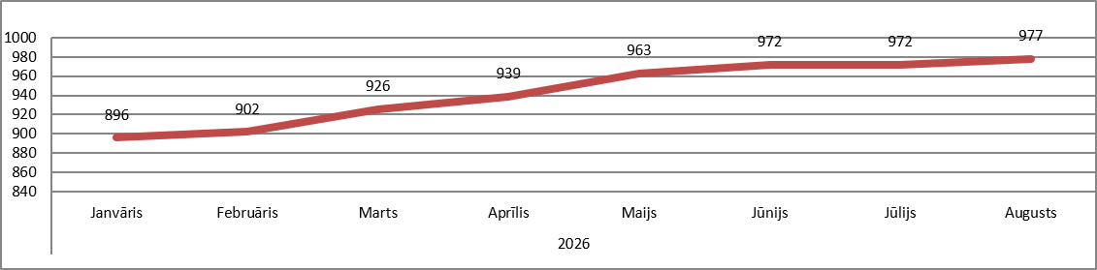

Source: ARCO REAL ESTATE

Kauguri, Jūrmala

In August 2026, standard-type apartment prices in Kauguri increased by 0.5%. The average price of a standard-type apartment in August was 887 EUR/m². Since the beginning of 2026, apartment prices in Kauguri have increased by 7%.

Dynamics of the average price of standard-type apartments in Kauguri, EUR/m²

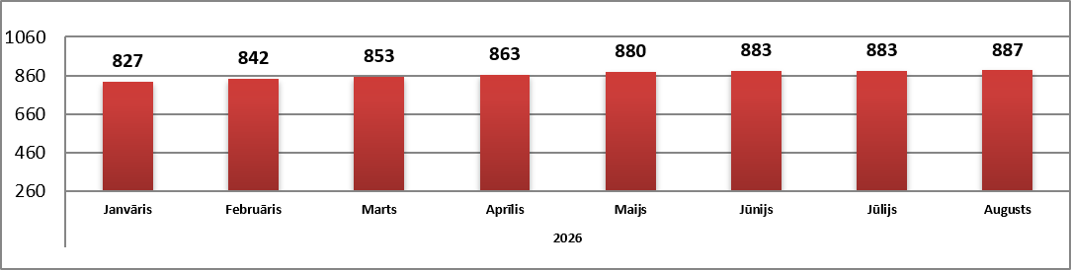

Source: ARCO REAL ESTATE

Salaspils

In August 2026, standard-type apartment prices in Salaspils increased by 0.6%. The average price per square meter of an apartment rose to EUR 913/m². In August, standard-type apartment prices in Salaspils were 8% higher than at the beginning of this year.

Dynamics of the average price of standard-type apartments in Salaspils, EUR/m²

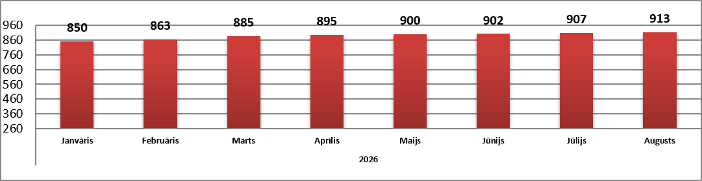

Source: ARCO REAL ESTATE

Jelgava

In August 2026, apartment prices in Jelgava remained unchanged. The average price of standard-type apartments in Jelgava in August was 800 EUR/m². In August, standard-type apartment prices in Jelgava were 4% higher than at the beginning of 2026.

Dynamics of the average price of standard-type apartments in Jelgava, EUR/m²

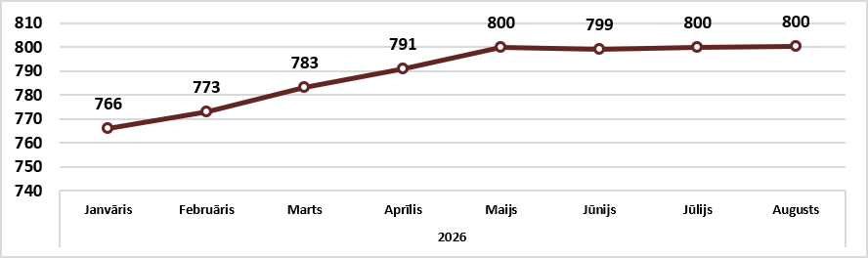

Source: ARCO REAL ESTATE

