Standard-type apartments, October 1, 2026

In September 2026, standard-type apartment prices in Riga housing estates experienced fluctuations – within a month, the average price of standard-type apartments increased by 0.6%. In September, the average price of standard-type apartments rose to 978 EUR/m².

Price changes for standard-type apartments since the beginning of 2026, in %

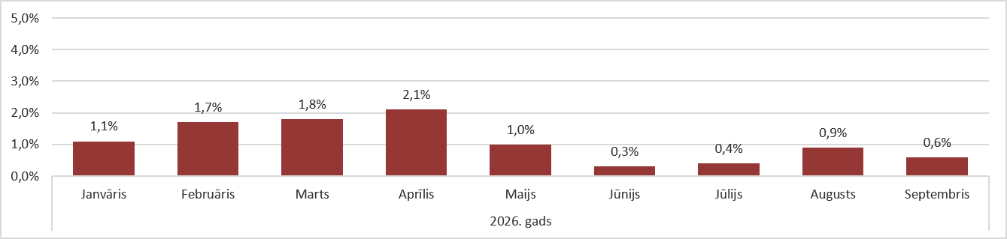

Source: ARCO REAL ESTATE

The average price increase detected in September was lower than in the previous month. Overall, apartment prices have risen by more than 10% on average since the beginning of 2026. Apartment prices increased every month this year, and the upward trend still continues.

The number of apartments offered for sale increased slightly in September. An increase in the apartment supply was also observed in September of the previous year, though it was more pronounced last year. In September 2026, there were nearly 1,200 apartments offered for sale in Riga's largest housing estates.
.

Dynamics of apartment supply in the largest housing estates of Riga

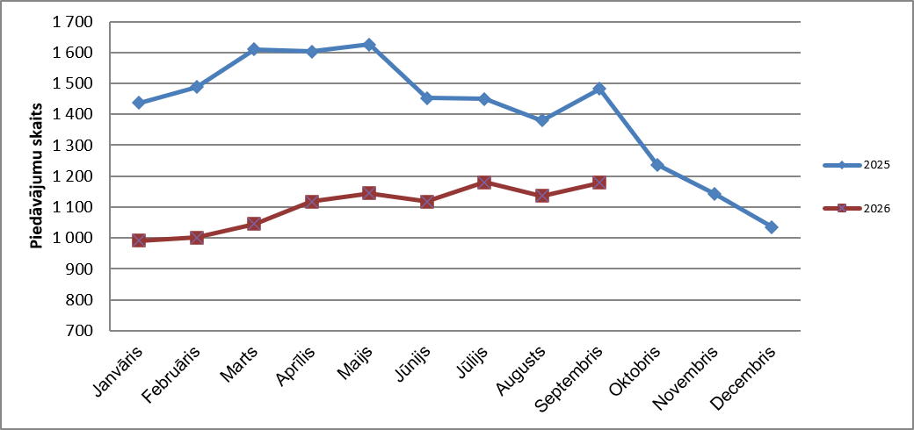

Source: ARCO REAL ESTATE

Since the beginning of 2026, apartment prices in Riga's largest housing estates increased by 7–13%. The most significant price changes were observed in Imanta, where prices rose by 13% this year. In Āgenskalns, the price increase for standard-type apartments was also relatively higher than in other housing estates, with prices growing by an average of 12%. In the remaining housing estates of Riga, price changes this year did not exceed 11%. The smallest price fluctuations were recorded in the most affordable housing estate, Bolderāja, as well as in the most expensive one, Teika. In both of these areas, the average apartment price growth in 2026 was 7%.

Price changes in the largest housing estates of Riga since January 1, 2026, in %

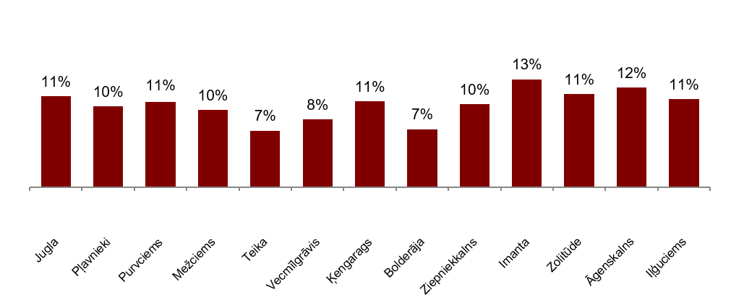

Source: ARCO REAL ESTATE

In September, the average price of standard-type apartments increased to 978 EUR/m². Prices were on average 40% lower than on August 1, 2007, when the average price of an unrenovated standard-type apartment reached an all-time highest level of EUR 1,620/m².

Dynamics of average price of standard-type apartments in the major housing estates of Riga, EUR/m²

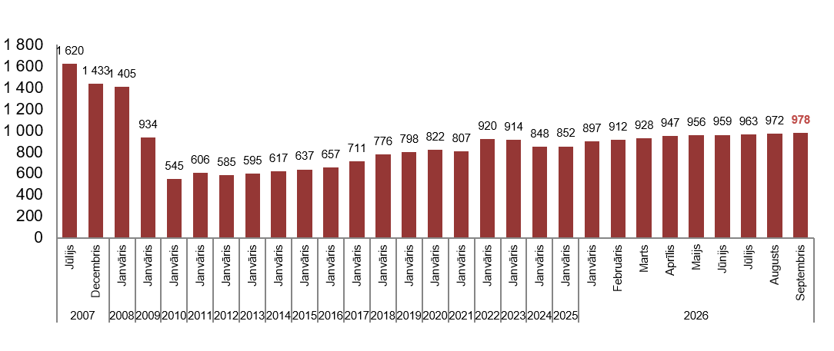

Source: ARCO REAL ESTATE

Changes in prices of standard-type apartments in housing estates of Riga, in %

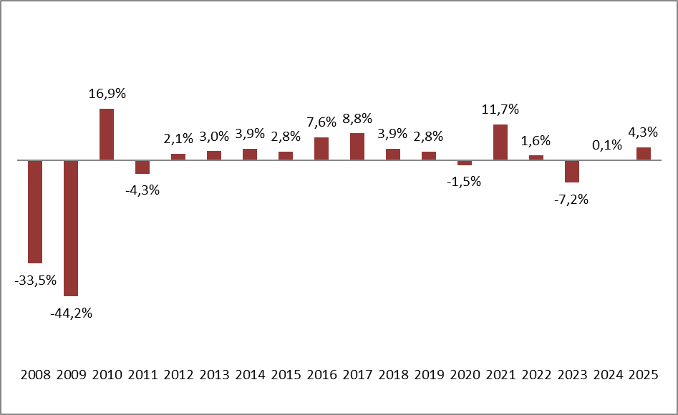

Source: ARCO REAL ESTATE

In September, the average price per square meter of standard-type apartments increased for one-room apartments (+0.6%), two-room apartments (+0.7%), and three-room apartments (+1%). For four-room apartments, the average price per square meter remained unchanged in September. Since the beginning of this year, the price of two-room apartments saw the highest increase (+11.2%).

Average prices of standard-type apartments in Riga housing estates by number of rooms, EUR/m²

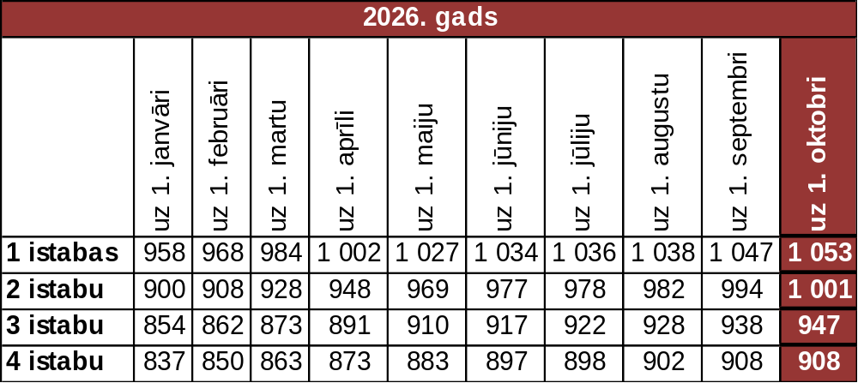

Source: ARCO REAL ESTATE

Compared to the previous month, the supply of apartments in Riga increased by 4% in September. The number of offers in the largest housing estates of Riga analyzed by “ARCO REAL ESTATE” also increased by 4%. Compared to September 2025, the supply of apartments was generally lower: the total number of apartments offered for sale was 15% lower, but the number of apartments offered for sale in the largest housing estates was 20% lower

Dynamics of supply of apartments in Riga

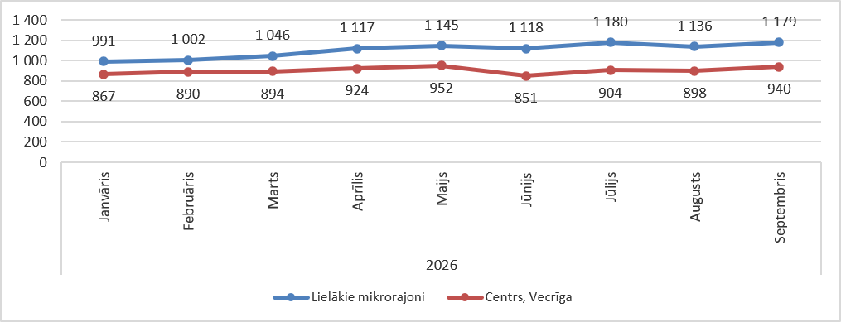

Source: ARCO REAL ESTATE

Summarizing the number of apartments offered for sale in Riga housing estates, it can be concluded that the largest supply in September still was in Āgenskalns, while the smallest supply was in Bolderāja.

Number of apartments offered for sale in Riga at the end of September 2026

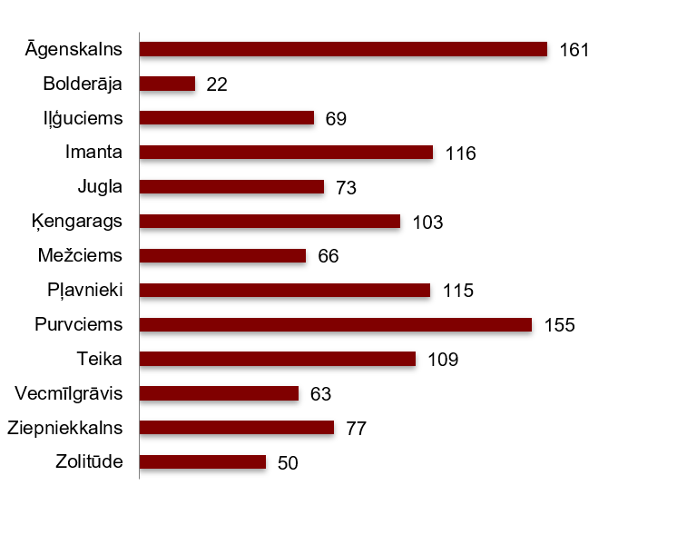

Source: ARCO REAL ESTATE

In September, the number of apartments offered for sale in Riga's largest housing estates both increased and decreased. However, overall, the number of apartments offered for sale was higher than in the previous month. The largest increase in the number of apartments offered for sale in September was recorded in Iļģuciems (+77%). Conversely, the number of apartments offered for sale in September decreased the most in Pļavnieki and Zolitūde (-15%).
.

In September, analyzing the number of apartments offered for sale in proportion to the size of the housing estate—namely, by population—the highest supply was found in Āgenskalns. On the other hand, the number of apartments offered for sale was proportionally the lowest in Iļģuciems.

Number of apartments offered for sale in proportion to the size of the housing estates in Riga in August 2026
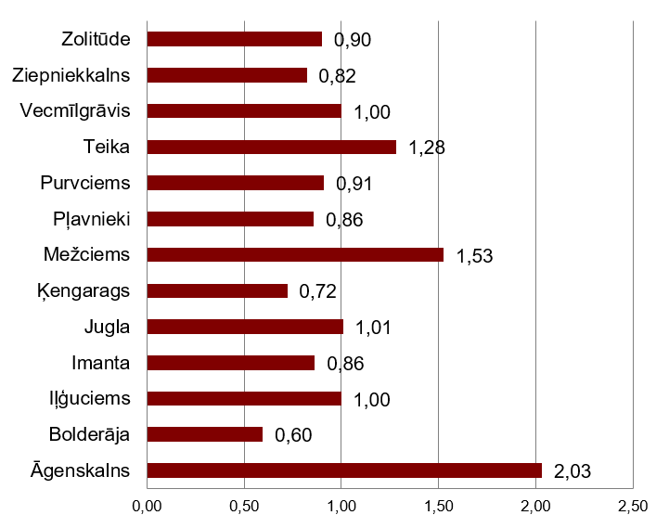

Source: ARCO REAL ESTATE

In September, changes could be observed in the prices of standard-type apartments in Riga housing estates. An increase in the average price of apartments could be observed in all the largest housing estates of Riga. The largest increase in the average price was observed in Jugla, where prices increased by 1.5% during the month. In other housing estates of Riga, such as Bolderāja and Iļģuciems, the price increase was also higher compared to previous months.

Changes in the average square meter price of standard-type apartments in Riga housing estates, in %

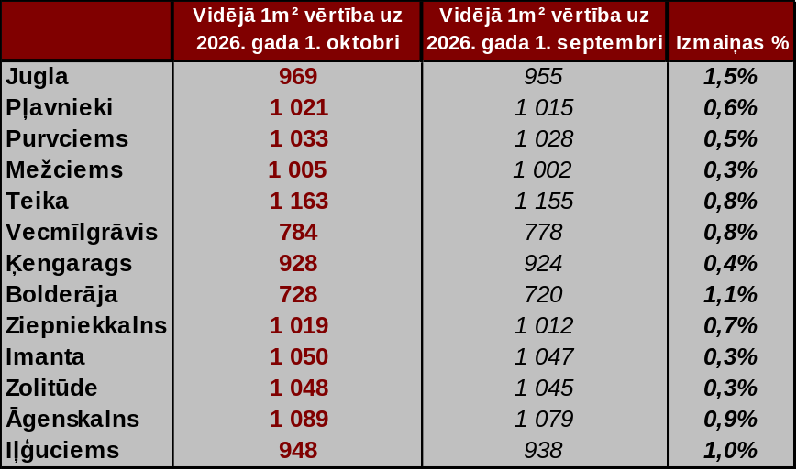

Source: ARCO REAL ESTATE

Compared to the beginning of 2026, in September, prices for standard-type apartments were higher in all major housing estates of Riga. The highest average price per square meter of an apartment was in Teika, but the lowest was still in Bolderāja.

Average standard-type apartment prices in housing estates of Riga, EUR/m²

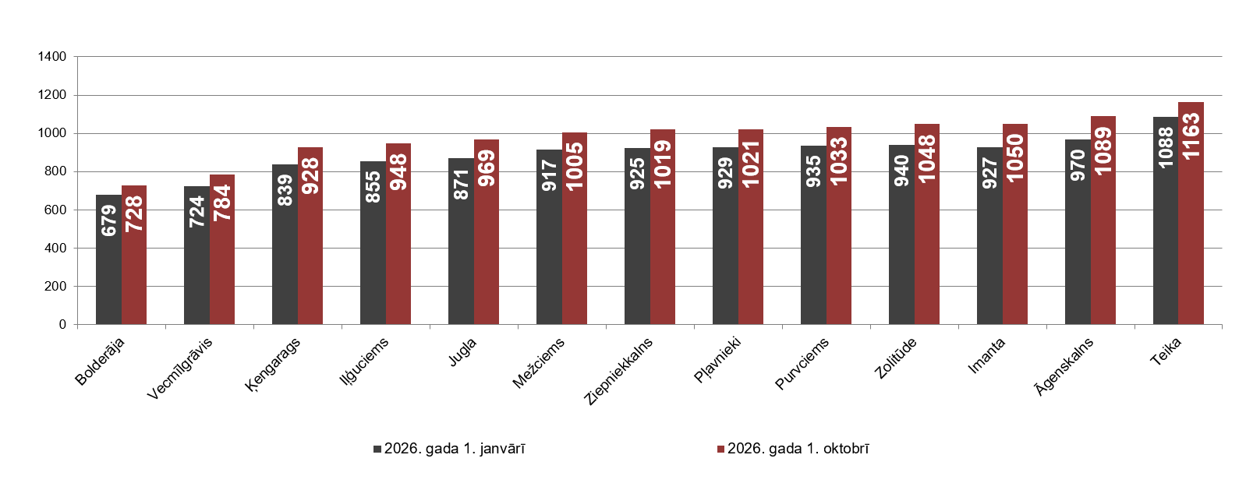

Source: ARCO REAL ESTATE

The highest prices for standard-type apartments in September remained in Teika, where the average price per square meter increased to 1,163 EUR/m². The lowest average price per square meter in September was in Bolderāja (728 EUR/m²), which also increased compared to the previous month.

Average standard-type apartment prices in housing estates of Riga on October 1, 2026, EUR/m²

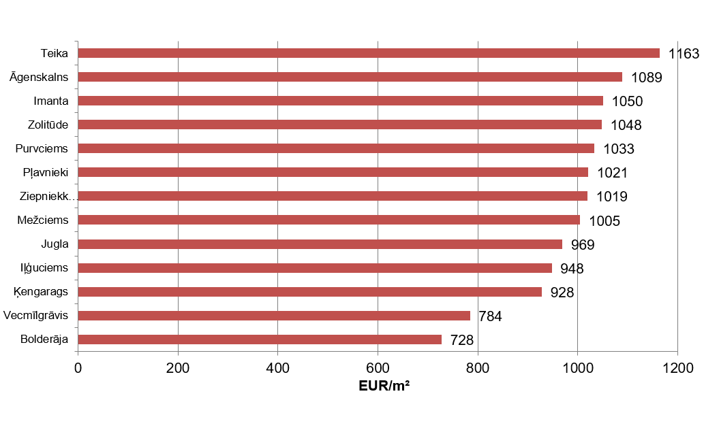

Source: ARCO REAL ESTATE

In September, the most expensive apartments still were apartments in the houses of the series 119 and 104, where the price of 2-room apartments in a satisfactory condition varied from 58 000 to 62 000 EUR depending on the location. In turn, the so-called Lithuanian design houses were the cheapest ones, where the price of 2-room apartments varied from 34 000 to 50 000 EUR, and the so-called Khrushchev-time houses, where the price of a 2-room apartment varied from 33 000 to 51 000 EUR depending on the housing estate.

Standard-type apartment prices by series in Riga housing estates in September 2026 (2-room apartments), EUR

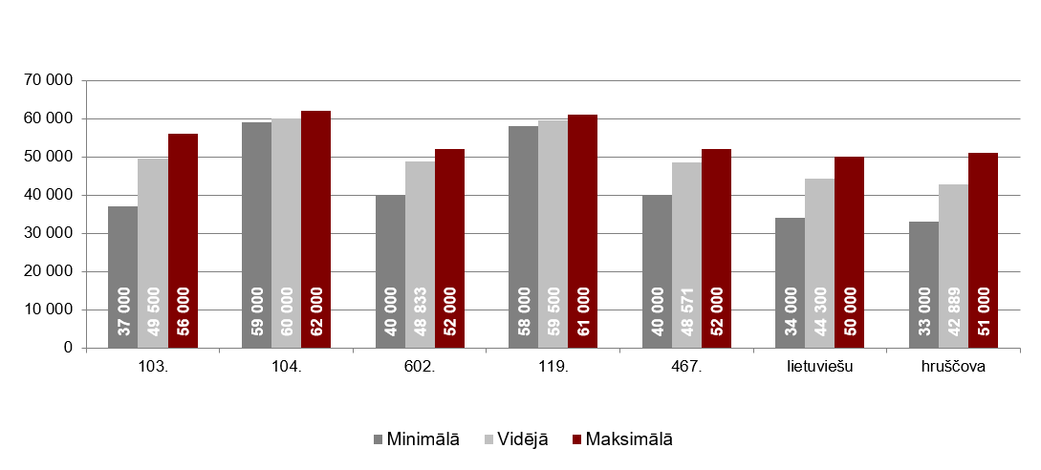

Source: ARCO REAL ESTATE

Apartment market in the vicinity of Riga

Ogre

In September 2026, standard-type apartment prices remained unchanged. The average price per square meter of an apartment was EUR 977/m². In September, apartment prices in Ogre were 11% higher than at the beginning of 2026.

Dynamics of the average price of standard-type apartments in Ogre, EUR/m²

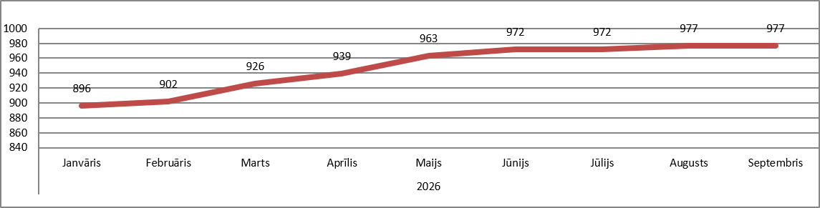

Source: ARCO REAL ESTATE

Kauguri, Jūrmala

In September 2026, standard-type apartment prices in Kauguri remained unchanged. The average price of a standard-type apartment in September was 887 EUR/m². Since the beginning of 2026, apartment prices in Kauguri have increased by 7%.

Dynamics of the average price of standard-type apartments in Kauguri, Jūrmala, EUR/m²

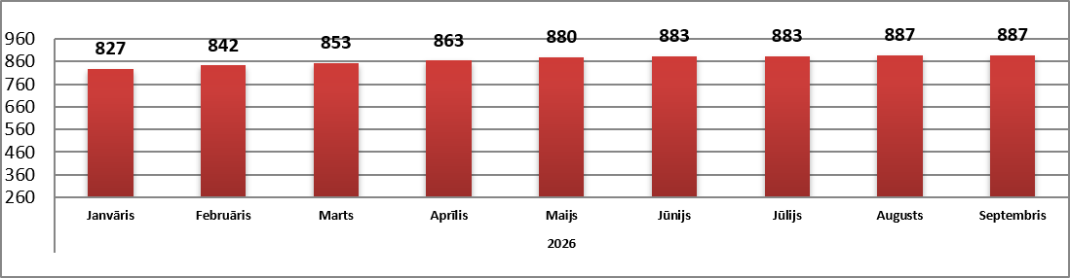

Source: ARCO REAL ESTATE

Salaspils

In September 2026, standard-type apartment prices in Salaspils increased by 0.1%. The average price per square meter of an apartment rose to EUR 913/m². In September, standard-type apartment prices in Salaspils were 8% higher than at the beginning of this year.

Dynamics of the average price of standard-type apartments in Salaspils, EUR/m²

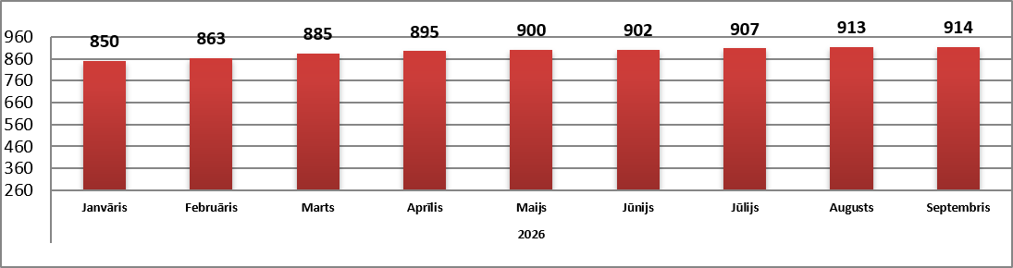

Source: ARCO REAL ESTATE

Jelgava

In Jelgava, apartment prices increased by 0.9% in September 2026. The average price of standard-type apartments in Jelgava in September was 807 EUR/m². In September, standard-type apartment prices in Jelgava were 5% higher than at the beginning of 2026.

Dynamics of the average price of standard-type apartments in Jelgava, EUR/m²

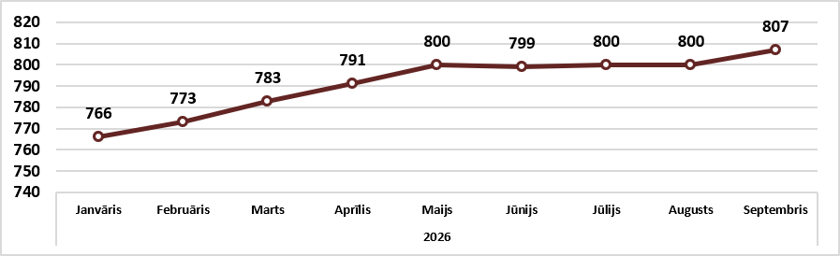

Source: ARCO REAL ESTATE

