Standard-type apartments, March 1, 2026

In February 2026, there was an increase in the prices of standard-type apartments in Riga housing estates - during the month, the average price of standard-type apartments increased by 1.7%, rising to 912 EUR/m² in February.

Price changes for standard-type apartments since the beginning of 2025, in %

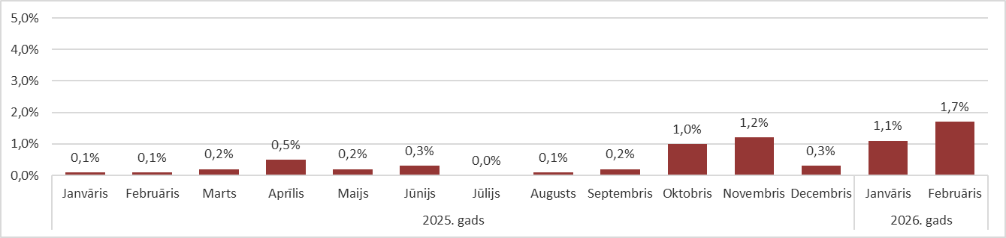

Source: ARCO REAL ESTATE

Prices for standard-type apartments continued to increase in the first months of the year. The reason for the price increase was still the low supply of apartments in all Riga housing estates. The supply of apartments stabilized in February. In February, the average price increase for standard-type apartments was the highest in recent years.

The decrease in the number of apartment offers in the largest housing estates of Riga stopped in February. The supply increased slightly in February and exceeded the 1,000 unit mark. The same low supply of standard apartments in February was also observed in 2021.

Dynamics of apartment supply in the largest housing estates of Riga

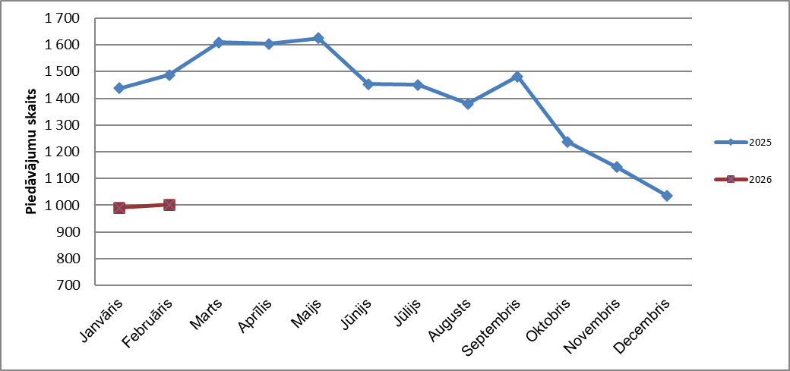

Source: ARCO REAL ESTATE

In the largest housing estates of Riga, apartment prices have increased by 1-5% since the beginning of 2026. The largest changes in apartment prices were observed in Imanta, where they increased by 5% this year. In Pļavnieki, the increase in prices for standard-type apartments was also relatively higher this year than in other housing estates - prices increased by an average of 4%. In the other housing estates of Riga, price changes did not exceed 3% this year. The smallest changes in apartment prices were observed in the cheapest housing estate - Bolderāja.

Price changes in the largest housing estates of Riga since January 1, 2026, in %

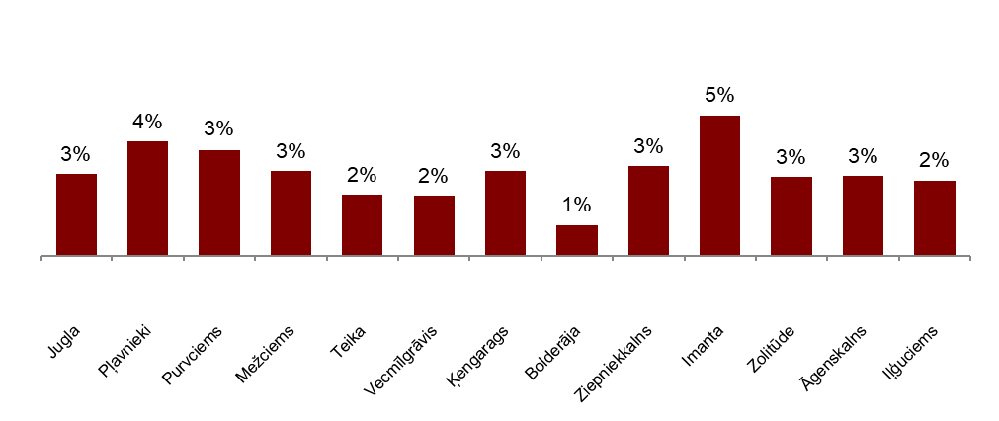

Source: ARCO REAL ESTATE

In February, the average price of a standard-type apartment rose to EUR 912 per square meter. Prices were on average 44% lower than on August 1, 2007, when the average price of an unrenovated standard-type apartment reached an all-time highest level of EUR 1,620/m².

Dynamics of average price of standard-type apartments in the major housing estates of Riga, EUR/m²

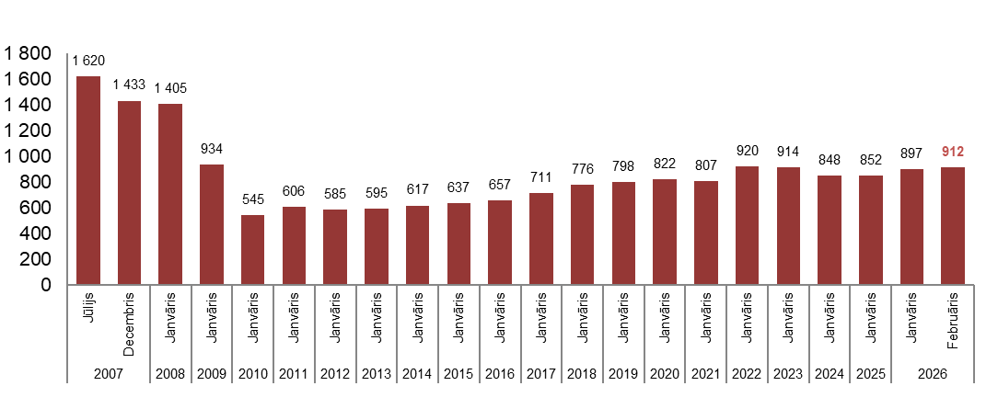

Source: ARCO REAL ESTATE

Changes in prices of standard-type apartments in housing estates of Riga, in %

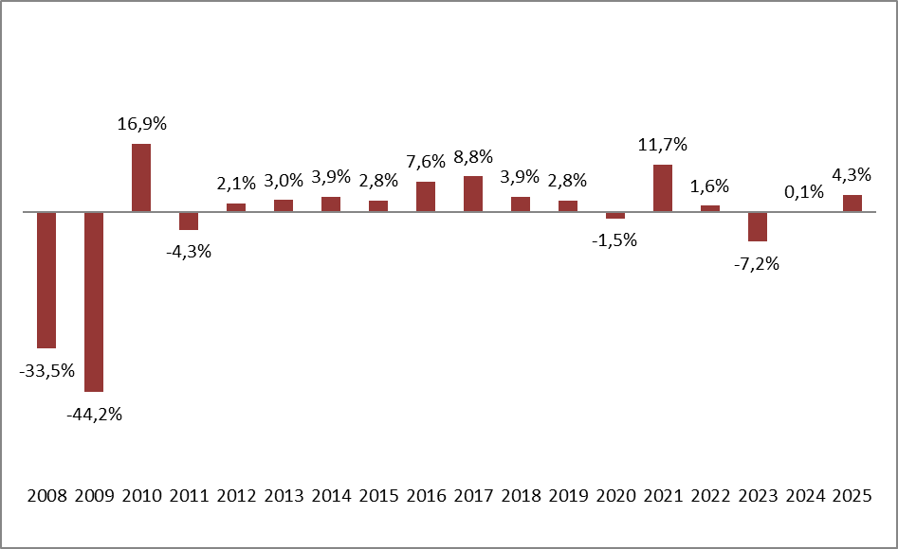

Source: ARCO REAL ESTATE

The average price per square meter of standard-type apartments increased in February for one-room apartments (+1.7%), two-room apartments (+2.2%), three-room apartments (+1.3%) and four-room apartments (+1.5%). Since the beginning of the previous year, the price of two-room apartments (+8%) has increased the most.

Average prices of standard-type apartments in Riga housing estates by number of rooms, EUR/m²

Source: ARCO REAL ESTATE

Compared to the previous month, the supply of apartments in Riga increased by 1% in February. The number of offers in the largest housing estates of Riga analyzed by “ARCO REAL ESTATE” also increased by 1%. Compared to January 2025, the supply of apartments was generally lower: the total number of apartments offered for sale was 23% lower, but the supply of apartments in the largest housing estates was 33% lower.

Dynamics of supply of apartments in Riga

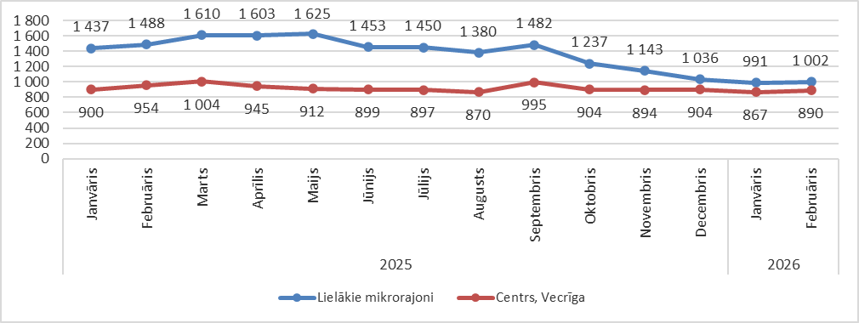

Source: ARCO REAL ESTATE

Summarizing the number of apartments offered for sale in Riga housing estates, it can be concluded that the largest supply in February was in Āgenskalns, while the smallest supply was in Bolderāja.

Number of apartments offered for sale in Riga at the end of February 2026

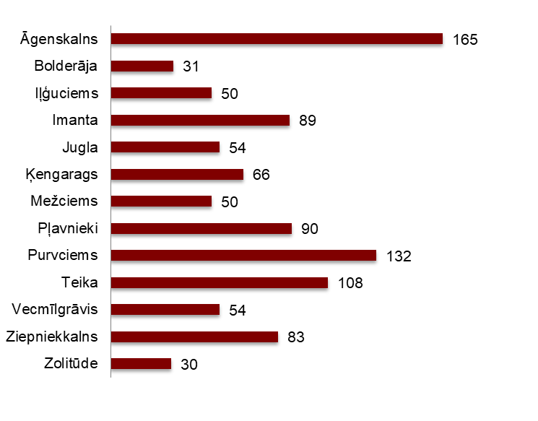

Source: ARCO REAL ESTATE

In February, the number of apartments offered for sale in Riga largest housing estates mostly increased. The decline in offer, which had been observed since September last year, stopped. The number of offers increased the most in February in Purvciems (+18%), but decreased the most in Zolitūde (-17%).

In February, when analysing the number of apartments offered for sale in proportion to the size of the housing estate, i.e., by population, the largest number of apartments offered for sale was found in Āgenskalns. In contrast, the number of apartments offered for sale in Ķengarags was proportionally the smallest.

Number of apartments offered for sale in proportion to the size of the housing estates in Riga in February 2026
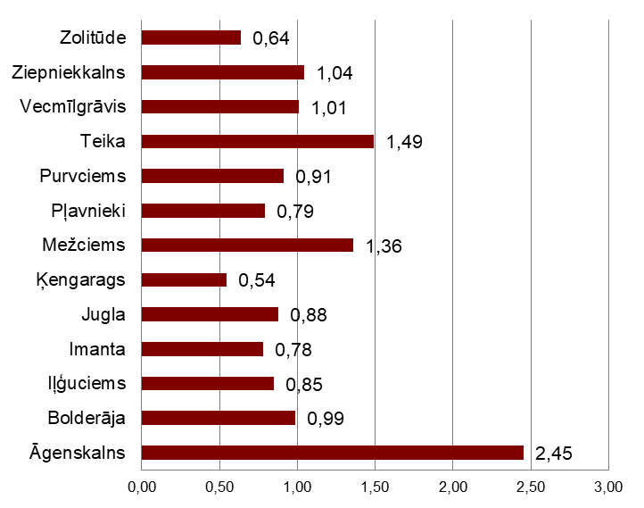

Source: ARCO REAL ESTATE

In February, changes could be observed in the prices of standard-type apartments in Riga housing estates. An increase in the average price of apartments could be observed in all the largest housing estates of Riga. The largest increase in the average price was observed in Pļavnieki, Imanta and Ziepniekkalns, where prices increased by more than 2% during the month. In February, apartment prices changed the least in Bolderāja.

Changes in the average square meter price of standard-type apartments in Riga housing estates, %

Source: ARCO REAL ESTATE

Compared to the beginning of 2026, in February 2026, the prices of standard-type apartments were higher in all major housing estates of Riga. The highest average price per square meter of apartments was in Teika, but the lowest was still in Bolderāja.

Average standard-type apartment prices in housing estates of Riga, EUR/m²

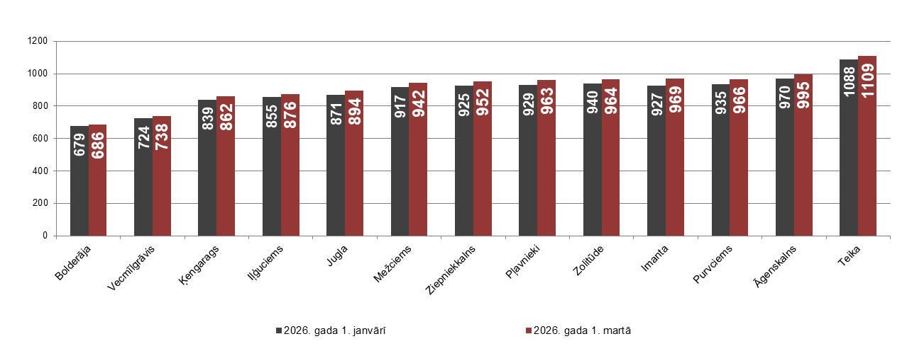

Source: ARCO REAL ESTATE

The highest prices for standard-type apartments in February remained in Teika, where the average price per square meter rose to EUR 1109/m². The lowest average price per square meter in February was in Bolderāja – EUR 686/m², which also increased compared to the previous month.

Average standard-type apartment prices in housing estates of Riga on March 1, 2026, EUR/m²

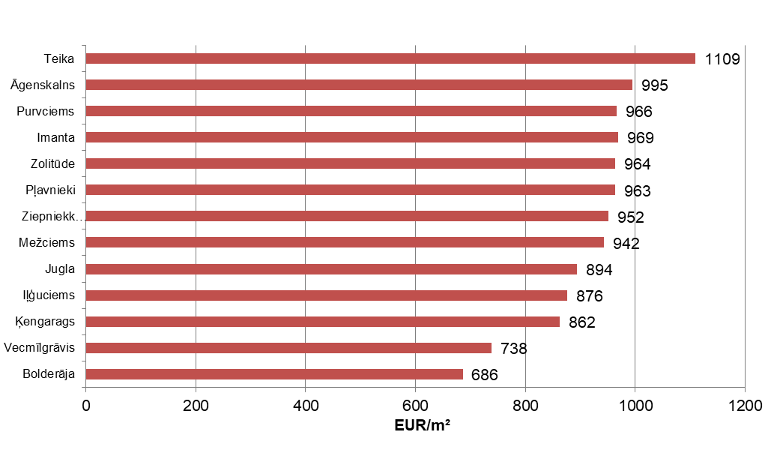

Source: ARCO REAL ESTATE

In February, the most expensive apartments still were apartments in the houses of the series 119 and 104, where the price of 2-room apartments in a satisfactory condition varied from 55 000 to 56 000 EUR depending on the location. In turn, the so-called Lithuanian design houses were the cheapest ones, where the price of 2-room apartments varied from 32 000 to 45 000 EUR, and the so-called Khrushchev-time houses, where the price of a 2-room apartment varied from 30 000 to 47 000 EUR depending on the housing estate.

Standard-type apartment prices by series in Riga housing estates in February 2026 (2-room apartments), EUR

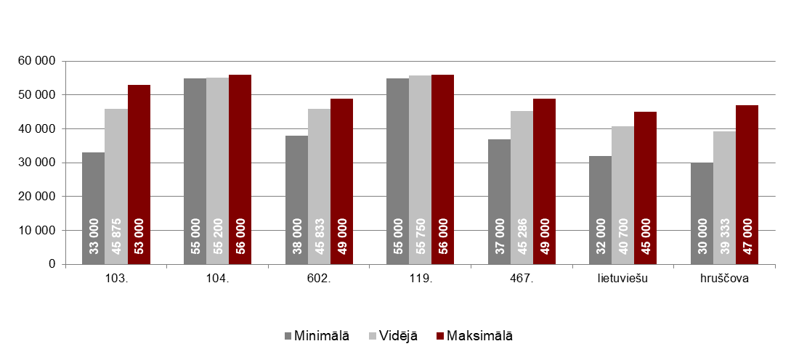

Source: ARCO REAL ESTATE

Apartment market in the vicinity of Riga

Ogre

In February 2026, the prices of standard-type apartments increased by 0.7%. The average price of one square meter of apartments reached 902 EUR/m². Apartment prices in Ogre in February were 2% higher than at the beginning of 2026.

Dynamics of the average price of standard-type apartments in Ogre, EUR/m²

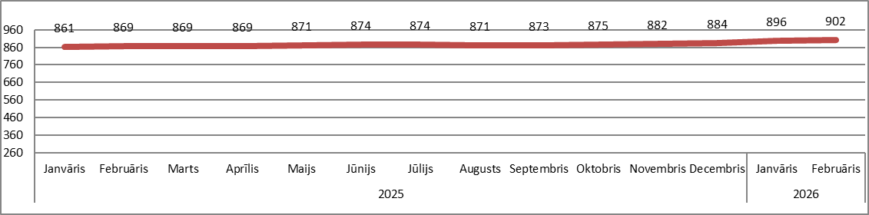

Source: ARCO REAL ESTATE

Kauguri, Jūrmala

In Kauguri, in February 2026, the prices of standard-type apartments increased by 1.7%. The average price of standard-type apartments in February was 842 EUR/m². Since the beginning of 2026, apartment prices in Kauguri have increased by 2% in February.

Dynamics of the average price of standard-type apartments in Jūrmala, Kauguri, EUR/m²

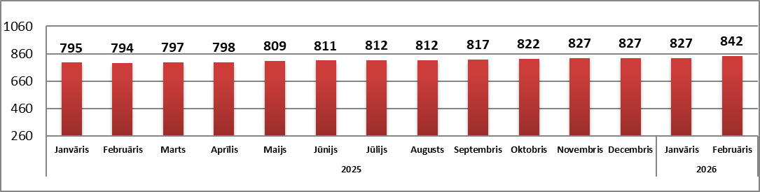

Source: ARCO REAL ESTATE

Salaspils

In February 2026, the prices of standard-type apartments in Salaspils increased by 1.5%. The average price per square meter of apartments increased to 863 EUR/m². In February, the prices of standard-type apartments in Salaspils were 2% higher than at the beginning of this year.

Dynamics of the average price of standard-type apartments in Salaspils, EUR/m²

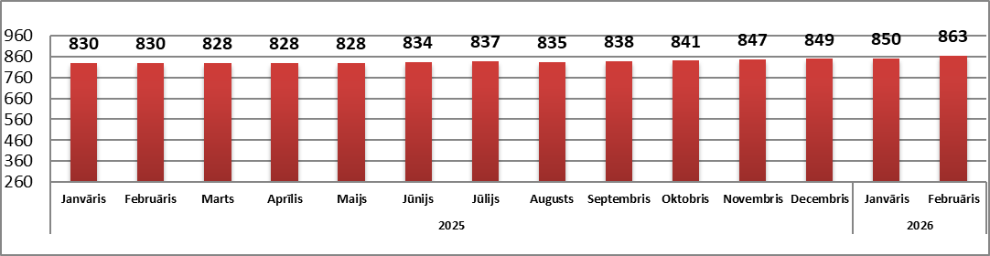

Source: ARCO REAL ESTATE

Jelgava

Apartment prices in Jelgava increased by 0.9% in February 2026. The average price of standard-type apartments in Jelgava in February was 773 EUR/m². In Jelgava, the prices of standard-type apartments in February were 1% higher than at the beginning of 2026.

Dynamics of the average price of standard-type apartments in Jelgava, EUR/m²

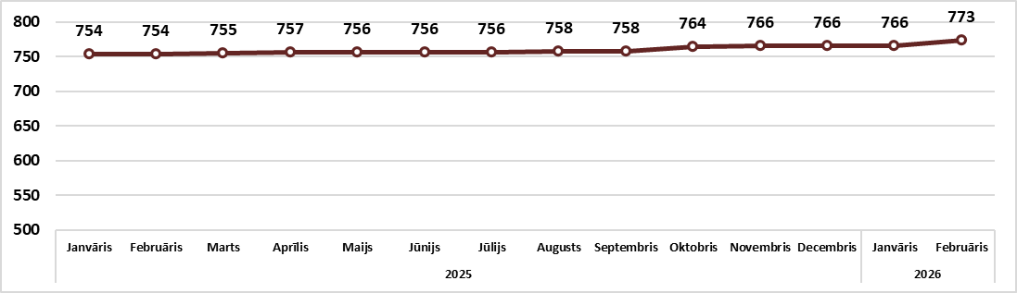

Source: ARCO REAL ESTATE

