Standard-type apartments, June 1, 2026

In May 2026, there was an increase in the prices of standard-type apartments in Riga housing estates - the average price of standard-type apartments increased by 1% during the month. The average price of standard-type apartments in May increased to 956 EUR/m².

Price changes for standard-type apartments since the beginning of 2026, in %

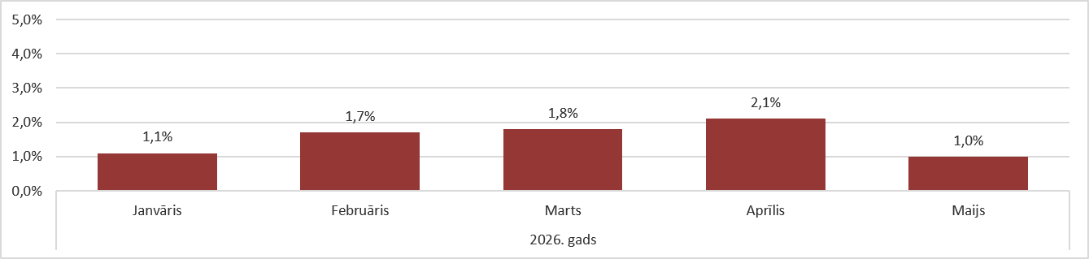

Source: ARCO REAL ESTATE

The average price increase in May was smaller than in previous months. Overall, apartment prices have increased by an average of 8% since the beginning of 2026. It is predicted that in 2026, the price increase for standard-type apartments will be one of the highest in the last decade. Although the supply of apartments continued to increase, the reason for the price increase was still the insufficient supply of apartments in all Riga housing estates.

The number of apartments offered for sale has increased since the beginning of the year, but it was still significantly lower than in the previous year. In May 2025, there were over 1,600 apartments on offer in Riga's largest housing estates, which was 30% more than in May this year.

Dynamics of apartment supply in the largest housing estates of Riga

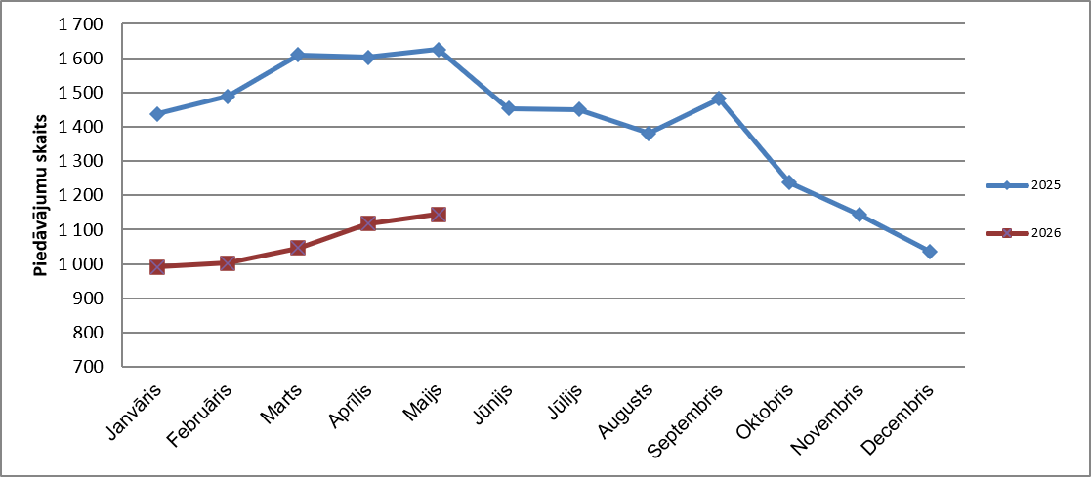

Source: ARCO REAL ESTATE

In the largest housing estates of Riga, apartment prices have increased by 5-11% since the beginning of 2026. The largest price changes were observed in Imanta, where they increased by 11% this year. Also in Āgenskalns, Zolitūde and Pļavnieki this year, the increase in prices for standard-type apartments was relatively higher than in other housing estates - prices increased by an average of 9%. In Purvciems, prices for standard-type apartments increased by an average of 8% this year. In the other housing estates of Riga, price changes did not exceed 7% this year. The lowest price changes were observed in the cheapest housing estate, namely Bolderāja, as well as in the most expensive housing estate - Teika. In both of these areas, the average increase in apartment prices was 5%.

Price changes in the largest housing estates of Riga since January 1, 2026, in %
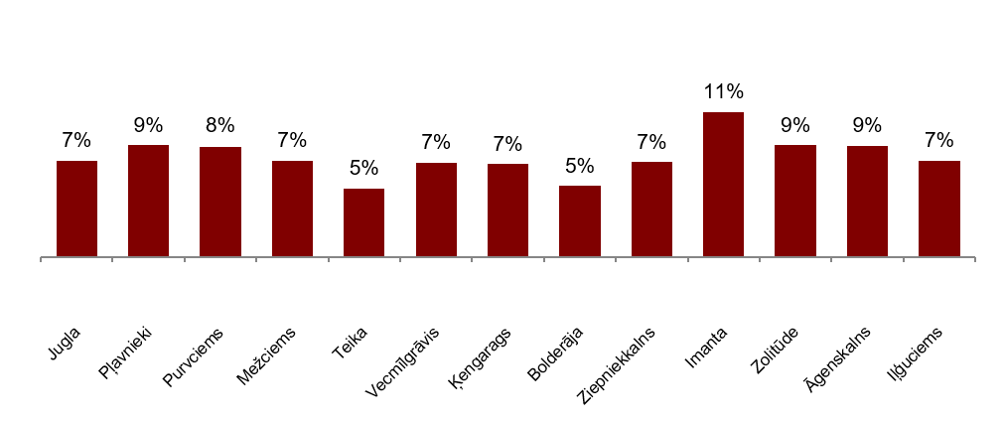

Source: ARCO REAL ESTATE

In May, the average price of standard-type apartments increased to 956 EUR/m². Prices were on average 41% lower than on August 1, 2007, when the average price of an unrenovated standard-type apartment reached an all-time highest level of EUR 1,620/m².

Dynamics of average price of standard-type apartments in the major housing estates of Riga, EUR/m²

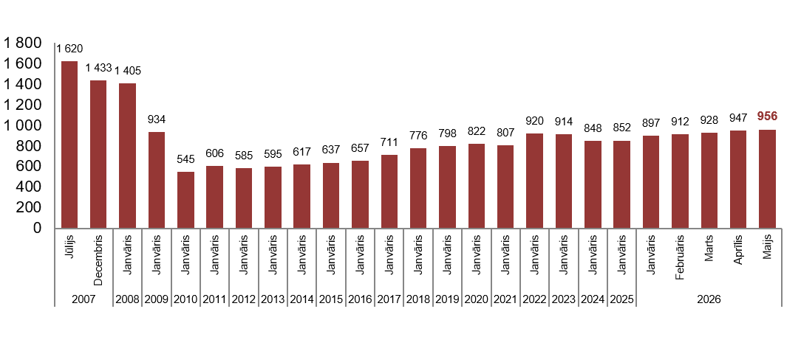
Source: ARCO REAL ESTATE

Changes in prices of standard-type apartments in housing estates of Riga, in %

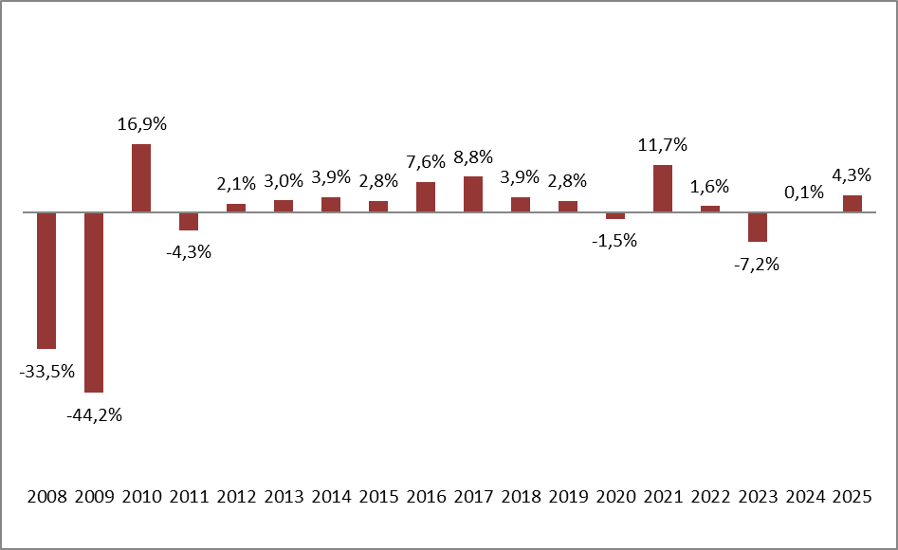

Source: ARCO REAL ESTATE

The average price per square meter of standard-type apartments increased in May for one-room apartments (+0.7%), two-room apartments (+0.8%), three-room apartments (+0.8%) and four-room apartments (+1.6%). Since the beginning of this year, the price of two-room apartments has increased the most (+8.6%).

Average prices of standard-type apartments in Riga housing estates by number of rooms, EUR/m²

Source: ARCO REAL ESTATE

Compared to the previous month, in May, the supply of apartments in Riga increased by 4%, while in the largest housing estates of Riga analyzed by “ARCO REAL ESTATE” it increased by 3%. Compared to May 2025, the supply of apartments was generally lower: the total number of apartments offered for sale was 18% lower, while the supply of apartments in the largest housing estates was 30% lower.

Dynamics of supply of apartments in Riga

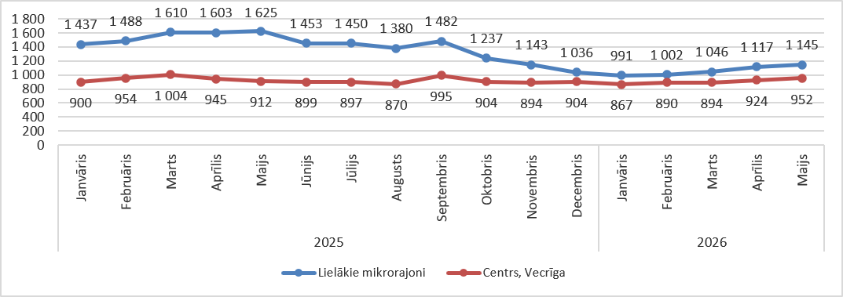

Source: ARCO REAL ESTATE

Summarizing the number of apartments offered for sale in Riga housing estates, it can be concluded that the largest supply in May still was in Āgenskalns, while the smallest supply was in Bolderāja.

Number of apartments offered for sale in Riga at the end of May 2026

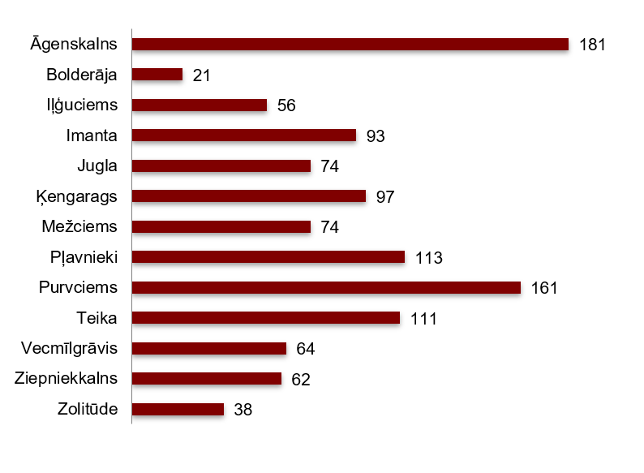
Source: ARCO REAL ESTATE

In May, the number of apartments offered for sale in the largest housing estates of Riga both increased and decreased. However, overall, the number of apartments offered for was higher than last month. The number of offers increased the most in May in Mežciems (+37%). The number of apartment offers decreased the most in May in Bolderāja (-28%).

In May, when analysing the number of apartments offered for sale in proportion to the size of the housing estate, i.e., by population, the largest number of apartments offered for sale was found in Āgenskalns. In contrast, the number of apartments offered for sale in Bolderāja was proportionally the smallest.
Number of apartments offered for sale in proportion to the size of the housing estates in Riga in May 2026

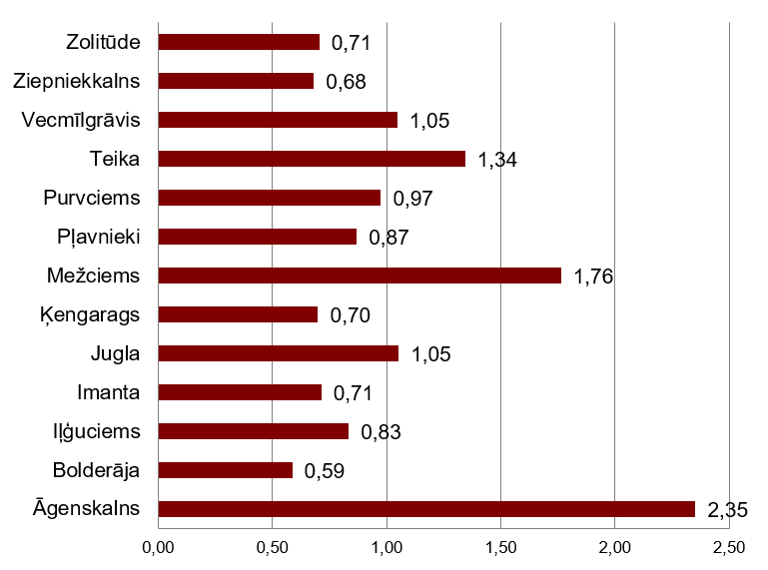

Source: ARCO REAL ESTATE

In May, changes could be observed in the prices of standard-type apartments in Riga housing estates. An increase in the average price of apartments could be observed in all the largest housing estates of Riga, except for Jugla. The largest increase in the average price was observed in Imanta, where prices increased by 1.9% during the month. In May, a relatively large increase in apartment prices was observed in Zolitūde.

Changes in the average square meter price of standard-type apartments in Riga housing estates, in %

Source: ARCO REAL ESTATE

Compared to the beginning of 2026, in May, prices for standard-type apartments were higher in all major housing estates of Riga. The highest average price per square meter of an apartment was in Teika, but the lowest was still in Bolderāja.

Average standard-type apartment prices in housing estates of Riga, EUR/m²

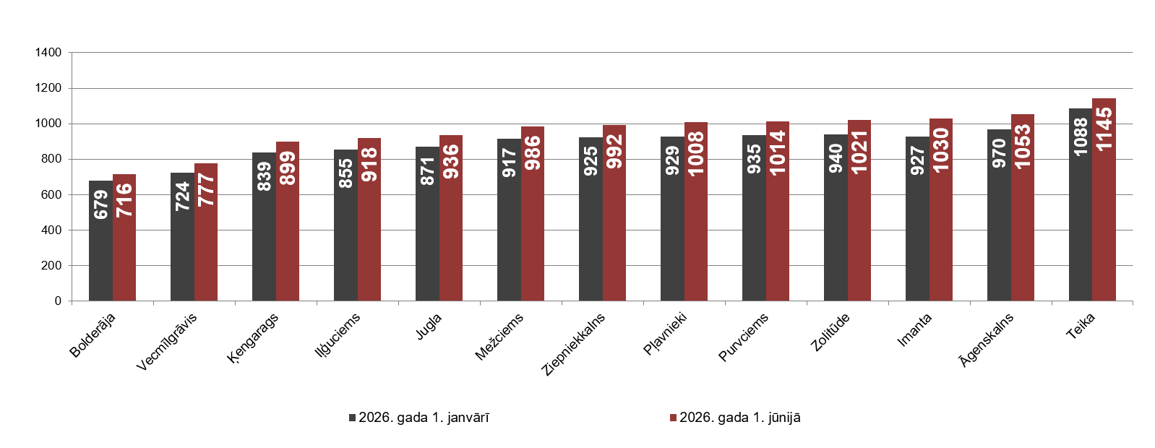

Source: ARCO REAL ESTATE

The highest prices for standard-type apartments in May remained in Teika, where the average price per square meter increased to 1,145 EUR/m². The lowest average price per square meter in May was in Bolderāja (716 EUR/m²), which also increased compared to the previous month.

Average standard-type apartment prices in housing estates of Riga on June 1, 2026, EUR/m²

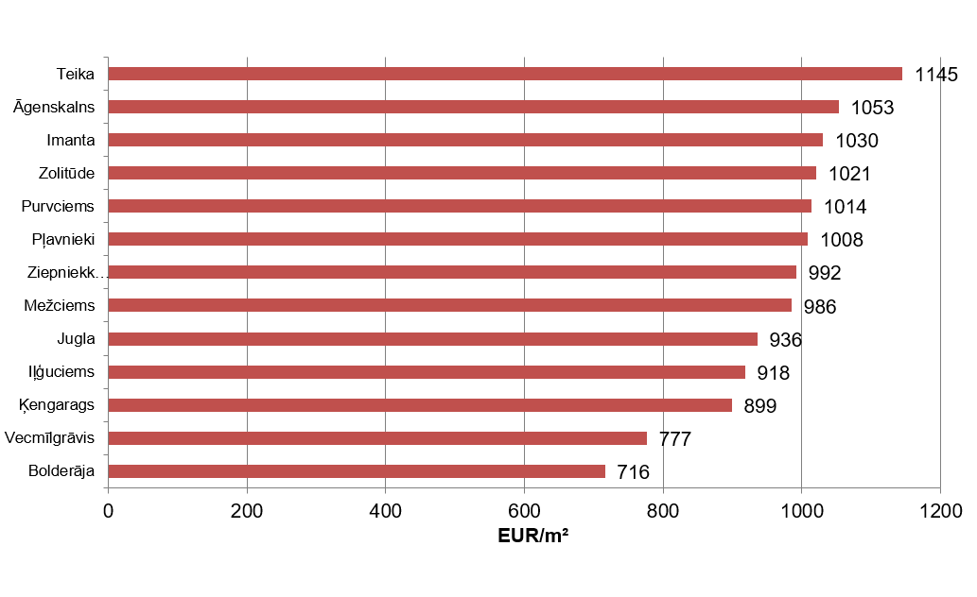

Source: ARCO REAL ESTATE

In May, the most expensive apartments still were apartments in the houses of the series 119 and 104, where the price of 2-room apartments in a satisfactory condition varied from 56 000 to 60 000 EUR depending on the location. In turn, the so-called Lithuanian design houses were the cheapest ones, where the price of 2-room apartments varied from 34 000 to 47 000 EUR, and the so-called Khrushchev-time houses, where the price of a 2-room apartment varied from 33 000 to 49 000 EUR depending on the housing estate.

Standard-type apartment prices by series in Riga housing estates in May 2026 (2-room apartments), EUR

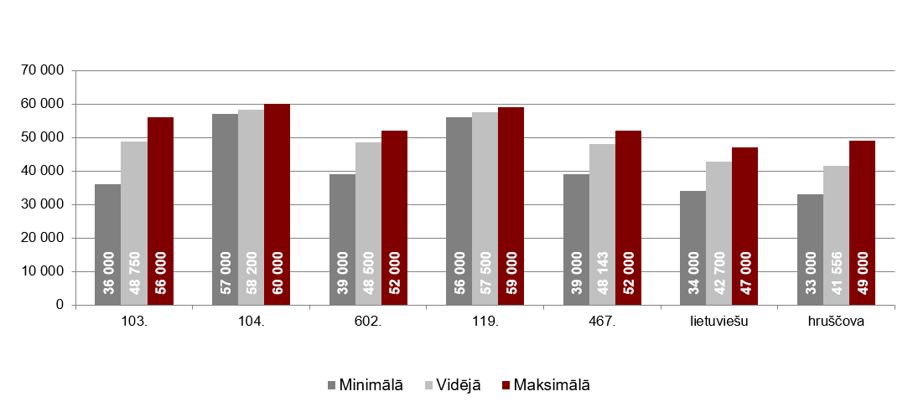

Source: ARCO REAL ESTATE

Apartment market in the vicinity of Riga

Ogre

In May 2026, the prices of standard-type apartments increased by 2.5% in Ogre. The average price of one square meter of apartments reached 963 EUR/m². Apartment prices in Ogre in May were 9% higher than at the beginning of 2026.

Dynamics of the average price of standard-type apartments in Ogre, EUR/m²

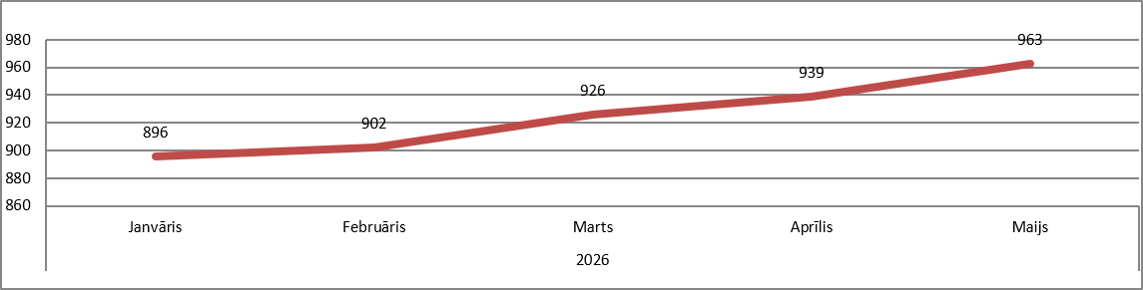

Source: ARCO REAL ESTATE

Kauguri, Jūrmala

In Kauguri, in May 2026, the prices of standard-type apartments increased by 1.9%. The average price of standard-type apartments in May was 880 EUR/m². Since the beginning of 2026, apartment prices in Kauguri have increased by 6%.

Dynamics of the average price of standard-type apartments in Kauguri, EUR/m²

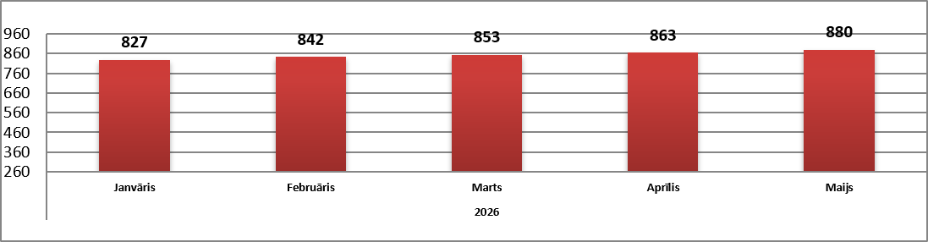

Source: ARCO REAL ESTATE

Salaspils

In May 2026, the prices of standard-type apartments in Salaspils increased by 0.5%. The average price per square meter of apartments increased to 900 EUR/m². In May, the prices of standard-type apartments in Salaspils were 6% higher than at the beginning of this year

Dynamics of the average price of standard-type apartments in Salaspils, EUR/m²

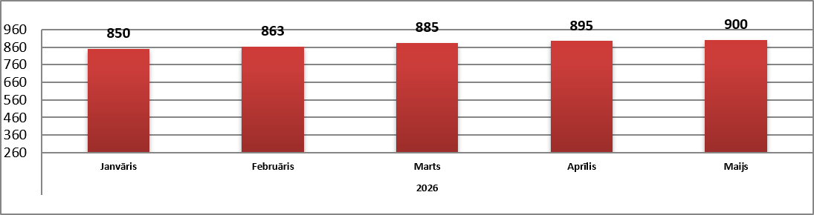

Source: ARCO REAL ESTATE

Jelgava

Apartment prices in Jelgava increased by 1.1% in May 2026. The average price of standard-type apartments in Jelgava in May was 800 EUR/m². In Jelgava, the prices of standard-type apartments in May were 4% higher than at the beginning of 2026.

Dynamics of the average price of standard-type apartments in Jelgava, EUR/m²

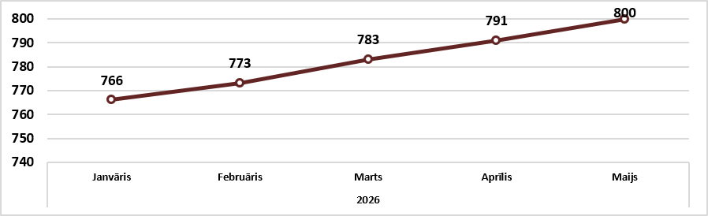

Source: ARCO REAL ESTATE

