Standard-type apartments, February 1, 2026

In January 2026, there was an increase in the prices of standard-type apartments in Riga housing estates - the average price of standard-type apartments increased by more than 1% during the month. The average price of standard-type apartments in January increased to 897 EUR/m².

Price changes for standard-type apartments since the beginning of 2025, in %

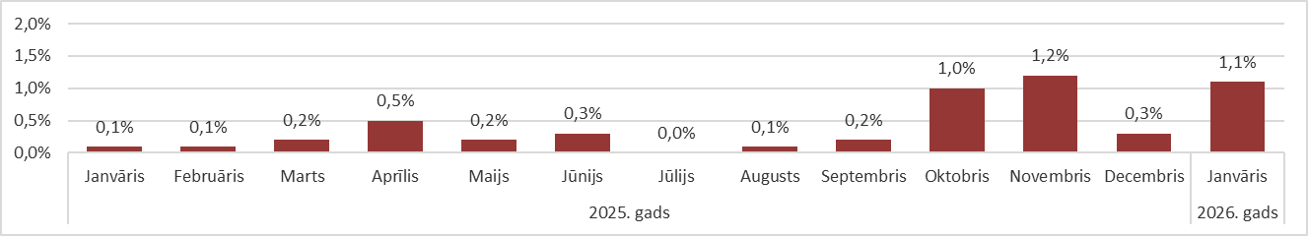

Source: ARCO REAL ESTATE

Prices for standard-type apartments continued to increase at the beginning of the year. The reason for the price increase was still the small supply of apartments in all Riga housing estates. The supply of apartments decreased for the fourth month in a row. In January, the largest supply of apartments remained in the most expensive housing estates of Riga, such as Āgenskalns and Teika.

The number of apartments offered for sale in the largest housing estates of Riga continued to decrease in January, and fell below the 1,000 unit mark. In January, the supply of standard-type apartments was the lowest in the last three years.

Dynamics of apartment supply in the largest housing estates of Riga

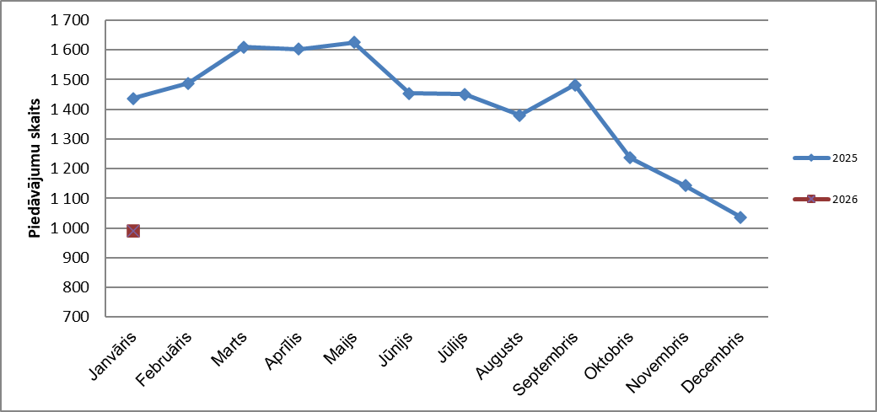

Source: ARCO REAL ESTATE

In the largest housing estates of Riga, apartment prices have increased by 2-10% since the beginning of 2025. The largest changes in apartment prices can be observed in Jugla, where they increased by 10% this year. In Imanta, the increase in prices for standard-type apartments was also large this year - prices increased by 8% on average. In other housing estates of Riga, price changes did not exceed 7% this year. The smallest changes in apartment prices were observed in the most expensive housing estate - Teika.

Price changes in the largest housing estates of Riga since January 1, 2025, in %

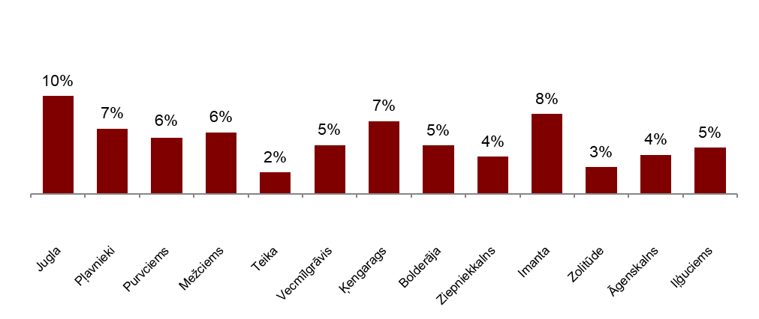

Source: ARCO REAL ESTATE

In January, the average price of a standard-type apartment rose to EUR 887 per square meter. Prices were on average 45% lower than on August 1, 2007, when the average price of an unrenovated standard-type apartment reached an all-time highest level of EUR 1,620/m².

Dynamics of average price of standard-type apartments in the major housing estates of Riga, EUR/m²
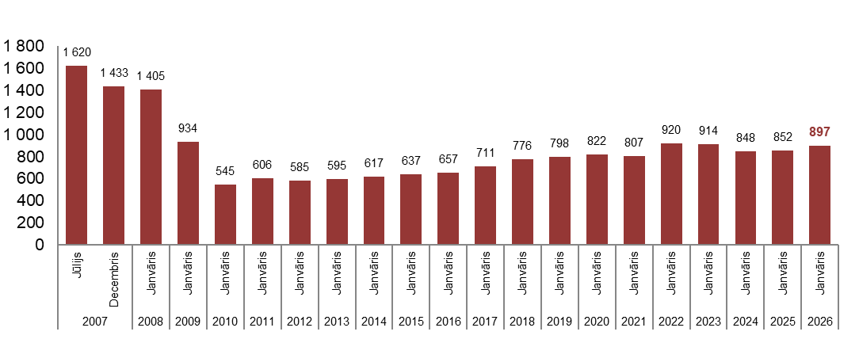
Source: ARCO REAL ESTATE

Changes in prices of standard-type apartments in housing estates of Riga, in %

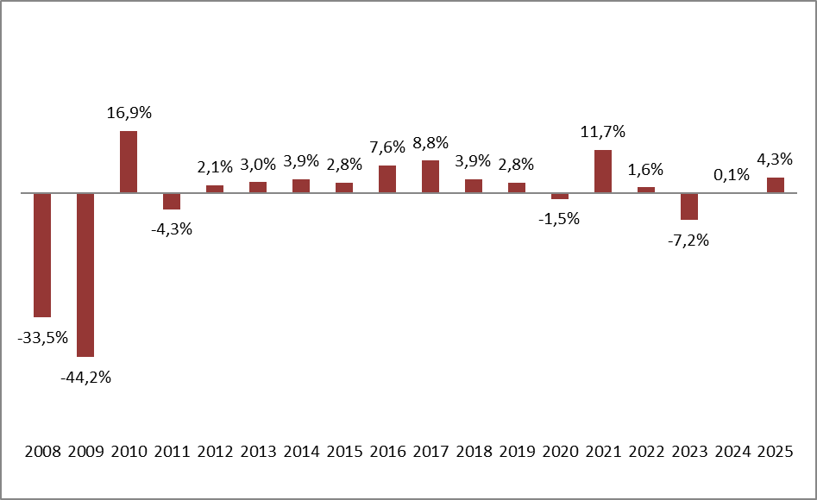

Source: ARCO REAL ESTATE

The average price per square meter of standard-type apartments increased for one-room (+1%), two-room apartments (+0.9%), three-room apartments (+0.9%) and four-room apartments (+1.6%). Since the beginning of the previous year, the price of two-room apartments (+5.8%) increased the most.

Average prices of standard-type apartments in Riga housing estates by number of rooms, EUR/m²

Source: ARCO REAL ESTATE

Compared to the previous month, the supply of apartments in Riga decreased by 3% in January. The number of apartments offered for sale in the largest housing estates of Riga analyzed by “ARCO REAL ESTATE” decreased by 4%. Compared to January 2025, the supply of apartments was generally lower: the total number of apartments offered for sale was 21% lower, but the supply of apartments in the largest housing estates was 31% lower.

Dynamics of supply of apartments in Riga

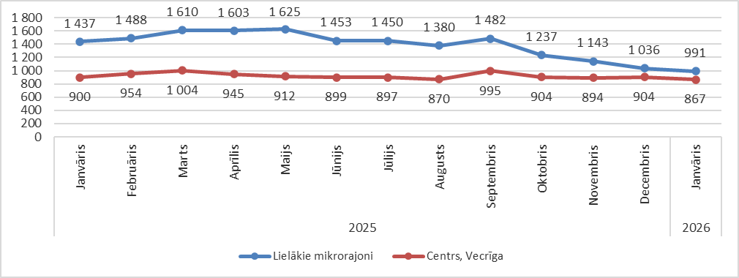

Source: ARCO REAL ESTATE

Summarizing the number of apartments offered for sale in Riga housing estates, it can be concluded that the largest supply in January was in Āgenskalns, while the smallest supply was in Bolderāja.

Number of apartments offered for sale in Riga at the end of January 2026

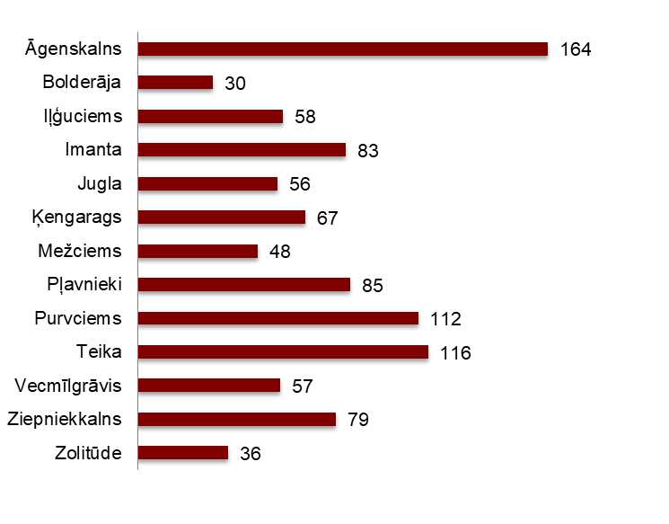

Source: ARCO REAL ESTATE

In January, the number of apartments offered for sale continued to decrease in almost all major housing estates of Riga.The decline in supply has been observed since September of last year. The number of apartments offered for sale decreased the most in January in Teika and Iļģuciems (-19%). The number of apartments offered for sale increased in January in Āgenskalns (+9%), Bolderāja (+67%), Vecmīlgrāvis (+24%) and Ziepniekkalns (+5%).

In January, when analysing the number of apartments offered for sale in proportion to the size of the housing estate, i.e., by population, the largest number of apartments offered for sale was found in Āgenskalns. In contrast, the number of apartments offered for sale in Ķengarags was proportionally the smallest.

Number of apartments offered for sale in proportion to the size of the housing estates in Riga in January 2026
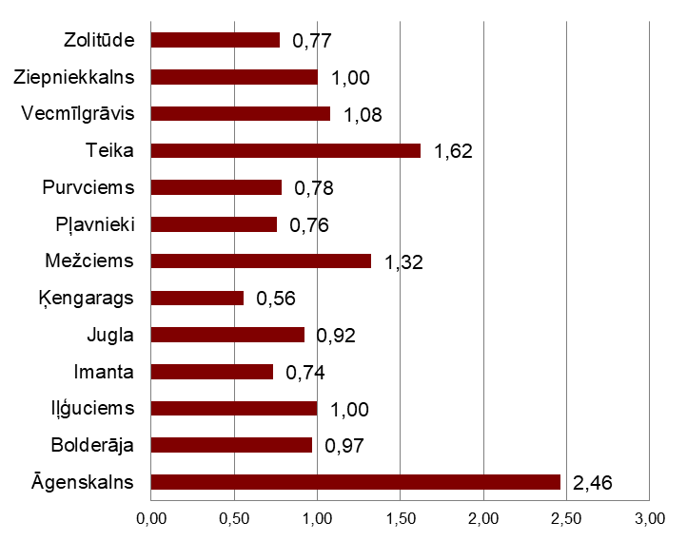

Source: ARCO REAL ESTATE

In January, changes could be observed in the prices of standard-type apartments in Riga housing estates. An increase in the average price of apartments could be observed in all the largest housing estates of Riga. The largest increase in the average price was observed in Imanta, where prices increased by more than 2% during the month. In January, apartment prices changed the least in Teika and Vecmīlgrāvis.

Changes in the average square meter price of standard-type apartments in Riga housing estates, %

Source: ARCO REAL ESTATE

Compared to the beginning of 2025, in January 2026, the prices of standard-type apartments were higher in all major housing estates of Riga. The highest average price per square meter of apartments was in Teika, but the lowest was still in Bolderāja.

Average standard-type apartment prices in housing estates of Riga, EUR/m²

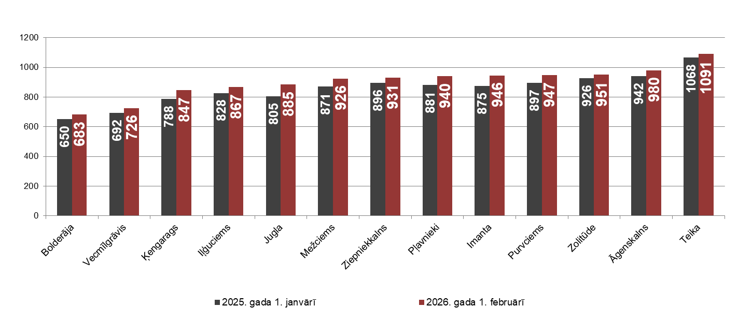

Source: ARCO REAL ESTATE

Sērijveida dzīvokļu augstākās cenas janvārī saglabājās Teikā, kur kvadrātmetra vidējā cena pieauga līdz 1 091 EUR/m². Viena kvadrātmetra zemākā vidējā cena janvārī bija Bolderājā (683 EUR/m²), kas arī palielinājās salīdzinājumā ar iepriekšējo mēnesi. The highest prices for standard-type apartments in January remained in Teika, where the average price per square meter rose to EUR 1091/m². The lowest average price per square meter in January was in Bolderāja – EUR 683/m², which also increased compared to the previous month.

Average standard-type apartment prices in housing estates of Riga on February 1, 2026, EUR/m²

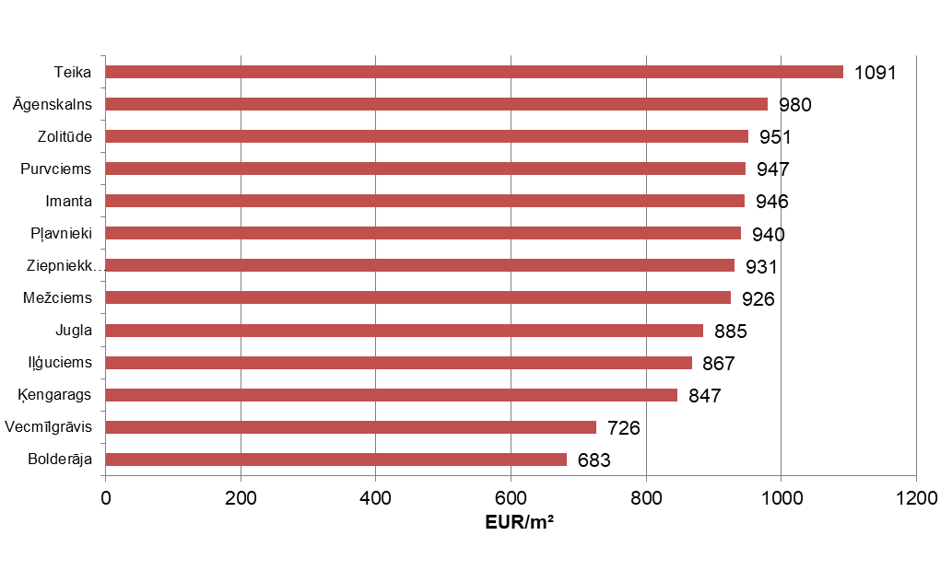

Source: ARCO REAL ESTATE

In January, the most expensive apartments still were apartments in the houses of the series 119 and 104, where the price of 2-room apartments in a satisfactory condition varied from 54 000 to 56 000 EUR depending on the location. In turn, the so-called Lithuanian design houses were the cheapest ones, where the price of 2-room apartments varied from 31 000 to 44 000 EUR, and the so-called Khrushchev-time houses, where the price of a 2-room apartment varied from 30 000 to 46 000 EUR depending on the housing estate.

Standard-type apartment prices by series in Riga housing estates in January 2026 (2-room apartments), EUR
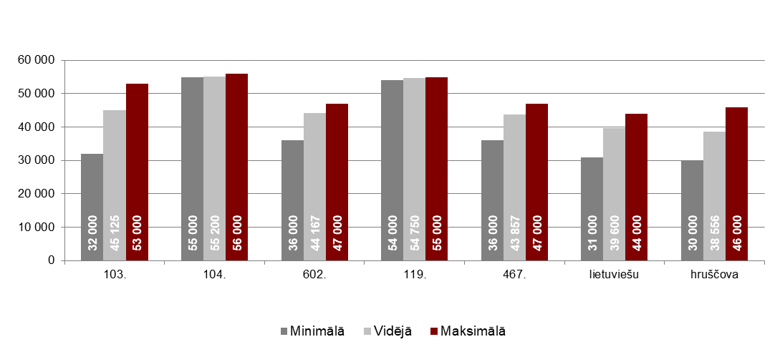

Source: ARCO REAL ESTATE

Apartment market in the vicinity of Riga

Ogre

In January 2026, the prices of standard-type apartments increased by 1.4%. The average price of one square meter of apartments reached 896 EUR/m². Apartment prices in Ogre in January were 6% higher than at the beginning of 2025.

Dynamics of the average price of standard-type apartments in Ogre, EUR/m²

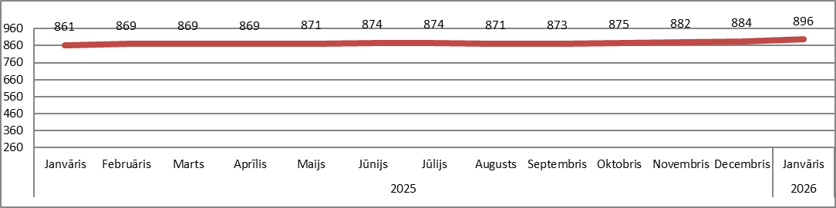

Source: ARCO REAL ESTATE

Kauguri, Jūrmala

In Kauguri, in January 2026, the prices of standard-type apartments remained at the level of the previous month. The average price of standard-type apartments in January was 827 EUR/m². Compared to the beginning of 2025, apartment prices in Kauguri were 5% higher.

Dynamics of the average price of standard-type apartments in Jūrmala, Kauguri, EUR/m²

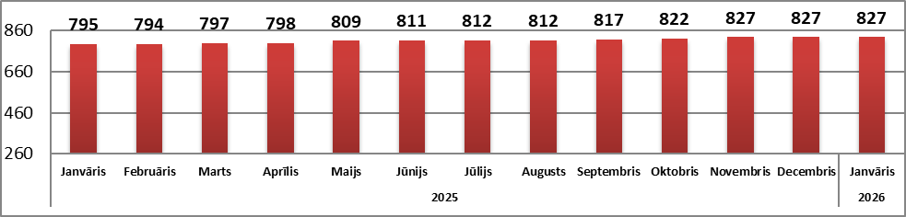

Source: ARCO REAL ESTATE

Salaspils

In January 2026, the prices of standard-type apartments in Salaspils increased by 0.2%. The average price per square meter of apartments increased to 850 EUR/m². In January, the prices of standard-type apartments in Salaspils were 2% higher than at the beginning of last year.

Dynamics of the average price of standard-type apartments in Salaspils, EUR/m²

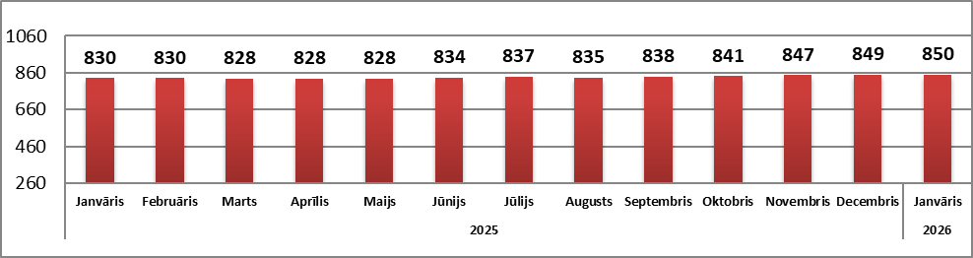

Source: ARCO REAL ESTATE

Jelgava

Apartment prices in Jelgava remained at the previous month's level in January 2026. The average price of standard-type apartments in Jelgava in January was 766 EUR/m². In Jelgava, the prices of standard-type apartments in January were 3% higher than at the beginning of 2025.

Dynamics of the average price of standard-type apartments in Jelgava, EUR/m²

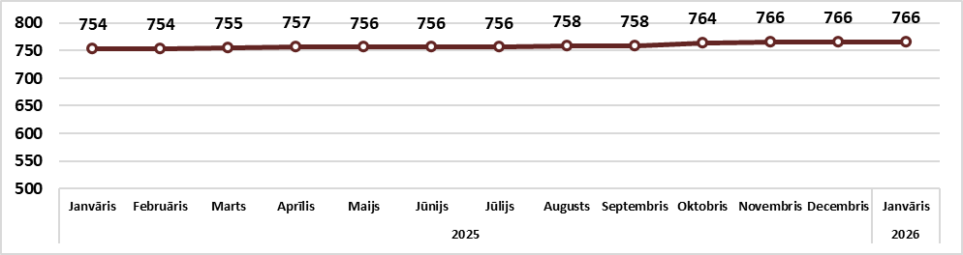

Source: ARCO REAL ESTATE

