Standard-type apartments, April 1, 2026

In March 2026, there was an increase in the prices of standard-type apartments in Riga housing estates - during the month, the average price of standard-type apartments increased by 1.8%, rising to 928 EUR/m² in March.

Price changes for standard-type apartments since the beginning of 2026, in %

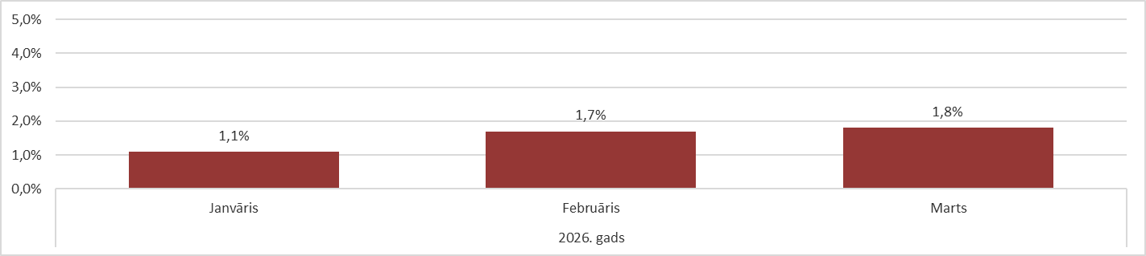

Source: ARCO REAL ESTATE

Prices of standard-type apartments in Riga housing estates increased in the first quarter of the year. Overall, apartment prices increased by an average of 5% in the first quarter. Thus, the price increase this year is already higher than in the previous year as a whole. The reason for the price increase can still be considered the insufficient supply of apartments in all Riga housing estates. The supply of apartments increased slightly in March. In March, the average price increase for standard-type apartments was the highest in recent years.

The number of apartments offered for sale increased for the second month in a row, however, it was still significantly lower than in March 2025, when there were more than 1,600 apartments on offer in Riga's largest housing estates.

Dynamics of apartment supply in the largest housing estates of Riga

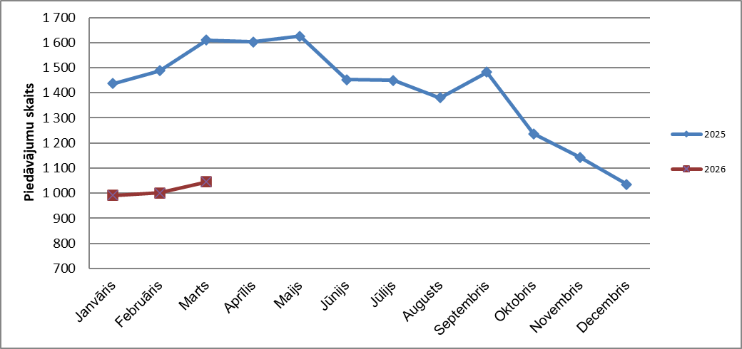

Source: ARCO REAL ESTATE

In the largest housing estates of Riga, apartment prices have increased by 2-7% since the beginning of 2026. The largest price changes were observed in Imanta, where they increased by 7% this year. Also in Pļavnieki this year, the increase in prices for standard-type apartments was relatively higher than in other housing estates - prices increased by an average of 6%. In the other housing estates of Riga, price changes did not exceed 5% this year. The smallest price changes were observed in the cheapest housing estate - Bolderāja.

Price changes in the largest housing estates of Riga since January 1, 2026, in %

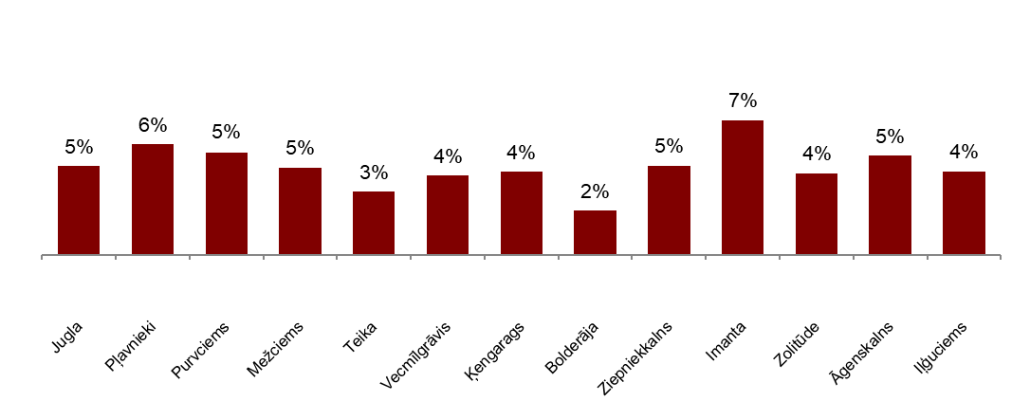

Source: ARCO REAL ESTATE

In March, the average price of standard-type apartments increased to 928 EUR/m Prices were on average 43% lower than on August 1, 2007, when the average price of an unrenovated standard-type apartment reached an all-time highest level of EUR 1,620/m².

Dynamics of average price of standard-type apartments in the major housing estates of Riga, EUR/m²

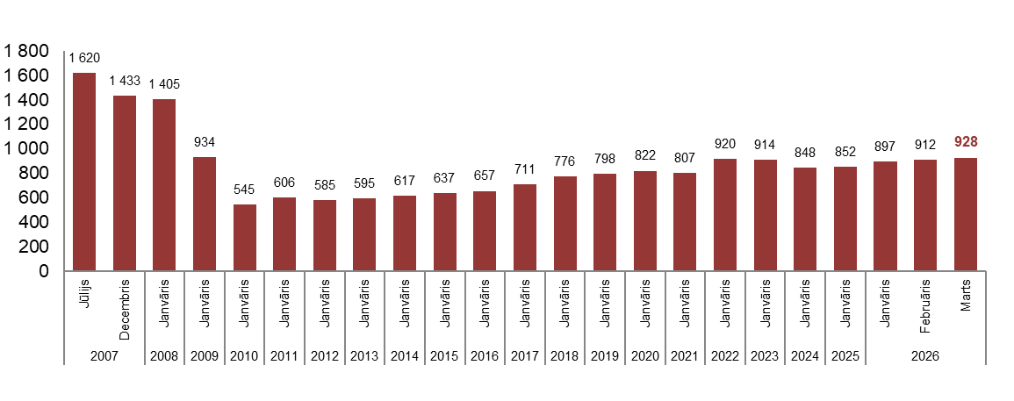

Source: ARCO REAL ESTATE

Changes in prices of standard-type apartments in housing estates of Riga, in %

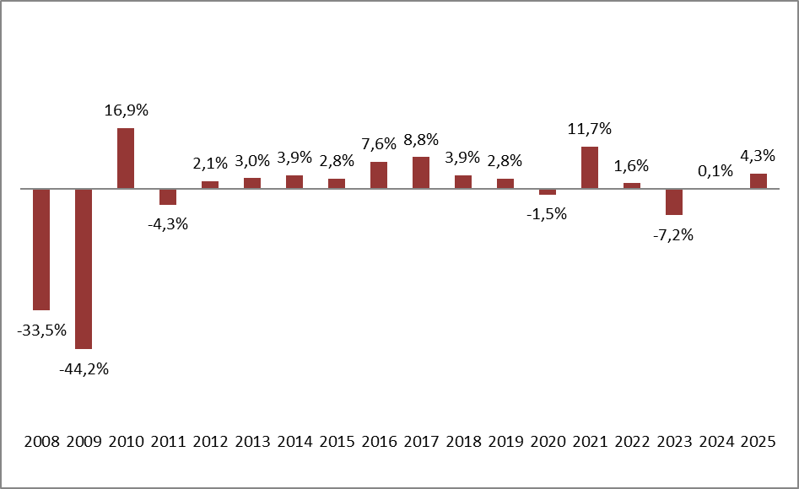

Source: ARCO REAL ESTATE

The average price per square meter of standard-type apartments increased in March for one-room apartments (+1.8%), two-room apartments (+2.2%), three-room apartments (+2.1%) and four-room apartments (+1.2%). Since the beginning of this year, the price of two-room apartments (+5%) has increased the most.

Average prices of standard-type apartments in Riga housing estates by number of rooms, EUR/m²

Source: ARCO REAL ESTATE

Compared to the previous month, the supply of apartments in Riga increased by 2% in March. The number of offers in the largest housing estates of Riga analyzed by “ARCO REAL ESTATE” also increased by 4%. Compared to March 2025, the supply of apartments was generally lower: the total number of apartments offered for sale was 27% lower, but the supply of apartments in the largest housing estates was 35% lower.

Dynamics of supply of apartments in Riga

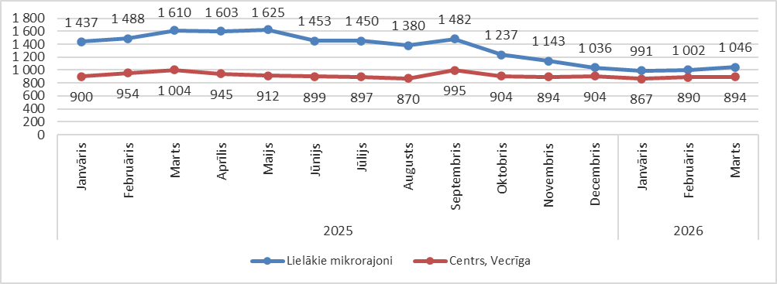

Source: ARCO REAL ESTATE

Summarizing the number of apartments offered for sale in Riga housing estates, it can be concluded that the largest supply in March was in Āgenskalns, while the smallest supply was in Bolderāja and Zolitūde.

Number of apartments offered for sale in Riga at the end of March 2026

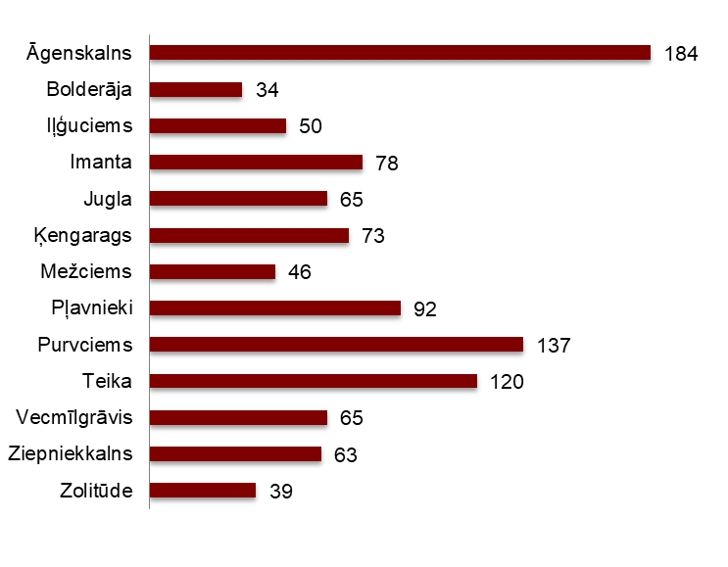

Source: ARCO REAL ESTATE

In March, the number of apartment offers in Riga largest housing estates increased. The offer increased for the second month in a row. The number of offers increased the most in March in Purvciems (+18%). The number of apartments offered for sale increased the most in March in Zolitūde (+30%).

In March, when analysing the number of apartments offered for sale in proportion to the size of the housing estate, i.e., by population, the largest number of apartments offered for sale was found in Āgenskalns. In contrast, the number of apartments offered for sale in Ķengarags was proportionally the smallest.

Number of apartments offered for sale in proportion to the size of the housing estates in Riga in March 2026
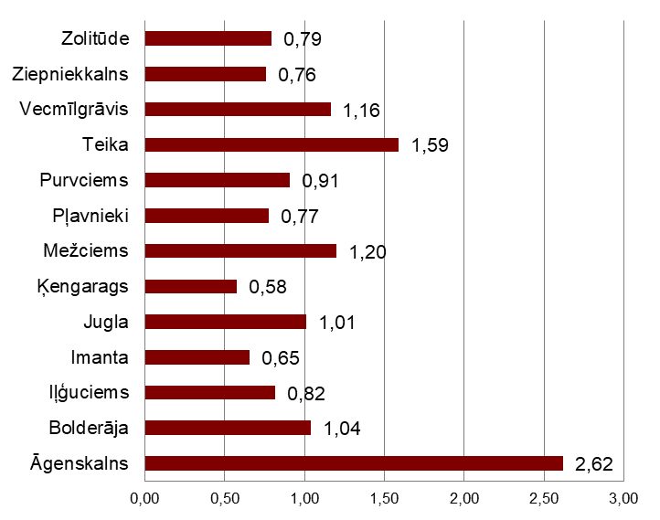

Source: ARCO REAL ESTATE

In March, changes could be observed in the prices of standard-type apartments in Riga housing estates. An increase in the average price of apartments could be observed in all the largest housing estates of Riga. The largest increase in the average price was observed in Āgenskalns, Imanta and Vecmīlgrāvis, where prices increased by more than 2% during the month. In March, apartment prices changed the least in Bolderāja.

Changes in the average square meter price of standard-type apartments in Riga housing estates, %

Source: ARCO REAL ESTATE

Compared to the beginning of 2026, in March, prices for standard-type apartments were higher in all major housing estates of Riga. The highest average price per square meter of an apartment was in Teika, but the lowest was still in Bolderāja.

Average standard-type apartment prices in housing estates of Riga, EUR/m²

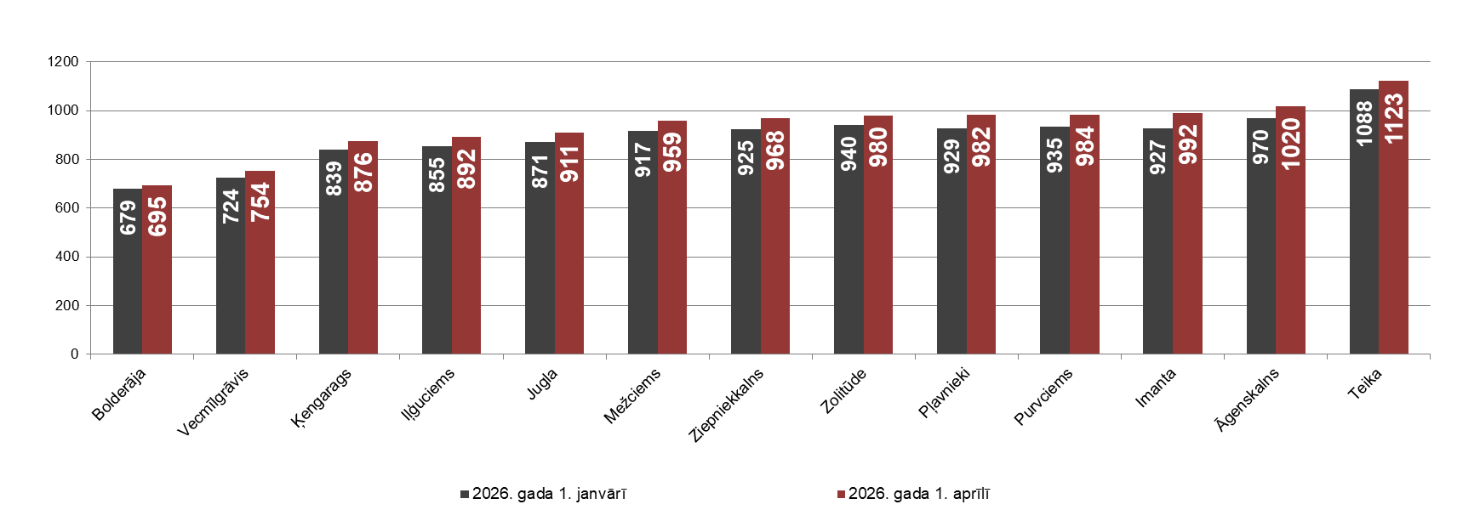

Source: ARCO REAL ESTATE

The highest prices for standard-type apartments in March remained in Teika, where the average price per square meter increased to 1,123 EUR/m². The lowest average price per square meter in March was in Bolderāja (695 EUR/m²), which also increased compared to the previous month.

Average standard-type apartment prices in housing estates of Riga on April 1, 2026, EUR/m²

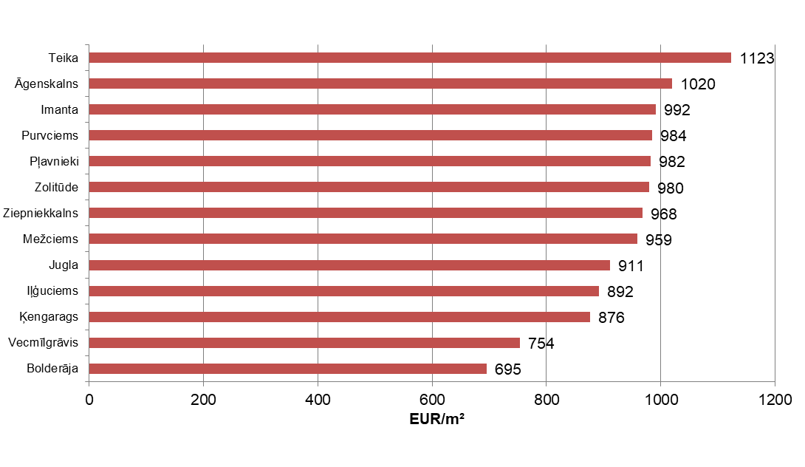

Source: ARCO REAL ESTATE

In March, the most expensive apartments still were apartments in the houses of the series 119 and 104, where the price of 2-room apartments in a satisfactory condition varied from 56 000 to 57 000 EUR depending on the location. In turn, the so-called Lithuanian design houses were the cheapest ones, where the price of 2-room apartments varied from 32 000 to 46 000 EUR, and the so-called Khrushchev-time houses, where the price of a 2-room apartment varied from 30 000 to 48 000 EUR depending on the housing estate.

Standard-type apartment prices by series in Riga housing estates in Msrch 2026 (2-room apartments), EUR
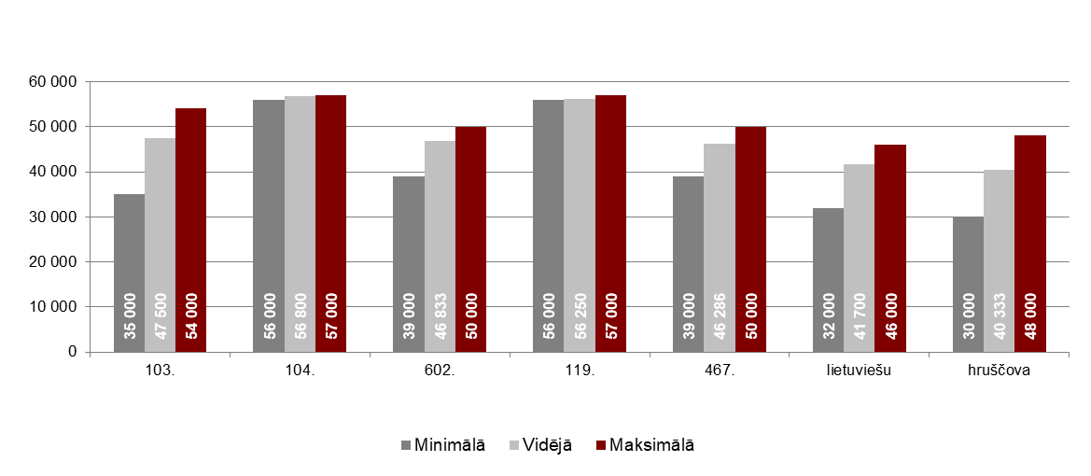

Source: ARCO REAL ESTATE

Apartment market in the vicinity of Riga

Ogre

In March 2026, the prices of standard-type apartments increased by 2.6%. The average price of one square meter of apartments reached 926 EUR/m². Apartment prices in Ogre in March were 5% higher than at the beginning of 2026.

Dynamics of the average price of standard-type apartments in Ogre, EUR/m²

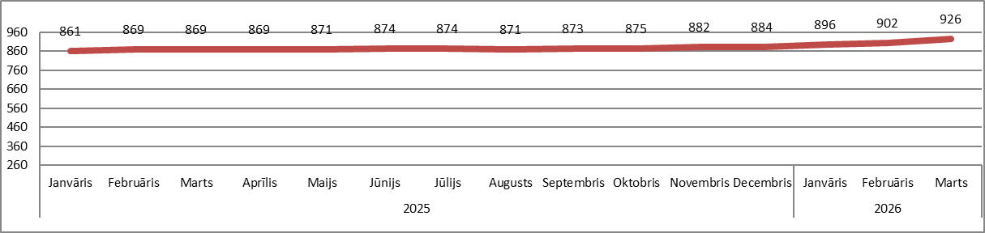

Source: ARCO REAL ESTATE

Kauguri, Jūrmala

In Kauguri, in March 2026, the prices of standard-type apartments increased by 1.3%. The average price of standard-type apartments in March was 853 EUR/m². Since the beginning of 2026, apartment prices in Kauguri have increased by 3%.

Dynamics of the average price of standard-type apartments in Jūrmala, Kauguri, EUR/m²

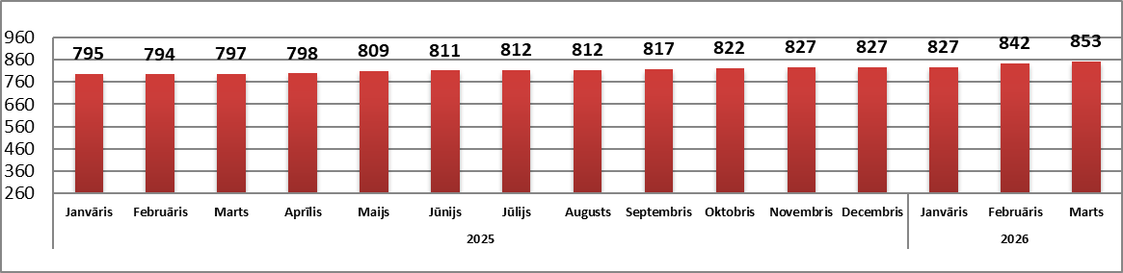

Source: ARCO REAL ESTATE

Salaspils

In March 2026, the prices of standard-type apartments in Salaspils increased by 2.6%. The average price per square meter of apartments increased to 885 EUR/m². In March, the prices of standard-type apartments in Salaspils were 4% higher than at the beginning of this year.

Dynamics of the average price of standard-type apartments in Salaspils, EUR/m²

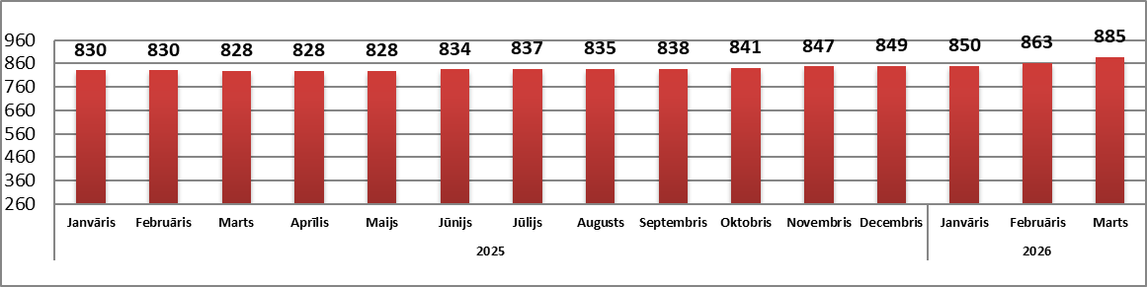

Source: ARCO REAL ESTATE

Jelgava

Apartment prices in Jelgava increased by 1.2% in March 2026. The average price of standard-type apartments in Jelgava in March was 783 EUR/m². In Jelgava, the prices of standard-type apartments in March were 2% higher than at the beginning of 2026.

Dynamics of the average price of standard-type apartments in Jelgava, EUR/m²

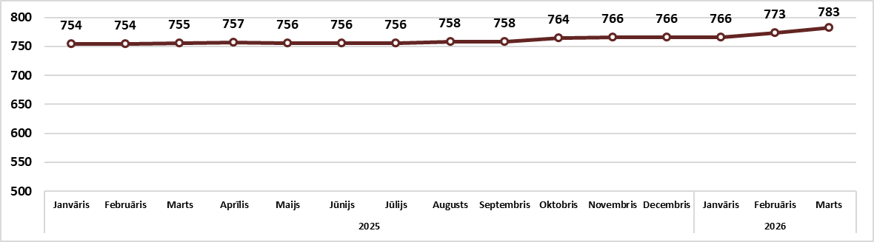

Source: ARCO REAL ESTATE

