**Standard-type apartments, September 1, 2025**

**In August 2025, there were still no significant changes in the prices of standard-type apartments in Riga’s housing estates - the average price of standard-type apartments increased by 0.1% during the month. The average price of standard-type apartments in August increased to 863 EUR/m².**

**Price changes for standard-type apartments since the beginning of 2025, in %**

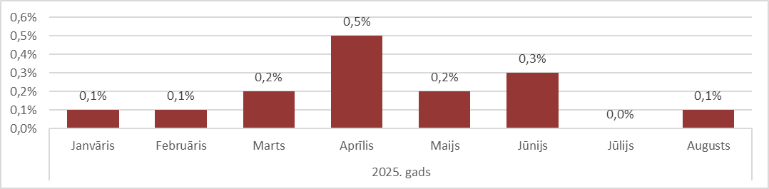

Source: ARCO REAL ESTATE

In the first eight months of 2025, the price of standard-type apartments in Riga increased by 1.4%. In some housing estates, the price of standard-type apartments rose by 3-4% this year. The largest increase in the price of standard-type apartments this year was observed in April.

The number of apartments on offer in Riga's largest housing estates continued to decline in August, reaching its lowest point this year – 1,380. In August, the supply of standard-type apartments was also low compared to 2024. In August 2024, the number of apartments on offer also decreased.

**Dynamics of apartment supply in the largest housing estates of Riga**

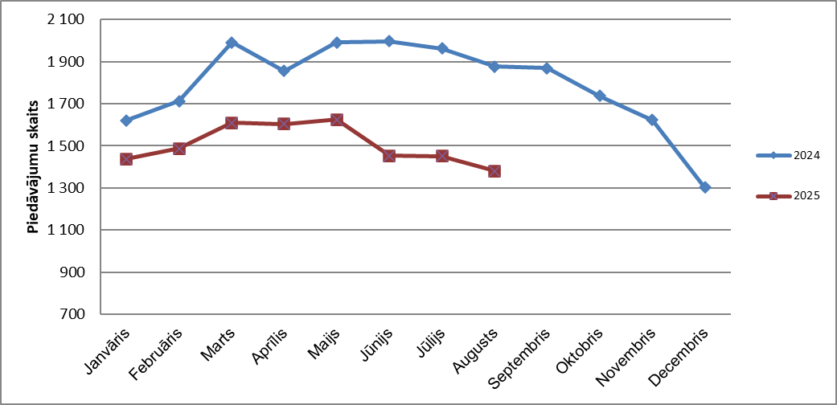

Source: ARCO REAL ESTATE

Since the beginning of 2025, apartment prices in Riga's largest housing estates have mainly seen only minor fluctuations. The largest changes in apartment prices have been observed in Jugla, where they have increased by more than 4% this year. In Imanta and Ķengarags, prices for standard-type apartments also rose by more than 3% in the first half of the year. In other housing estates, price changes this year did not exceed 2%. The smallest changes in apartment prices were observed in the most expensive and cheapest housing estates – Teika and Bolderāja, respectively. In Bolderāja, the average price even decreased slightly this year.

**Price changes in the largest housing estates of Riga since January 1, 2025, in %**

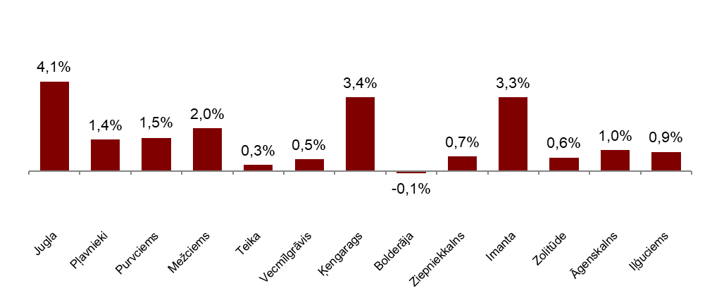

Source: ARCO REAL ESTATE

In August, the average price of a standard-type apartment rose to EUR 863 per square meter. Prices were on average 47% lower than on August 1, 2007, when the average price of an unrenovated standard-type apartment reached an all-time highest level of EUR 1,620/m².

**Dynamics of average price of standard-type apartments in the major housing estates of Riga, EUR/m²**

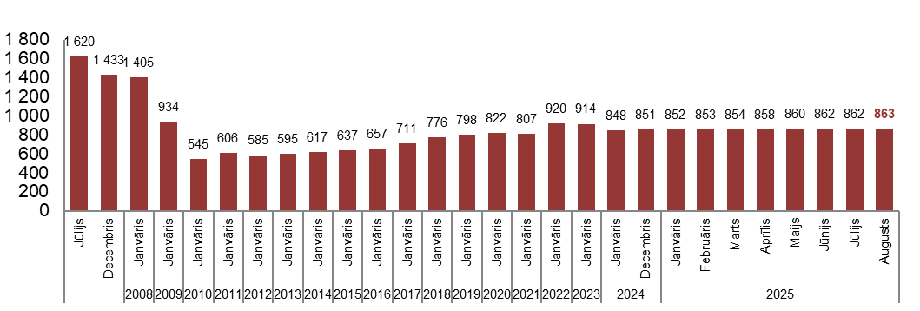

Source: ARCO REAL ESTATE

**Changes in prices of standard-type apartments in housing estates of Riga, in %**

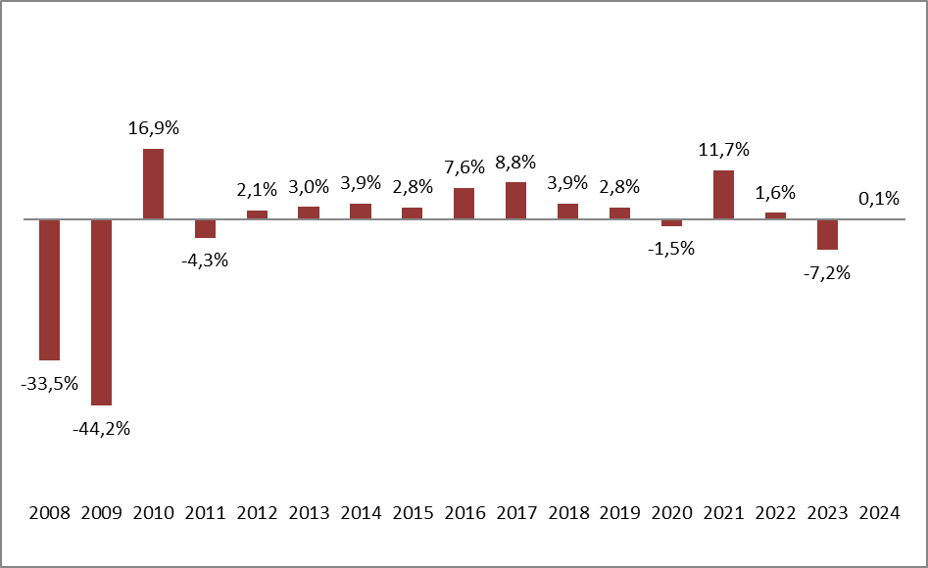

Source: ARCO REAL ESTATE

In August, no changes were observed in the prices of three-room apartments. The average price per square meter of standard-type apartments increased for one-room (+0.1%), two-room (+0.1%) and four-room (+0.1%) apartments. Since the beginning of the year, the price of two-room apartments has increased the most (+1.9%).

**Average prices of standard-type apartments in Riga housing estates by number of rooms, EUR/m²**



Source: ARCO REAL ESTATE

Compared to the previous month, the supply of apartments in Riga decreased by 6% in August. The number of apartments offered for sale in the largest housing estates of Riga analysed by “ARCO REAL ESTATE” decreased by 5% in August. Compared to August 2024, the supply of apartments in August of this year was generally lower: the total number of apartments offered for sale was 24% lower, but the supply of apartments in the largest housing estates was 26% lower.

**Dynamics of supply of apartments in Riga**

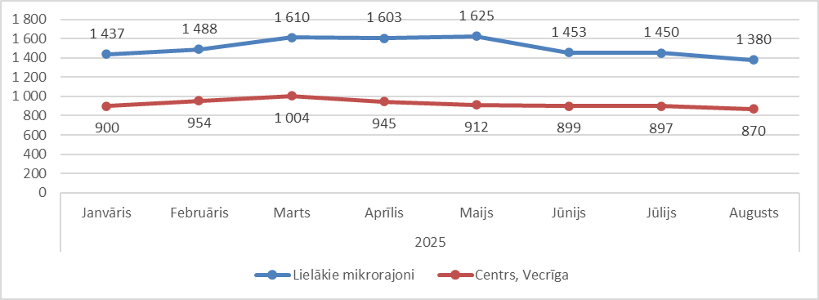

Source: ARCO REAL ESTATE

Summarizing the number of apartments offered for sale in Riga housing estates, it can be concluded that the largest supply in August was in Āgenskalns, while the smallest supply was in Bolderāja.

**Number of apartments offered for sale in Riga at the end of August 2025**

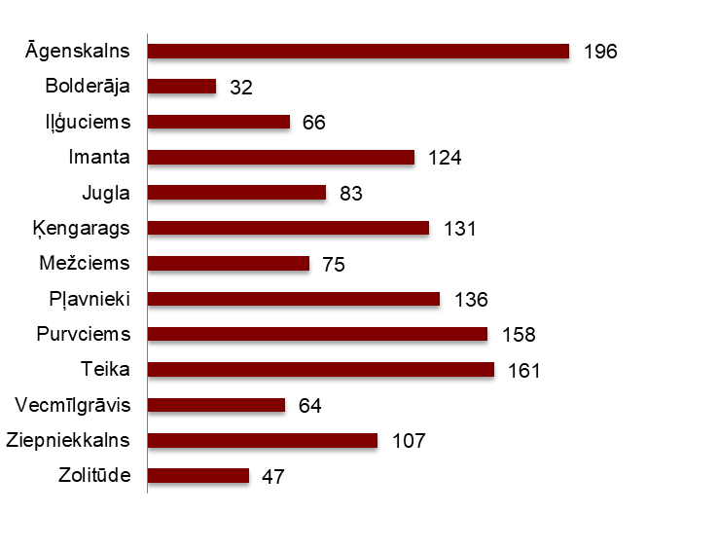

Source: ARCO REAL ESTATE

Last month, the number of apartments on offer decreased in almost all of Riga's largest housing estates. The largest decrease in the number of offers was observed in Pļavnieki (-19%). In contrast, only Āgenskalns saw an increase in the number of apartments offered for sale in August (+7%). In Teika, the number of apartment offers in August remained at the July level.

When analysing the supply of apartments in proportion to the size of the housing estate, i.e., by population, the largest supply in August was found in Āgenskalns. On the other hand, the number of apartments offered for sale was proportionally the lowest in Zolitūde.

**Number of apartments offered for sale in proportion to the size of the housing estates in Riga in August 2025**

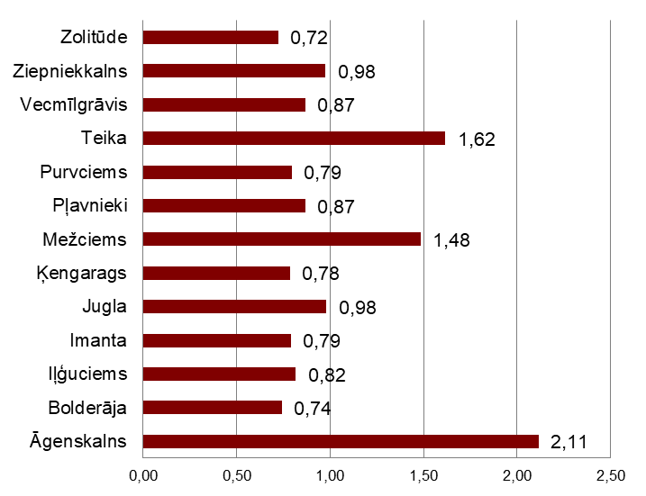

Source: ARCO REAL ESTATE

In August, there were no significant changes in the prices of standard-type apartments in Riga's housing estates. Most of Riga's largest housing estates saw both negative and positive price fluctuations. The largest price increase was observed in Mežciems, where prices rose by 0.5% over the month. In several housing estates, no price changes were observed in August. Negative price fluctuations in August were observed in Ķengarags and Bolderāja.

**Changes in the average square meter price of standard-type apartments in Riga housing estates, %**



Source: ARCO REAL ESTATE

Compared to the beginning of 2025, in August 2025, prices for standard-type apartments increased slightly in all major housing estates in Riga, except for Bolderāja. Compared to the beginning of 2024, only minor changes in apartment prices were observed.

**Average standard-type apartment prices in housing estates of Riga, EUR/m²**

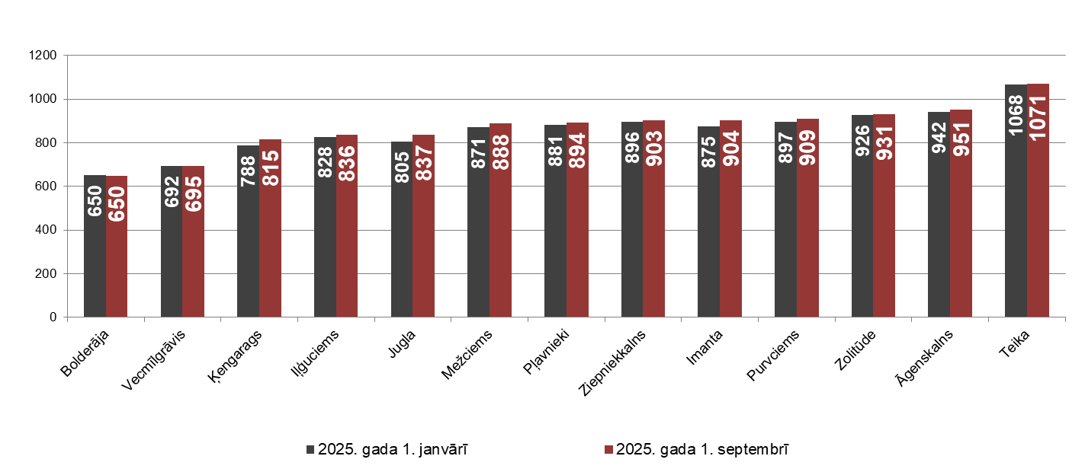

Source: ARCO REAL ESTATE

The highest prices for standard-type apartments in August remained in Teika, where the average price per square meter remained unchanged at EUR 1,071/m². The lowest average price per square meter in August was in Bolderāja – EUR 650/m², which decreased slightly in August.

**Average standard-type apartment prices in housing estates of Riga on September 1, 2025, EUR/m²**

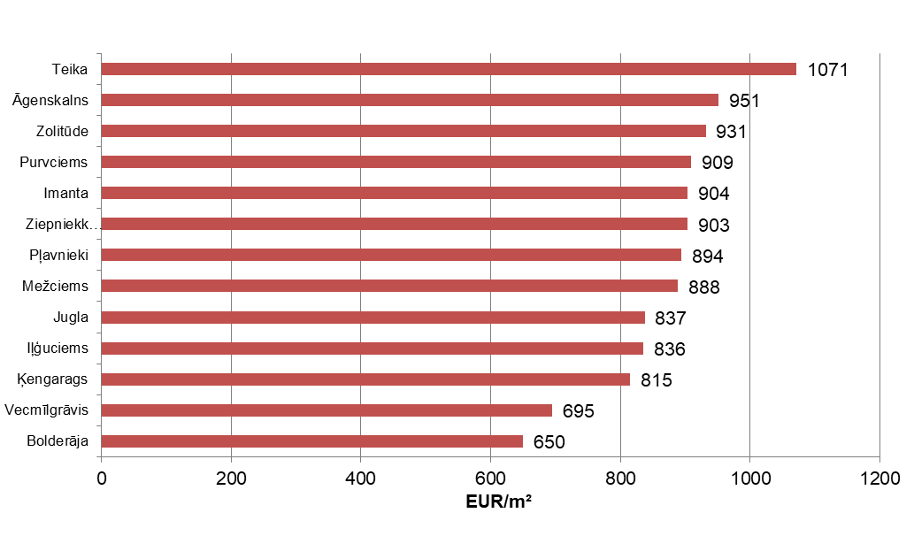

Source: ARCO REAL ESTATE

In August, the most expensive apartments still were apartments in the houses of the series 119and 104, where the price of 2-room apartments in a satisfactory condition varied from 52 000 to 55 000 EUR depending on the location. In turn, the so-called Lithuanian design houses were the cheapest ones, where the price of 2-room apartments varied from 30 000 to 42 000 EUR, and the so-calledKhrushchev-time houses, where the price of a 2-room apartment varied from 29 000 to 44 000 EUR depending on the housing estate.

**Standard-type apartment prices by series in Riga housing estates in August 2025 (2-room apartments), EUR**

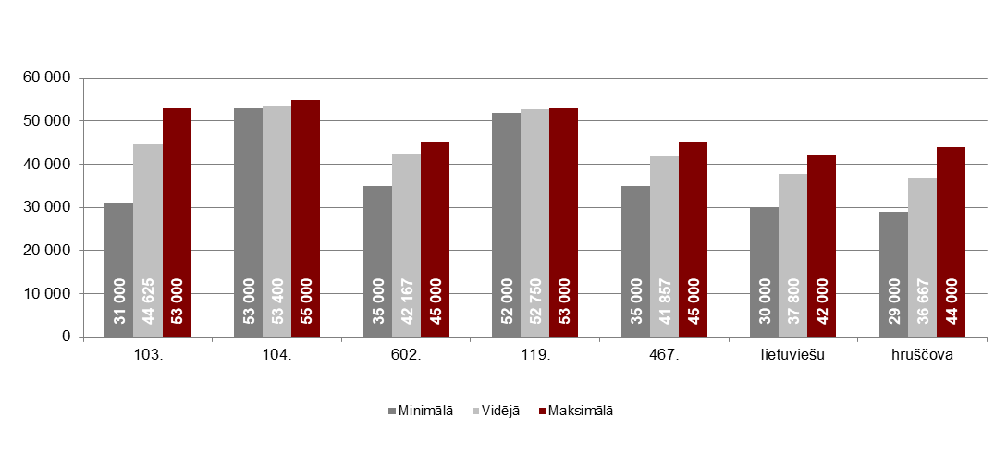

Source: ARCO REAL ESTATE

**Apartment market in the vicinity of Riga**

**Ogre**

In August 2025, prices for standard-type apartments fell by 0.3%. The average price per square metre of apartment space was EUR 871/m². Apartment prices in Ogre in August were 3% higher than at the beginning of 2025.

**Dynamics of the average price of standard-type apartments in Ogre, EUR/m²**

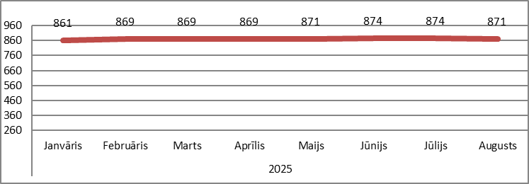

Source: ARCO REAL ESTATE

**Kauguri, Jūrmala**

In August, prices for standard-type apartments in Kauguri remained unchanged. The average price for standard-type apartments in August was EUR 812 per square metre. Since the beginning of 2024, apartment prices in Kauguri have risen by 3%.

**Dynamics of the average price of standard-type apartments in Jūrmala, Kauguri, EUR/m²**

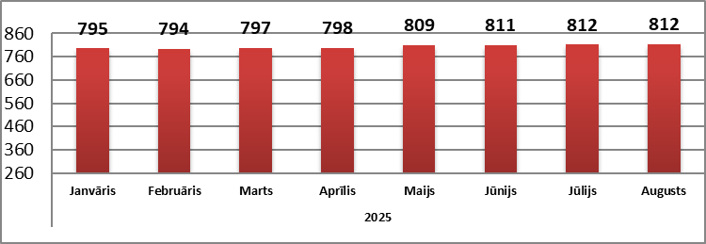

Source: ARCO REAL ESTATE

**Salaspils**

In August, prices for standard-type apartments in Salaspils fell by 0.2%. The average price per square meter of apartment space dropped to EUR 835/m². In August, prices for standard-type apartments in Salaspils were 0.6% higher than at the beginning of the year.

**Dynamics of the average price of standard-type apartments in Salaspils, EUR/m²**

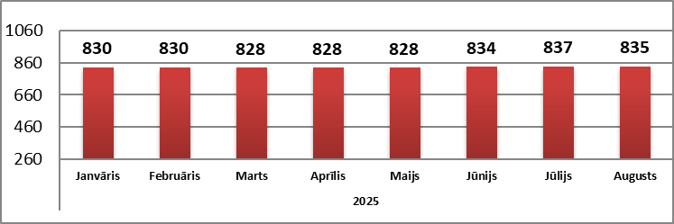

Source: ARCO REAL ESTATE

**Jelgava**

Apartment prices in Jelgava increased by 0.2% in August. The average price of a standard-type apartment in Jelgava in August was EUR 758/m². Prices for standard-type apartments in Jelgava in August were 2% higher than at the beginning of 2025.

**Dynamics of the average price of standard-type apartments in Jelgava, EUR/m2**

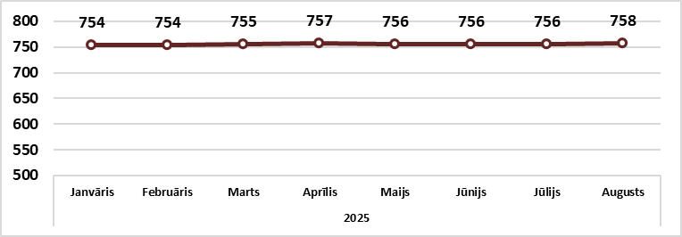

Source: ARCO REAL ESTATE