**Standard-type apartments, October 1, 2025**

**In September 2025, there were still no significant changes in the prices of standard-type apartments in Riga’s housing estates - the average price of standard-type apartments increased by 0.2% during the month. The average price of standard-type apartments in September increased to 865 EUR/m².**

**Price changes for standard-type apartments since the beginning of 2025, in %**

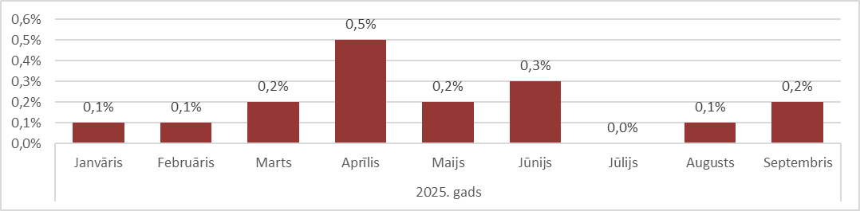

Source: ARCO REAL ESTATE

In the first nine months of 2025, the price of standard-type apartments in Riga increased by 1.6%. In some housing estates, the price of standard-type apartments rose by 4-5% this year. The largest increase in the price of standard-type apartments this year was observed in April.

After a decline during the summer months, the number of apartments on offer in Riga's largest housing estates increased again in September, reaching almost 1,500 units. However, even in September, the supply of standard-type apartments was low compared to 2024. In September last year, the supply of apartments continued to decline.

**Dynamics of apartment supply in the largest housing estates of Riga**

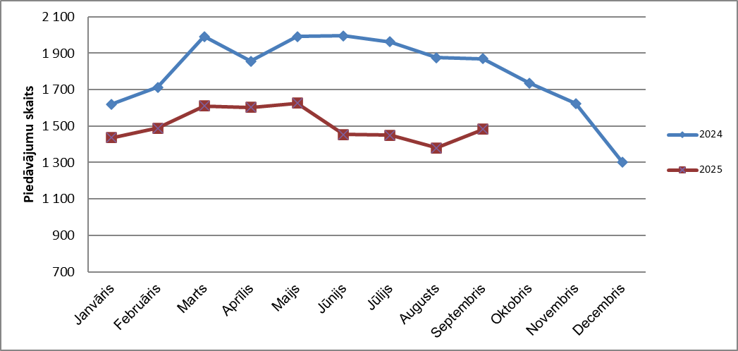

Source: ARCO REAL ESTATE

Since the beginning of 2025, apartment prices in Riga's largest housing estates have mainly fluctuated slightly. The largest changes in apartment prices were observed in Jugla, where they increased by almost 5% this year. In Imanta and Ķengarags, prices for standard-type apartments also increased by 3-4% this year. In other housing estates, price changes this year mostly did not exceed 2%. The smallest changes in apartment prices were observed in the most expensive housing estate – Teika. In Bolderāja, where apartment prices are the lowest, the average price has even decreased slightly this year.

**Price changes in the largest housing estates of Riga since January 1, 2025, in %**

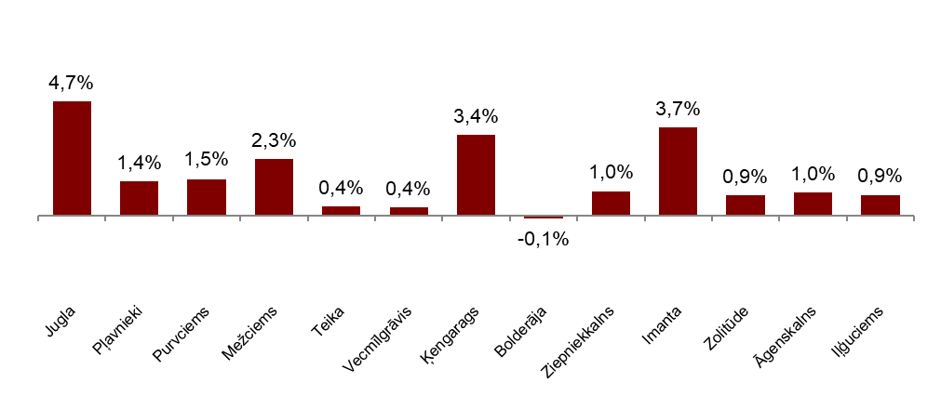

Source: ARCO REAL ESTATE

In September, the average price of a standard-type apartment rose to EUR 865 per square meter. Prices were on average 47% lower than on August 1, 2007, when the average price of an unrenovated standard-type apartment reached an all-time highest level of EUR 1,620/m².

**Dynamics of average price of standard-type apartments in the major housing estates of Riga, EUR/m²**

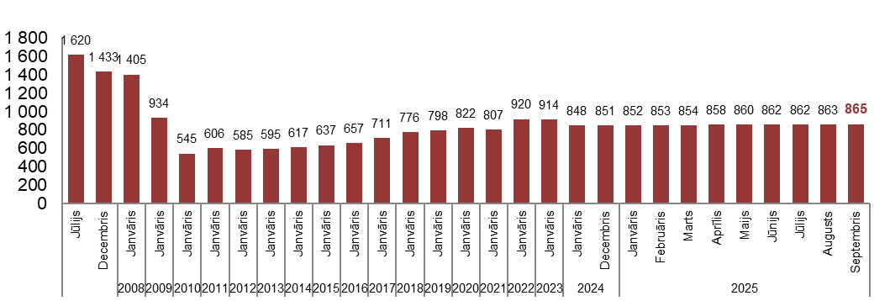

Source: ARCO REAL ESTATE

**Changes in prices of standard-type apartments in housing estates of Riga, in %**

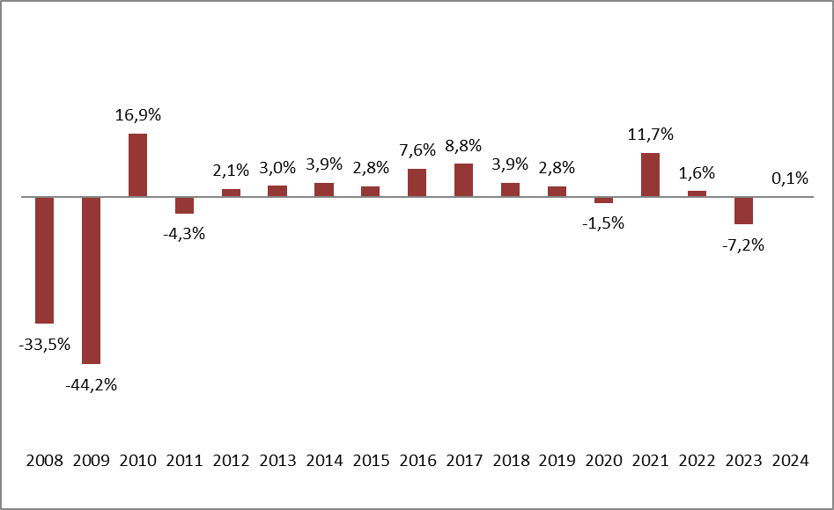

Source: ARCO REAL ESTATE

The average price per square meter of a standard apartment increased for one-room apartments (+0.1%), two-room apartments (+0.2%), three-room apartments (+0.3%) and four-room apartments (+0.2%). Since the beginning of the year, the price of two-room apartments has increased the most (+2.1 %).

**Average prices of standard-type apartments in Riga housing estates by number of rooms, EUR/m²**



Source: ARCO REAL ESTATE

Compared to the previous month, the supply of apartments in Riga increased by 12% in September. The number of offers in the largest housing districts of Riga analysed by ARCO REAL ESTATE increased by 7%. Compared to September 2024, the supply of apartments in September this year increased overall: the total number of apartments on offer was up by 12%, while the supply of apartments in the largest housing estates was up by 7%.

**Dynamics of supply of apartments in Riga**

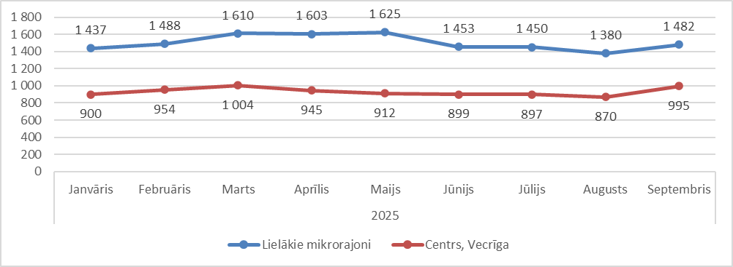

Source: ARCO REAL ESTATE

Summarizing the number of apartments offered for sale in Riga housing estates, it can be concluded that the largest supply in September was in Āgenskalns, while the smallest supply was in Bolderāja.

**Number of apartments offered for sale in Riga at the end of September 2025**

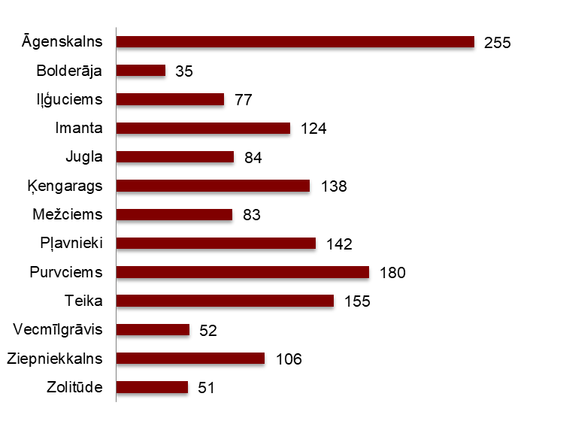

Source: ARCO REAL ESTATE

Last month, the number of apartments on offer increased in almost all of Riga's largest housing districts. The number of offers increased most significantly in Āgenskalns (+30%). Also in the previous month, when a decrease in offers was observed in all housing districts, the number of offers in Āgenskalns increased. The number of apartment offers in September decreased most sharply in Vecmīlgrāvis (-19 %).

In September, when analysing the number of offers in proportion to the size of the housing estate, i.e., by population, the largest number of offers was found in Āgenskalns. In contrast, the number of offers in Zolitūde was proportionally the smallest.

**Number of apartments offered for sale in proportion to the size of the housing estates in Riga in September 2025**

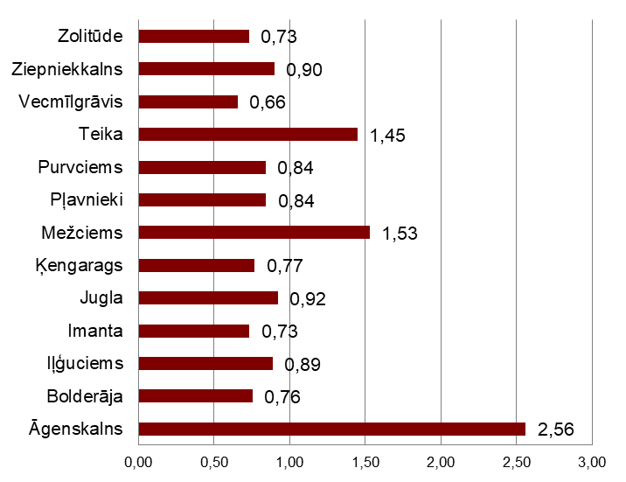

Source: ARCO REAL ESTATE

In September, there were no significant changes in the prices of standard-type apartments in Riga's housing estates. Approximately half of Riga's largest housing estates saw positive price fluctuations. The largest price increase was observed in Jugla, where prices rose by 0.6% over the month. In several housing estates, no price changes were observed in September. Negative price fluctuations in September were observed only in Vecmīlgrāvis.

**Changes in the average square meter price of standard-type apartments in Riga housing estates, %**



Source: ARCO REAL ESTATE

Compared to the beginning of 2025, in September of this year, prices for standard-type apartments increased slightly in all of Riga's major housing districts, with the exception of Bolderāja. Also, compared to the beginning of 2024, only minor changes in apartment prices have been observed.

**Average standard-type apartment prices in housing estates of Riga, EUR/m²**

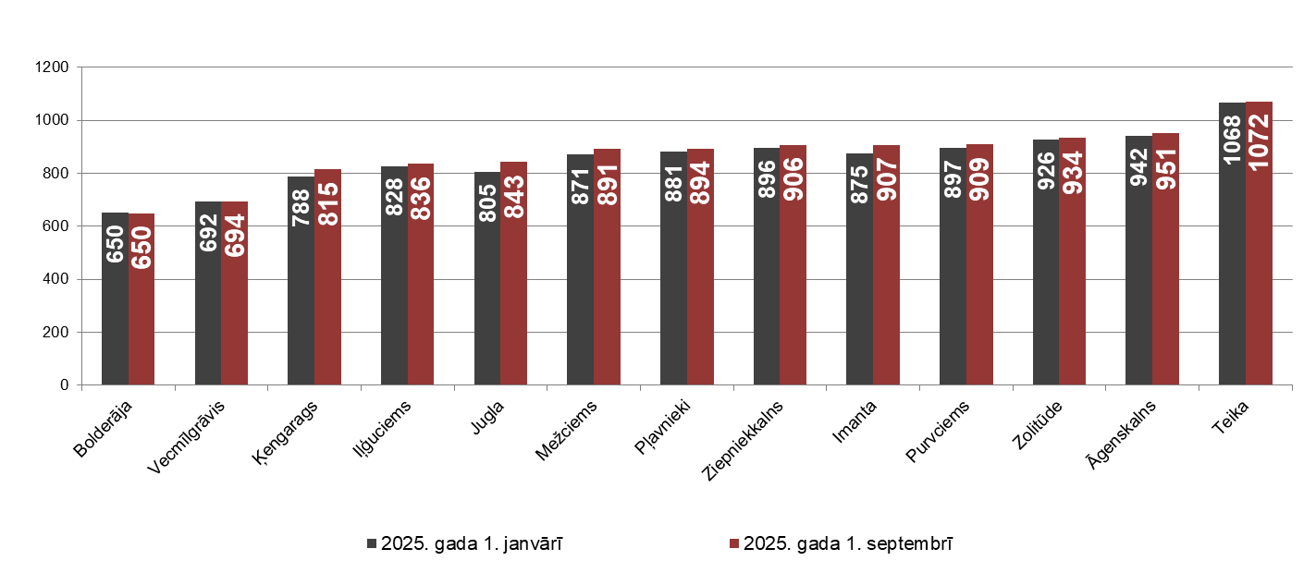

Source: ARCO REAL ESTATE

The highest prices for standard-type apartments in September remained in Teika, where the average price per square meter rose to EUR 1072/m². The lowest average price per square meter in September was in Bolderāja – EUR 650/m², which remained unchanged from the previous month.

**Average standard-type apartment prices in housing estates of Riga on October 1, 2025, EUR/m²**

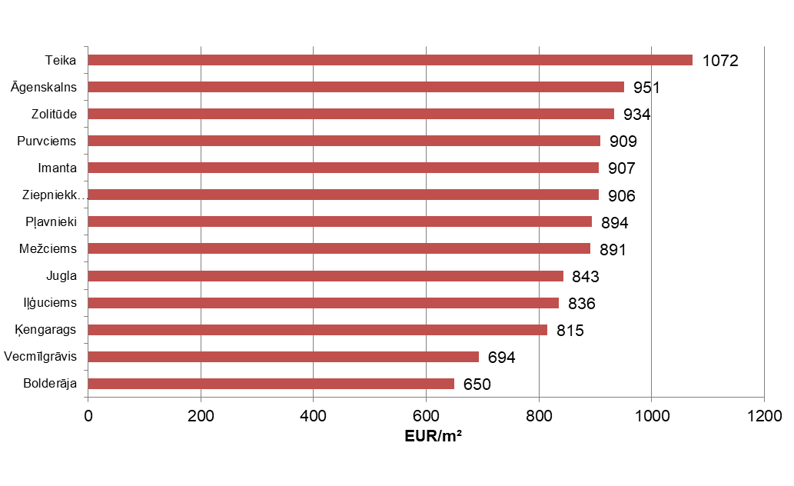

Source: ARCO REAL ESTATE

In September, the most expensive apartments still were apartments in the houses of the series 119and 104, where the price of 2-room apartments in a satisfactory condition varied from 52 000 to 55 000 EUR depending on the location. In turn, the so-called Lithuanian design houses were the cheapest ones, where the price of 2-room apartments varied from 30 000 to 42 000 EUR, and the so-calledKhrushchev-time houses, where the price of a 2-room apartment varied from 29 000 to 44 000 EUR depending on the housing estate.

**Standard-type apartment prices by series in Riga housing estates in September 2025 (2-room apartments), EUR**

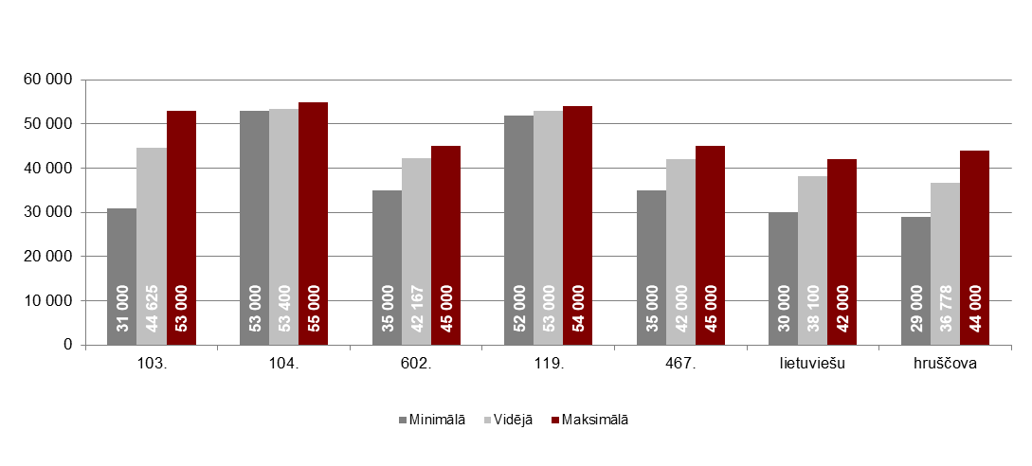

Source: ARCO REAL ESTATE

**Apartment market in the vicinity of Riga**

**Ogre**

In September 2025, prices for standard-type apartments increased by 0.2%. The average price per square meter of apartment space was EUR 873/m². Apartment prices in Ogre in September were 3% higher than at the beginning of 2025.

**Dynamics of the average price of standard-type apartments in Ogre, EUR/m²**

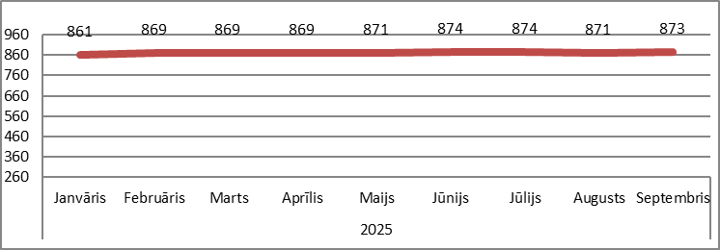

Source: ARCO REAL ESTATE

**Kauguri, Jūrmala**

In September, prices for standard -type apartments in Kauguri increased by 0.5%. The average price for standard -type apartments in September was EUR 817/m². Since the beginning of 2024, apartment prices in Kauguri have increased by 4%.

**Dynamics of the average price of standard-type apartments in Kauguri, EUR/m²**

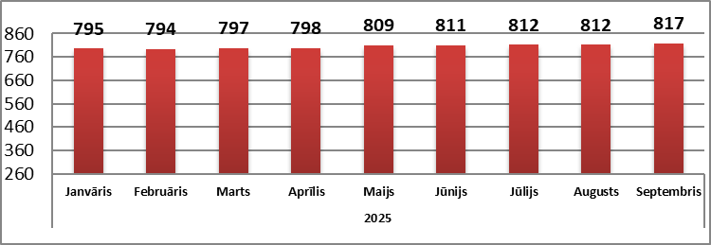

Source: ARCO REAL ESTATE

**Salaspils**

In September, prices for standard-type apartments in Salaspils increased by 0.3%. The average price per square meter of apartment space rose to EUR 838/m². In September, prices for standard-type apartments in Salaspils were 1% higher than at the beginning of the year.

**Dynamics of the average price of standard-type apartments in Salaspils, EUR/m²**

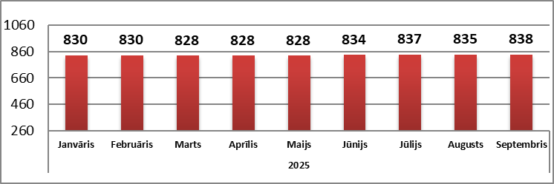

Source: ARCO REAL ESTATE

**Jelgava**

Apartment prices in Jelgava remained unchanged in September. The average price of a standard-type apartment in Jelgava in September was EUR 758/m². Prices for standard-type apartments in Jelgava in September were 2% higher than at the beginning of 2025.

**Dynamics of the average price of standard-type apartments in Jelgava, EUR/m2**

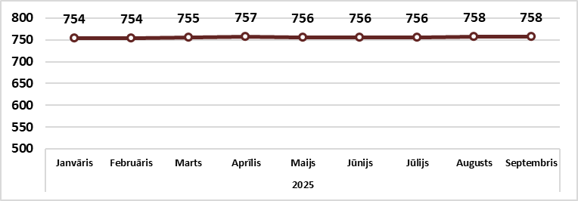

Source: ARCO REAL ESTATE