Standard-type apartments, January 1, 2026

In December 2025, there were no significant changes in the prices of standard-type apartments in Riga's housing estates - the average price of standard-type apartments increased by 0.3% during the month. The average price of standard-type apartments in December increased to 887 EUR/m².

Price changes for standard-type apartments since the beginning of 2025, in %

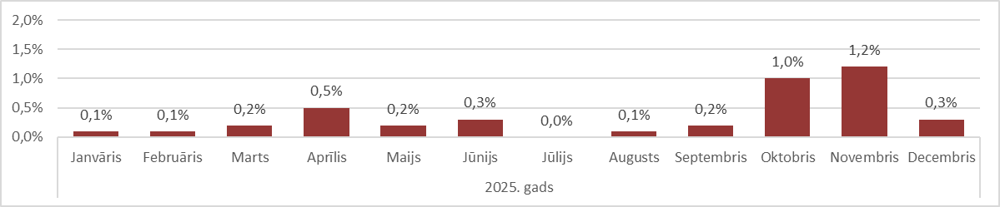

Source: ARCO REAL ESTATE

The prices of standard-type apartments increased the most this year in October and November. The supply of standard-type apartments usually tends to decrease significantly at the end of the year. In December, the highest supply of apartments remained in the most expensive housing estates of Riga – Āgenskalns and Teika. The supply of standard-type apartments in the vicinity of Riga also decreased to a minimum at the end of the year.

The number of apartments offered for sale in Riga's largest housing estates continued to fall in December and fell below the 1,100 mark. In December, the supply of standard-type apartments was one of the lowest in recent years. In 2020 and 2021, the supply of apartments in December fell even lower - below the 1,000 mark.

Dynamics of apartment supply in the largest housing estates of Riga

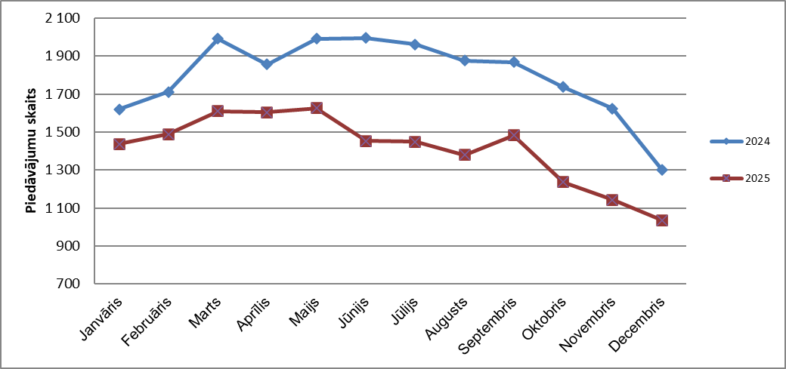

Source: ARCO REAL ESTATE

In the largest housing estate of Riga, apartment prices have increased by 2-8% since the beginning of 2025. The largest changes in apartment prices were observed in Jugla, where they increased by 8% this year. In Imanta and Ķengarags, the increase in prices for standard-type apartments was also large this year - prices increased by an average of 6%. In the other housing estates of Riga, price changes did not exceed 5% this year. The smallest changes in apartment prices were observed in the most expensive housing estate -​​Teika, as well as in Zolitūde.

Price changes in the largest housing estates of Riga since January 1, 2025, in %

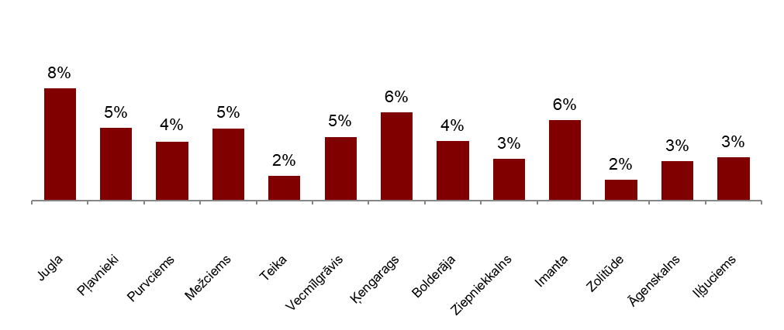

Source: ARCO REAL ESTATE

In December, the average price of a standard-type apartment rose to EUR 887 per square meter. Prices were on average 45% lower than on August 1, 2007, when the average price of an unrenovated standard-type apartment reached an all-time highest level of EUR 1,620/m².

Dynamics of average price of standard-type apartments in the major housing estates of Riga, EUR/m²
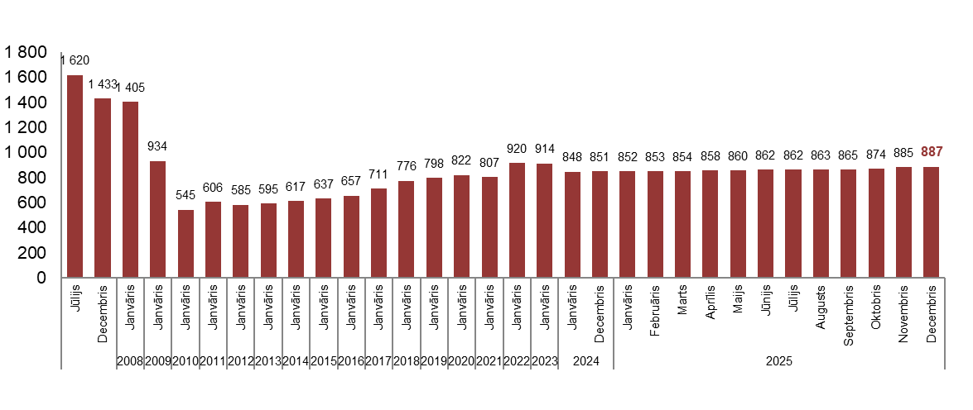

Source: ARCO REAL ESTATE

Changes in prices of standard-type apartments in housing estates of Riga, in %

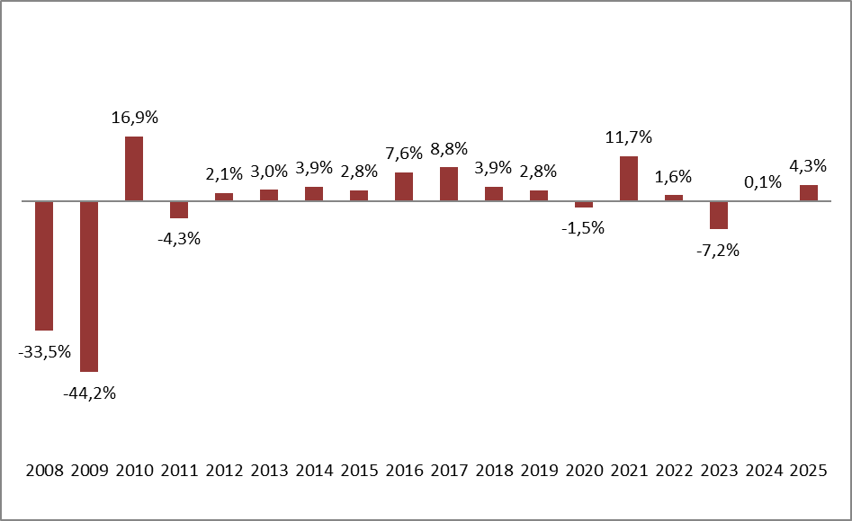

Source: ARCO REAL ESTATE

The average price per square meter of standard-type apartments increased for one-room (+0.3%), two-room (+0.3%), three-room (+0.4%) and four-room apartments (+0.1%). Since the beginning of the year, the price of two-room apartments has increased the most (+4.9%).

Average prices of standard-type apartments in Riga housing estates by number of rooms, EUR/m²

Source: ARCO REAL ESTATE

Compared to the previous month, the supply of apartments in Riga decreased by 5% in December. The number of apartments offered for sale in the largest housing estates of Riga analyzed by “ARCO REAL ESTATE” decreased by 9%. Compared to November 2024, the supply of apartments was generally lower: the total number of apartments offered for sale was 9% lower, but the supply of apartments in the largest housing estates was 20% lower.

Dynamics of supply of apartments in Riga

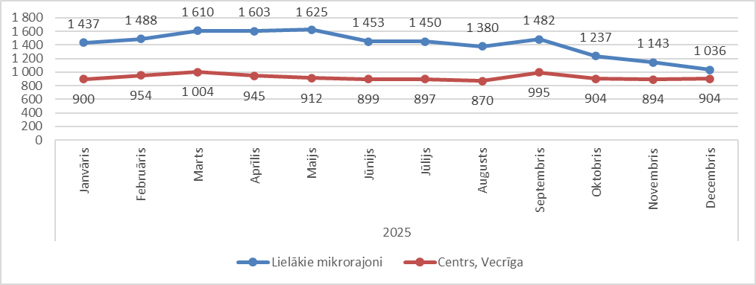

Source: ARCO REAL ESTATE

Summarizing the number of apartments offered for sale in Riga housing estates, it can be concluded that the largest supply in December was in Āgenskalns, while the smallest supply was in Bolderāja.

Number of apartments offered for sale in Riga at the end of December 2025

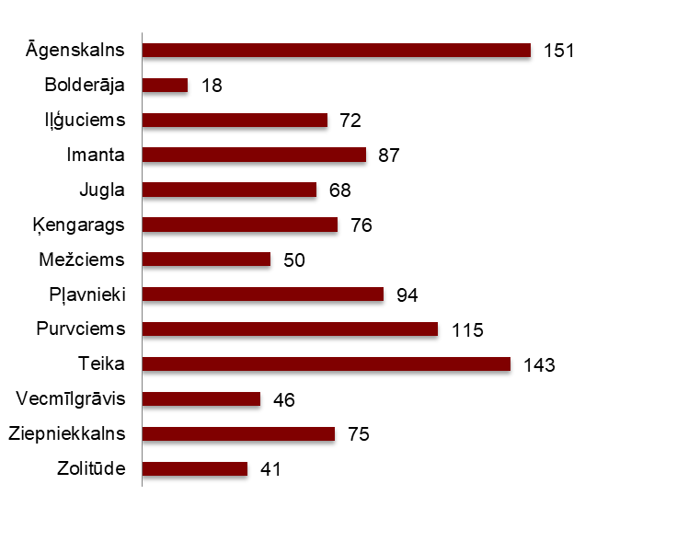

Source: ARCO REAL ESTATE

In December, the number of apartments offered for sale decreased in almost all major housing estates of Riga. The decline in the supply has been observed since September. The number of apartments offered for sale decreased the most in Bolderāja (-25%). The number of apartment offered for sale increased slightly in December only in two housing estates – Iļģuciems (+3%) and Imanta (+1%).

In December, when analysing the number of apartments offered for sale in proportion to the size of the housing estate, i.e., by population, the largest number of apartments offered for sale was found in Āgenskalns. In contrast, the number of apartments offered for sale in Bolderāja was proportionally the smallest.

Number of apartments offered for sale in proportion to the size of the housing estates in Riga in December 2025

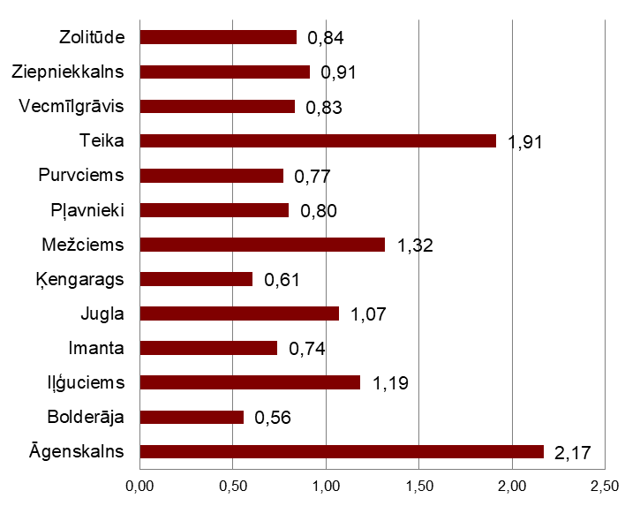

Source: ARCO REAL ESTATE

In December, changes could be observed in the prices of standard-type apartments in Riga's housing estates. An increase in the average price of apartments could be observed in almost all the largest housing estates of Riga. The largest increase in the average price was observed in Vecmīlgrāvis, where prices increased by more than 1% during the month. In Jugla, Ziepniekkalns and Zolitūde, no price changes were observed in the last month of the year.

Changes in the average square meter price of standard-type apartments in Riga housing estates, %

Source: ARCO REAL ESTATE

Compared to the beginning of 2025, in December 2025, the prices of standard-type apartments increased slightly in all major housing estates of Riga. The highest average price per square meter of an apartment was in Teika, but the lowest was still in Bolderāja.

Average standard-type apartment prices in housing estates of Riga, EUR/m²

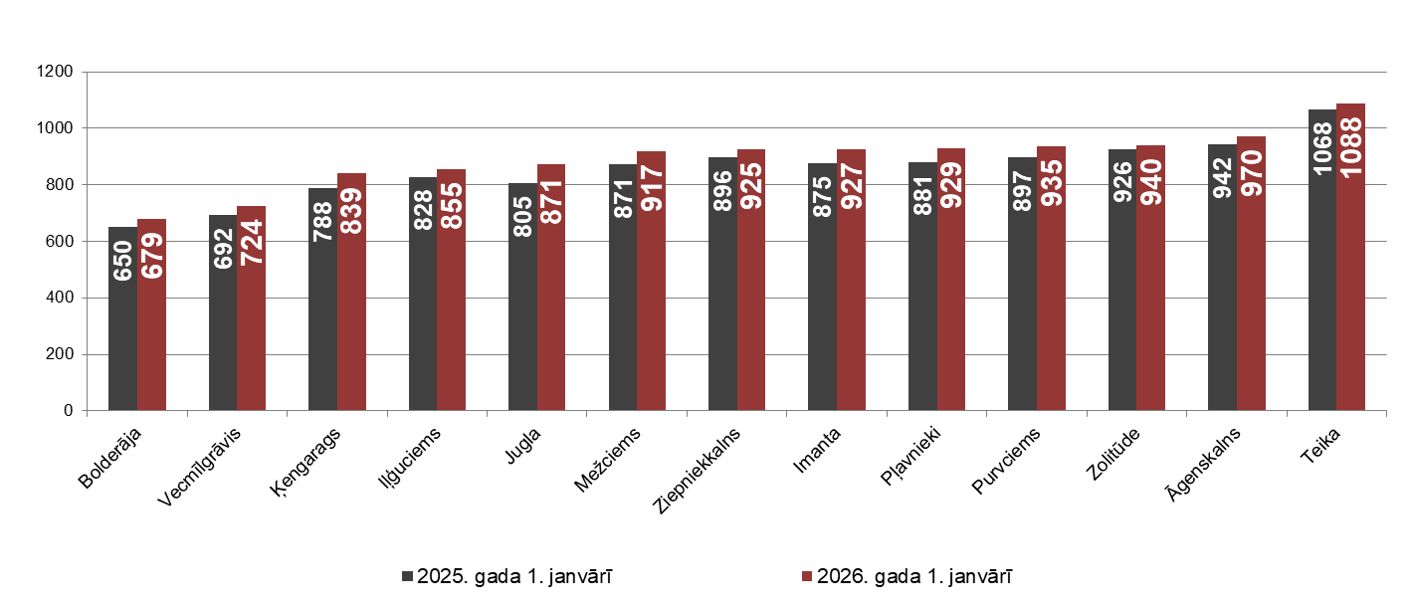

Source: ARCO REAL ESTATE

The highest prices for standard-type apartments in December remained in Teika, where the average price per square meter rose to EUR 1088/m². The lowest average price per square meter in December was in Bolderāja – EUR 679/m², which also increased compared to the previous month.

Average standard-type apartment prices in housing estates of Riga on January 1, 2026, EUR/m²

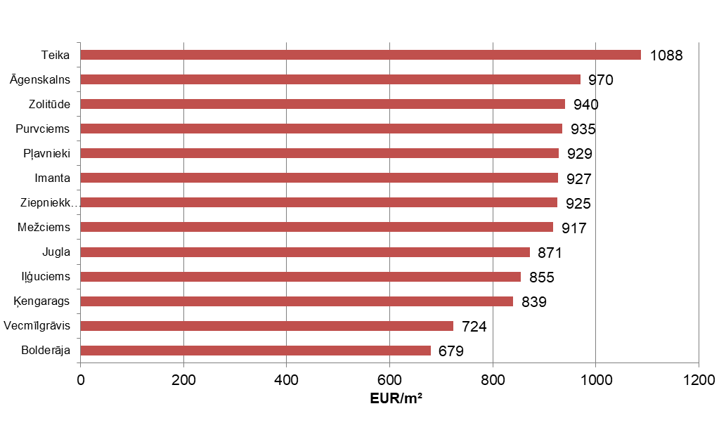

Source: ARCO REAL ESTATE

In December, the most expensive apartments still were apartments in the houses of the series 119 and 104, where the price of 2-room apartments in a satisfactory condition varied from 54 000 to 56 000 EUR depending on the location. In turn, the so-called Lithuanian design houses were the cheapest ones, where the price of 2-room apartments varied from 31 000 to 44 000 EUR, and the so-called Khrushchev-time houses, where the price of a 2-room apartment varied from 30 000 to 45 000 EUR depending on the housing estate.

Standard-type apartment prices by series in Riga housing estates in December 2025 (2-room apartments), EUR

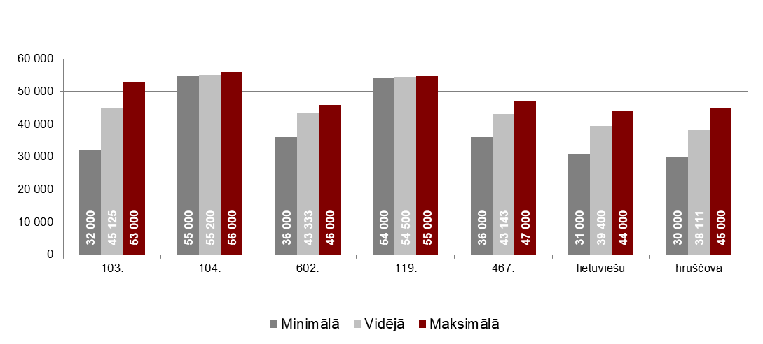

Source: ARCO REAL ESTATE

Apartment market in the vicinity of Riga

Ogre

In December 2025, the prices of standard-type apartments in Ogre increased by 0.3%. The average price of one square meter of apartments reached 884 EUR/m². Apartment prices in Ogre in December were 4% higher than at the beginning of 2025.

Dynamics of the average price of standard-type apartments in Ogre, EUR/m²

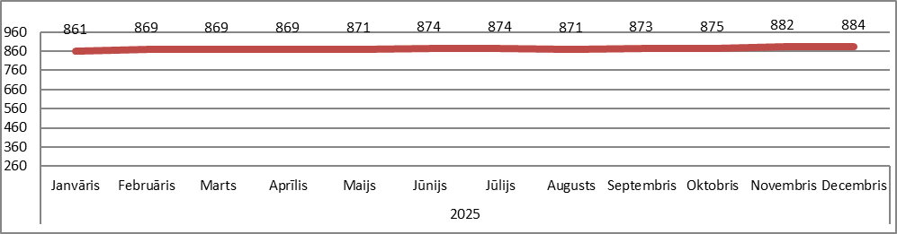

Source: ARCO REAL ESTATE

Kauguri, Jūrmala

In Kauguri, the prices of standard-type apartments in December remained at the previous month's level. The average price of standard-type apartments in December was 827 EUR/m². Since the beginning of 2025, apartment prices in Kauguri have increased by 5%.

Dynamics of the average price of standard-type apartments in Jūrmala, Kauguri, EUR/m²

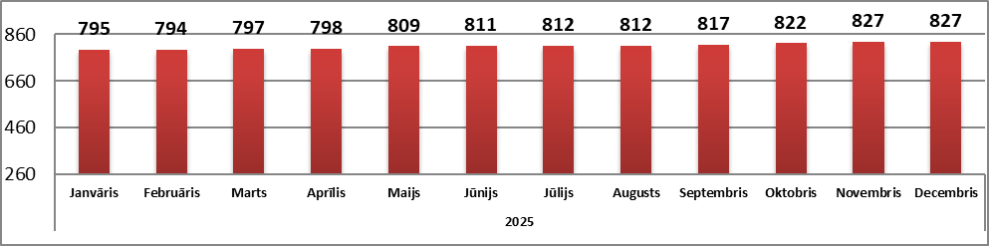

Source: ARCO REAL ESTATE

Salaspils

In December, the prices of standard-type apartments in Salaspils increased by 0.2%. The average price per square meter of apartments increased to 849 EUR/m². In December, the prices of standard-type apartments in Salaspils were 2% higher than at the beginning of the year.

Dynamics of the average price of standard-type apartments in Salaspils, EUR/m²

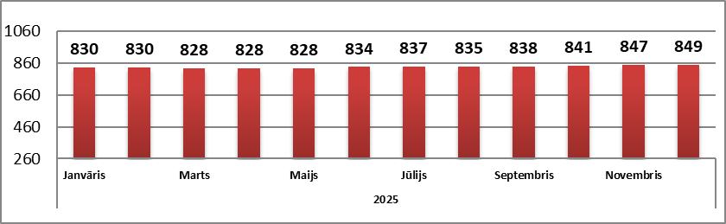

Source: ARCO REAL ESTATE

Jelgava

In Jelgava, apartment prices in December remained at the previous month's level. The average price of standard-type apartments in Jelgava in December was 766 EUR/m². In Jelgava, standard-type apartment prices in December were 3% higher than at the beginning of 2025.

Dynamics of the average price of standard-type apartments in Jelgava, EUR/m²

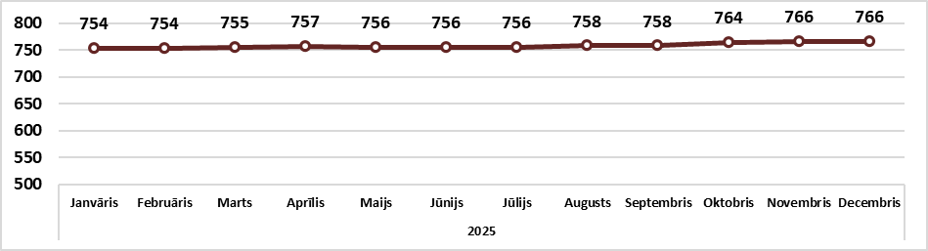

Source: ARCO REAL ESTATE

