Standard-type apartments, December 1, 2025

In November 2025, the largest price increase of this year was observed in the prices of standard-type apartments in Riga's housing estates - the average price of standard-type apartments increased by more than 1% during the month. The average price of standard-type apartments in November reached 885 EUR/m².

Price changes for standard-type apartments since the beginning of 2025, in %

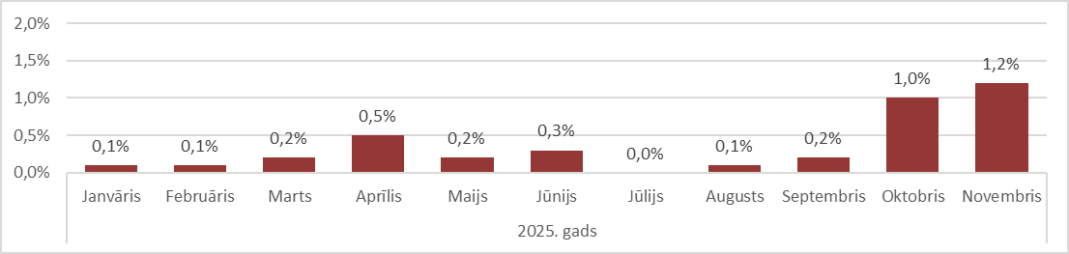

Source: ARCO REAL ESTATE

The increase in the average price of standard-type apartments was influenced by the low level of apartment supply, which has not been seen in the autumn months for the last four years. The supply of standard-type apartments in the vicinity of Riga was also low, which contributed to a gradual increase in prices. The prices of standard-type apartments increased the most this year in Jūrmala - Kauguri.

The number of apartments offered for sale in the largest housing estates of Riga continued to fall in November and almost reached the 1,100 mark. In November, the supply of standard-type apartments was the lowest in the last four years. The supply of standard-type apartments was also significantly lower compared to November 2024. The supply level was also equally low in November 2020.

Dynamics of apartment supply in the largest housing estates of Riga

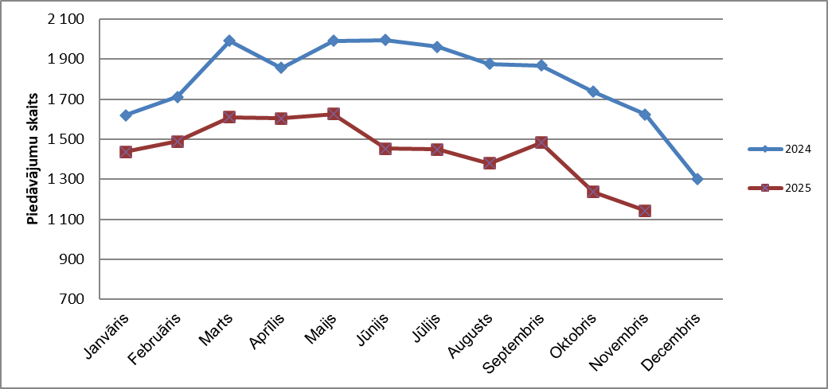

Source: ARCO REAL ESTATE

In the largest housing estates of Riga, apartment prices have increased by 1-8% since the beginning of 2025. The largest changes in apartment prices were observed in Jugla, where they increased by 8% this year. In Imanta and Ķengarags, the increase in prices for standard-type apartments was also large this year - prices increased by 6% on average. In the other housing estates of Riga, price changes did not exceed 5% this year. The smallest changes in apartment prices were observed in the most expensive housing estate - Teika.

Price changes in the largest housing estates of Riga since January 1, 2025, in %

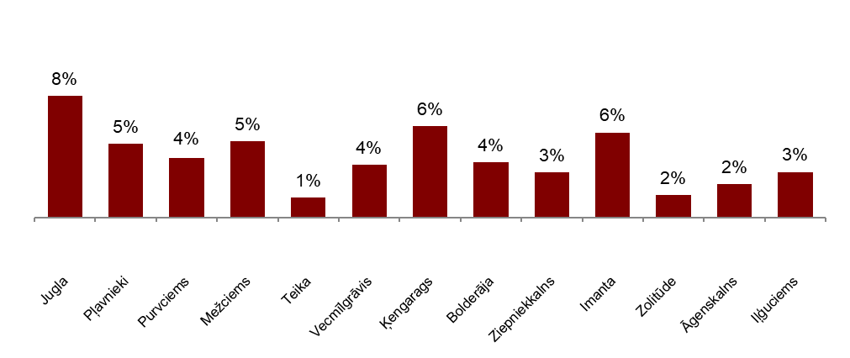

Source: ARCO REAL ESTATE

In November, the average price of a standard-type apartment rose to EUR 885 per square meter. Prices were on average 45% lower than on August 1, 2007, when the average price of an unrenovated standard-type apartment reached an all-time highest level of EUR 1,620/m².

Dynamics of average price of standard-type apartments in the major housing estates of Riga, EUR/m²

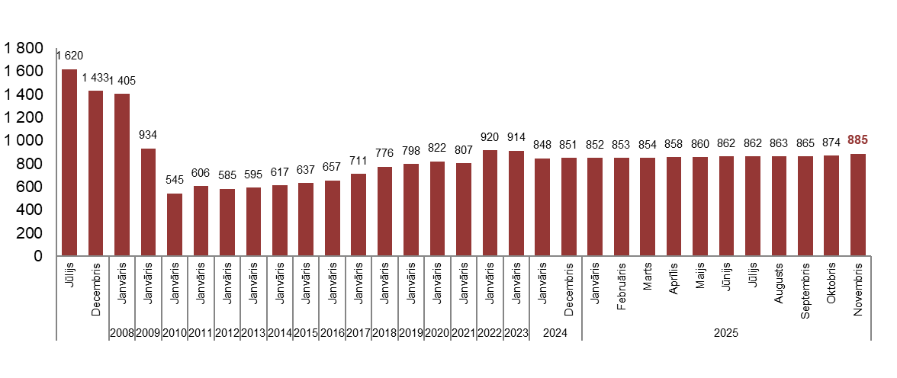

Source: ARCO REAL ESTATE

Changes in prices of standard-type apartments in housing estates of Riga, in, %

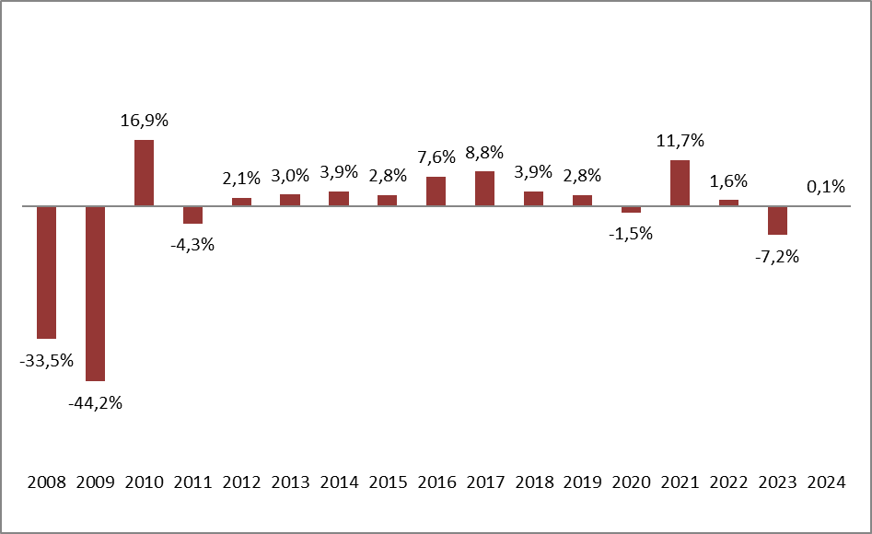

Source: ARCO REAL ESTATE

The average price per square meter of standard-type apartments increased for one-room (+1.2%), two-room apartments (+1%), three-room apartments (+1.3%) and four-room apartments (+1.3%). Since the beginning of the year, the price of two-room apartments has increased the most (+4.5%).

Average prices of standard-type apartments in Riga housing estates by number of rooms, EUR/m²

Source: ARCO REAL ESTATE

Compared to the previous month, the supply of apartments in Riga decreased by 6% in November. The number of offers in the largest housing estates of Riga analysed by ARCO REAL ESTATE decreased by 8%. Compared to November 2024, the supply of apartments was generally lower: the total number of apartments offered for sale was 20% lower, but the supply of apartments in the largest housing estates was 30% lower.

Dynamics of supply of apartments in Riga

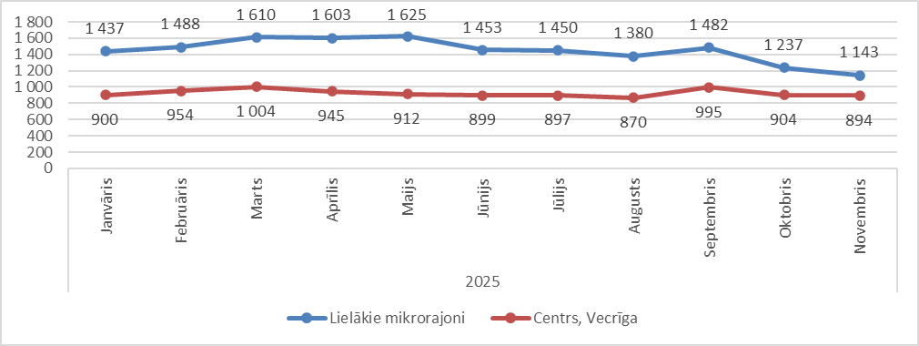

Source: ARCO REAL ESTATE

Summarizing the number of apartments offered for sale in Riga housing estates, it can be concluded that the largest supply in November was in Āgenskalns, while the smallest supply was in Bolderāja

Number of apartments offered for sale in Riga at the end of November 2025

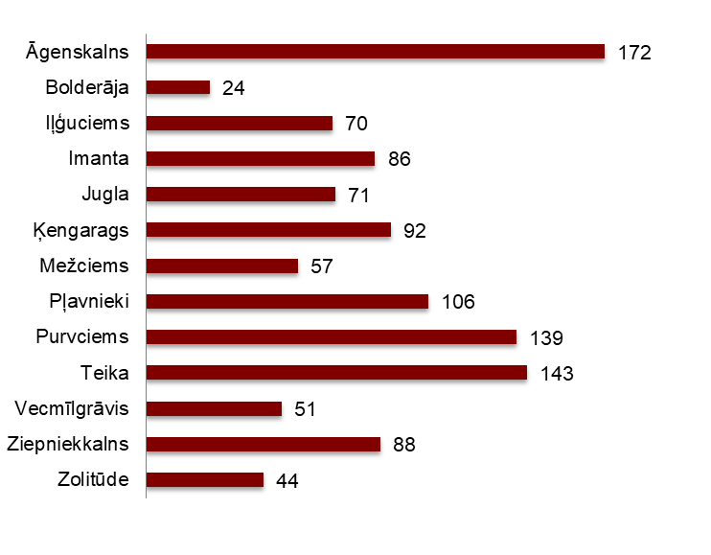

Source: ARCO REAL ESTATE

In November, the number of apartments offered for sale decreased in almost all major housing estates of Riga. A decrease in the supply of apartments was also observed in the previous month. The number of apartments offered for sale decreased the most in November in Vecmīlgrāvis (-23%). The number of apartments offered for sale increased in November only in three housing estates – Bolderāja (+9%), Iļģuciems (+3%) and Teika (+5%).

In November, when analysing the number of apartments offered for sale in proportion to the size of the housing estate, i.e., by population, the largest number of apartments offered for sale was found in Āgenskalns. In contrast, the number of apartments offered for sale in Ķengarags and Imanta was proportionally the smallest.

Number of apartments offered for sale in proportion to the size of the housing estates in Riga in November 2025

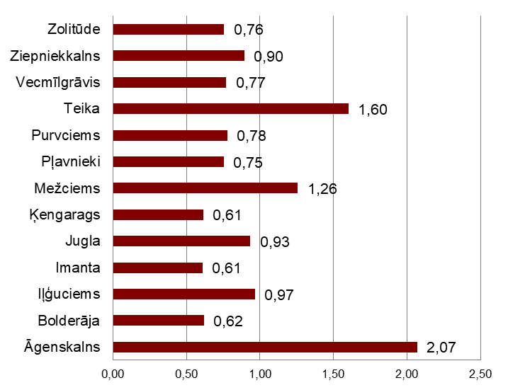

Source: ARCO REAL ESTATE

In November, changes could be observed in the prices of standard-type apartments in Riga's housing estates. An increase in the average price of apartments could be observed in all the largest housing estates of Riga. The largest increase in the average price was observed in Jugla and Vecmīlgrāvis, where prices increased by more than 2% during the month. The smallest price changes were observed in Zolitūde - there the average price increased by only 0.2%.

Changes in the average square meter price of standard-type apartments in Riga housing estates, %

Source: ARCO REAL ESTATE

Compared to the beginning of 2025, in November of this year, prices for standard-type apartments increased slightly in all of Riga's major housing estates. The highest average price per square meter of an apartment was in Teika, but the lowest was still in Bolderāja.

Average standard-type apartment prices in housing estates of Riga, EUR/m²

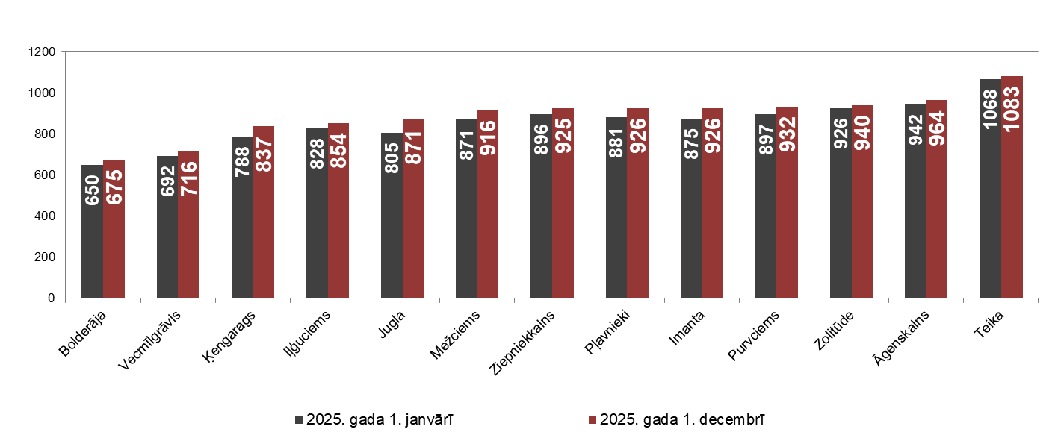

Source: ARCO REAL ESTATE

The highest prices for standard-type apartments in November remained in Teika, where the average price per square meter rose to EUR 1083/m². The lowest average price per square meter in November was in Bolderāja – EUR 675/m², which also increased compared to the previous month.

Average standard-type apartment prices in housing estates of Riga on December 1, 2025, EUR/m²

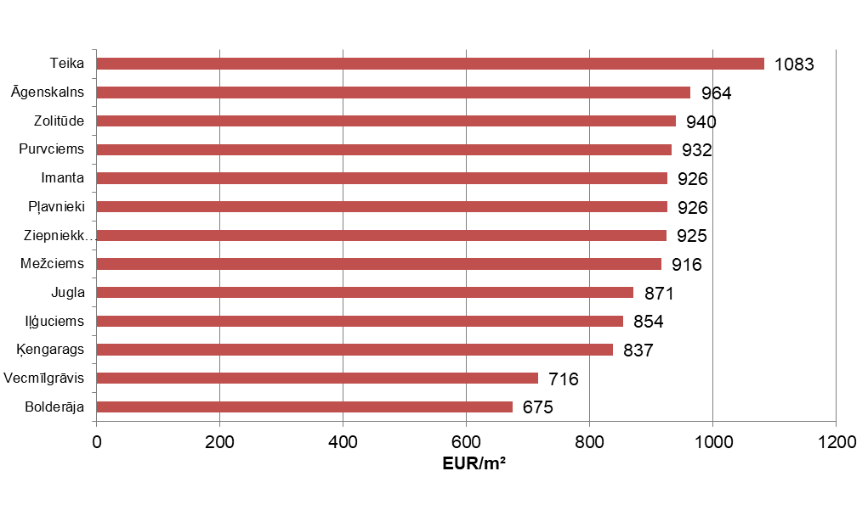

Source: ARCO REAL ESTATE

In November, the most expensive apartments still were apartments in the houses of the series 119 and 104, where the price of 2-room apartments in a satisfactory condition varied from 53 000 to 56 000 EUR depending on the location. In turn, the so-called Lithuanian design houses were the cheapest ones, where the price of 2-room apartments varied from 31 000 to 44 000 EUR, and the so-called Khrushchev-time houses, where the price of a 2-room apartment varied from 30 000 to 45 000 EUR depending on the housing estate.

Standard-type apartment prices by series in Riga housing estates in November 2025 (2-room apartments), EUR

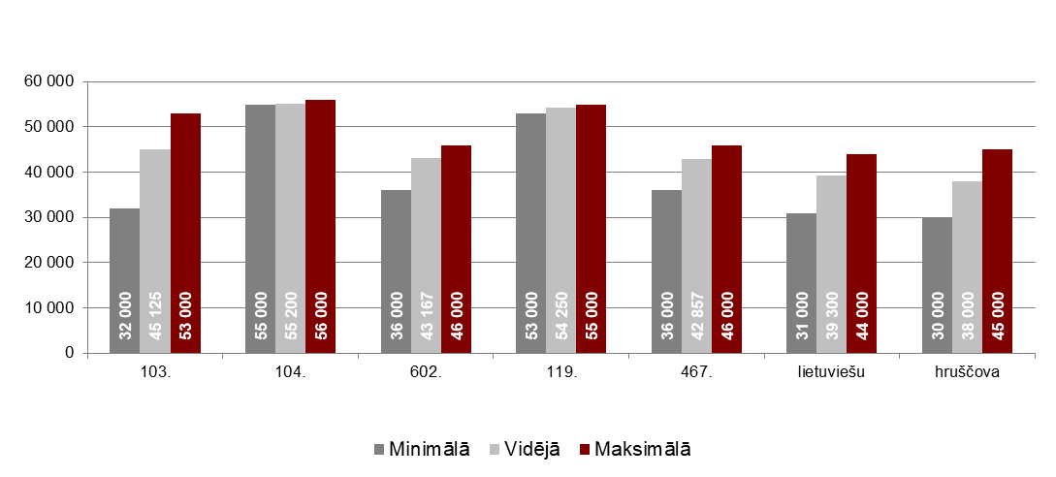

Source: ARCO REAL ESTATE

Apartment market in the vicinity of Riga

Ogre

In November 2025, the prices of standard-type apartments increased by 0.7%. The average price of one square meter of apartments reached 882 EUR/m². Apartment prices in Ogre in November were 4% higher than at the beginning of 2025.

Dynamics of the average price of standard-type apartments in Ogre, EUR/m²

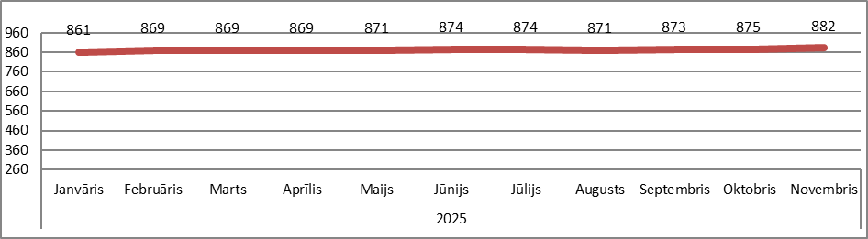

Source: ARCO REAL ESTATE

Kauguri, Jūrmala

In Kauguri, the prices of standard-type apartments increased by 0.7% in November. The average price of standard-type apartments in November was 827 EUR/m². Since the beginning of 2025, apartment prices in Kauguri have increased by 5%.

Dynamics of the average price of standard-type apartments in Jūrmala, Kauguri, EUR/m²

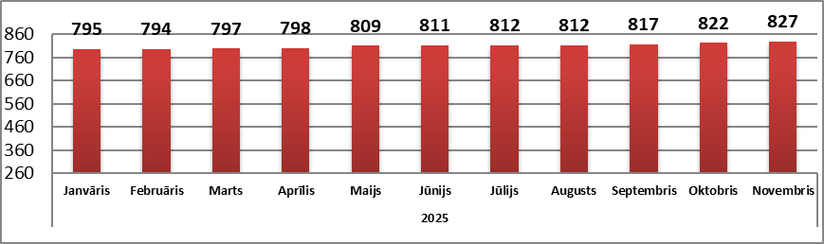

Source: ARCO REAL ESTATE

Salaspils

In November, the prices of standard-type apartments in Salaspils increased by 0.7%. The average price of one square meter of apartments increased to 847 EUR/m². In November, the prices of standard-type apartments in Salaspils were 2% higher than at the beginning of the year.

Dynamics of the average price of standard-type apartments in Salaspils, EUR/m²

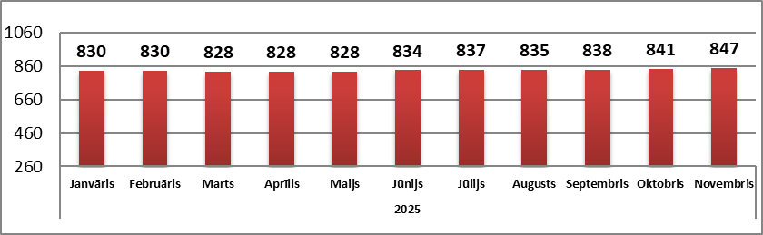

Source: ARCO REAL ESTATE

Jelgava

In Jelgava, apartment prices increased by 0.2% in November. The average price of standard-type apartments in Jelgava in November was 766 EUR/m². In Jelgava, standard-type apartment prices in November were 3% higher than at the beginning of 2025.

Dynamics of the average price of standard-type apartments in Jelgava, EUR/m²

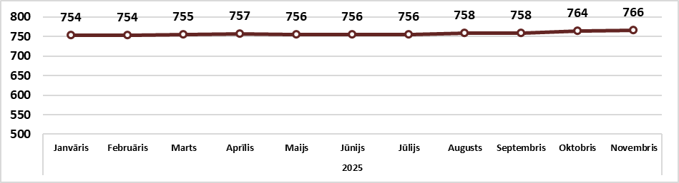

Source: ARCO REAL ESTATE

